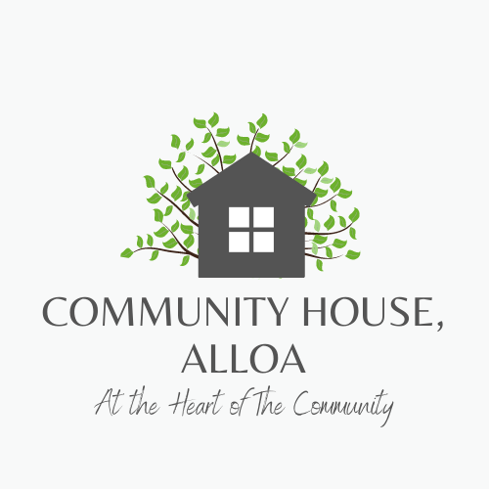

Community House
Practitioners Assistant
28 hours per week (potential to increase to 30)

Job Description

Summary of Post

The post holder will be required to Assist both Community House Practitioners and The Chief Officer in all the weekly activities, including forward planning and preparation of all groups and activities.

Prepare for the daily activities as required in advance of sessions. Prepare snacks/dinners for children and young people and the adult groups and sessions this includes preparing homemade soups, baking etc so being confident in the kitchen is a bonus. Clearing away plates and dishes, loading and unloading the dishwasher, ensuring cleaning is paramount.

Responsible for weekly shopping via Tesco online ordering and in person as and when required. Access to own car is preferable however not essential for the right candidate. If a car user Business Cover Insurance is essential as per our policy as you may be required to get additional shopping or potentially take a patron in your car however this is not common but has been known on occasion.

Prepare refreshments including tea/coffee/juice and other snacks for groups throughout the day. Personally aid service users with games and activities as set out during planning sessions. Actively suggest ideas for groups and thinkshower with staff to bring exciting new opportunities to the organisation. Develop appropriate and positive relationships with the children, young people and adults who use the project.

Ensure that policies and procedures are always adhere. To support practitioners with report writing in line with our policies, these are entered onto the Oasis system in line with GIRFEC. To adhere to confidentiality without exception with the exclusion of any child or adult disclosures relevant to legislation who is at risk.

Must be proficient with admin and able to operate Office 365 although training can be provided. This allows for calendar entries to be kept up to date and to keep the lines of communication open and seamless for the team via email and teams. To clear away activity equipment and sanitise at the end of the session. To meet regularly with the Chief Officer for support and supervision sessions, currently bi-monthly. To undertake necessary training as deemed appropriate with the Chief Officer.

To participate in an annual review with the Chief Officer. General Administrative duties including scanning, uploading of sensitive information appropriately, shredding and diary management.

This description is indicative of the nature of the responsibilities associated with this post. It is not exhaustive, and the post holder may be required to undertake other duties and responsibilities in accordance with the objectives of the Project as deemed appropriate by the Chief Officer and the Management Committee. The contents of this Job Description will be periodically reviewed and updated as appropriate.

Hours of work:
28 hours per week currently 9.30am – 5.30pm with 1 hour for lunch, Monday to Thursday. This may be increasing to a 30-hour contract with hours changing to 09:30am – 18:00pm so candidate must be willing to undertake new hours as and when approved.

Salary:
Currently £9.80 per hour depending on age but meets the national living wage.

Benefits:
We offer a generous annual leave entitlement with 40 days per year inclusive of public holidays this is pro rata for part time staff, we also offer a company pension scheme.

We run a TOIL system and timesheets are completed via Oasis, so flexibility is required to meet the needs of the services and activities we run, so flexibility is essential for this post.

Essential skills, experience, and qualifications

The postholder must be caring, empathetic, non-judgemental, and understanding with the mindset to go at the service user’s pace. The ability to take direction and instruction from all senior staff without issue, to be initiative-taking and forward thinking and able to work autonomously without being always guided. Whilst there is support and guidance in place there is also a need for initiative and ability to undertake tasks without being prompted, we are a small team and rely on one another.

There will be administrative work so an understanding Microsoft office 365 including work, excel, outlook and teams is a bonus although training will be provided. Oasis is our database and training will be provided to learn how to use this along with a laptop and mobile phone. Filing, scanning, making, and taking calls and uploading data is part of this role as is report writing and planning.

An SVQ in either child or social care would be good but not essential, more important is someone willing to take instruction and who can demonstrate initiative and to undertake an SVQ to achieve SSSC registration.

Details of employability support (training opportunities/mentor)

The successful candidate will be able to undergo a variety of on-site, side by side training and external training. Including First Aid, Food Hygiene, Safe and Together Training, Child Protection and Adult Protection among many other courses that are available to all staff through local connections i.e., Clackmannanshire Council, NHS, Transform and the Scottish Drug Forum. There will be IT training to use Office 365 and Oasis which is a CRM system which will be held with IT Works and other additional training offered by IT Works.
The successful candidate will also be supported by the practitioners to whom they are assisting and the Chief Officer who will hold regular 1-2-1 sessions to ensure support and identify any training issues that need to be addressed.
Programmes:
We deliver a variety of programmes and activities and will be delivering the “own my life course” in the new year. This is a programme for woman who have experienced domestic abuse, due to this service delivery all staff must be female, Membership of the Protecting Vulnerable Groups (PVG) scheme is a requirement this post.
*For the purposes of the Equality Act 2010 it is an occupational requirement that this post be filled by a woman
Knowledge | Essential | Desirable
Knowledge and understanding of child protection regulation | ✓
Knowledge and understanding of domestic abuse issues or capacity to acquire such an understanding. |  | ✓
Understanding of feminist analysis of domestic abuse or capacity to acquire such an understanding. |  | ✓
Knowledge, understanding and commitment to equality and human rights law and good practice. |  | ✔

Skills | Essential | Desirable
Ability to communicate clearly and effectively in writing and orally. | ✔
Ability to plan, prioritise workload and work independently. | ✔
Ability to actively listen to others. | ✓
Ability to challenge others constructively. | ✓
Ability to work well with others and keep calm under pressure. | ✓
ICT literate (minimum: Able to use Outlook / Outlook express; conduct an internet search and use webmail; and use Word, Excel, and other standard Office packages). |  | ✔
You must have one of the following qualifications or an equivalent or willing to work towards this:  - SVQ 3 Social Services (Children and Young People) at SCQF Level 7  - HNC Early Education and Childcare  - SVQ 3 Social Care |  | ✔
Drivers Licence and Access to car |  | ✔

Experience | Essential | Desirable
Experience of working / engaging with vulnerable children, experienced domestic abuse |  | ✔
Experience of providing one to one support to children and young people |  | ✔
Experience of writing reports and keep up to date records |  | ✔
Experience of and commitment to building and working in partnership with other agencies and stakeholder to ensure successful delivery the service |  | ✔
Experience of attending and contributing to Multiagency meetings such as LAC reviews, Child Protection Case Conferences, or Children’s hearings |  | ✔

