Job Description
Job Title: Corporate Partnerships Manager - Scotland
Directorate: Income Generation
Team/Department: Partnerships and Philanthropy Team/Scotland Fundraising

Context and Background
The NSPCC's mission is to end cruelty to children. Every childhood is worth fighting for. This is our belief. We all share it. And it drives our fundraising team to get out there and bring in the funds we need to protect children and prevent abuse.

We’ve been here for children for over 100 years. From our campaigns to our services- we strive to make a difference for children in everything we do, protecting children today and preventing abuse tomorrow.

The Scotland Fundraising Team’s aim is to maximise income to support our work in Scotland, providing the best possible supporter experience, and building long-term relationships between donors and our cause.

We rely on the fundraising support of people across Scotland, with 90% of our annual income coming from voluntary donations. We are looking to significantly grow our income in new and innovative ways. To achieve this growth, we need the very best team in place to deliver to ambitious targets.

We believe that partnerships with companies are one of the best ways to raise money, reach millions of people, and engage the UK public with our work. As much as a one-off donation is always welcome, we want to develop long-term, mutually beneficial relationships that put companies at the heart of what we do and simultaneously meet commercial needs.

As a Corporate Partnerships Manager, not only will the work you do make a real difference to children’s lives, but opportunities will be provided for you to develop your fundraising experience and skills within a sector leading organisation.

Join us at this exciting time and you’ll become part of an expanding team that cares about the work they do and the people they work with. You’ll discover opportunities to grow, along with challenges and a shared purpose that’ll bring the best out in you. And you’ll get to find your own way to make a difference that means more, and that impacts young lives in Scotland. We want to ensure roles are accessible and inclusive

of everyone, which is why the NSPCC offers a high degree of flexibility around ways of working.

Equality, Diversity and Inclusion (EDI) is at the heart of what we do. At the NSPCC, we understand how important it is that our workforce is representative of the people we support and who support us. We believe that every individual has the right to be their true self and to live a full life without prejudice, fear or barriers. This is the starting point for all our commitments and actions and underpins our commitment to be there for all children.


NSPCC Value’s

Job purpose
We’re looking for an enthusiastic and confident Corporate Partnerships Fundraiser to manage a varied and exciting portfolio of new and long-standing accounts across Scotland and to identify, develop and win new corporate support through Charity of the year’s and commercial & strategic opportunities.
Key relationships - Internal
- Senior Partnerships & Philanthropy Manager
- Head of Fundraising – Scotland
- Scotland Fundraising Team
- Regional Corporate Partnerships Team
- Community Supporters Department
- Regional and national communications teams

Key relationships - External
- CEO’s, CSR Managers, managers, and employees of supporting companies
- Corporate influencers and volunteers

Main duties and responsibilities
- To lead on corporate fundraising activity in Scotland.

- To manage, monitor and evaluate income against budget, forecasting as required to meet and exceed annual income targets.

- To develop a fully researched and engaged prospect pipeline of five and six figure future corporate supporters.

- To help maintain a comprehensive Charity of the Year Calendar.

- To play a key role in maximising income for the NSPCC from existing commercial partnerships and relationships.

- To provide account management professionally and creatively for current and new partners.

- To find ways in which companies can provide ‘added value’ through gift in kind, pro bono and volunteering as well as leveraging contacts, experience and using buying power.

- To be aware of sector and departmental best practice, bringing and sharing within the team to create a standard of excellence in our corporate support which is sector leading.

Responsibilities for all Staff within Income Generation

A commitment to safeguard and promote the welfare of children and young people

- To update databases and supporter information systems on a regular basis in line with Data Protection legislation and NSPCC policy and procedures to ensure all records are up-to-date and accurate.

- To actively participate in regular department and team meetings, contributing to discussions and decisions, which in the long term will be beneficial to the NSPCC’s development of fundraising activities.

- To maintain an awareness of own and others’ Health and Safety and comply with the NSPCC’s Health & Safety policy and procedures.

- To take personal responsibility for keeping up to date with NSPCC work, including securing updates on project and service developments and general NSPCC news.

Person specification
- Minimum of two years’ experience working in a fundraising role, (ideally in Scotland) or three years’ experience within a sales or marketing environment.

- Experience of success in developing relationships to achieve results within a fundraising, sales or marketing environment.

- Experience of account management or partnership management within the third or commercial sector.

- A track record of demonstrating initiative and creativity to achieve desired outcomes.

- Experience of new business development and securing relationships.

- An outgoing, confident individual, who can work on their own initiative and is achievement and results orientated.

- Ability to work to short term objectives and long-term goals.

- A highly organised individual with strong planning and prioritisation skills.

- Excellent written and verbal communications skills to analyse, interpret and present complex information in a clear and persuasive way for a wide range of audiences to inspire support.

- Flexibility to work collaboratively with and through other teams and departments to maximise results and achieve desired outcomes.

Additional Information
For more information or to chat through this exciting opportunity, please contact Jenny Seftor, Senior Philanthropy and Partnerships Manager at jenny.seftor@nspcc.org.uk or on 0141 212 3898
Interview Dates: 7th or 9th February 2023

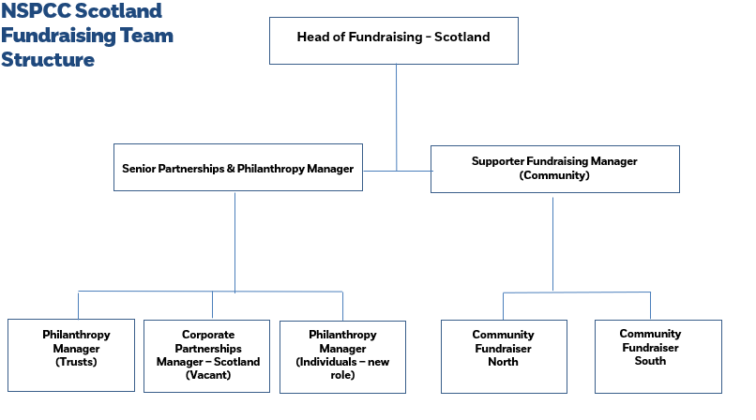
Safer Recruitment
As an organisation, we are committed to creating and fostering a culture that promotes safeguarding and the welfare of all children and adults at risk.
Our safer recruitment practices support this by ensuring that there is a consistent and thorough process of obtaining, collating, analysing and evaluating information from and about candidates to ensure that all persons appointed are suitable to work with our children and adults.
The recruitment and selection of our people will be conducted in a professional, timely and responsive manner and in compliance with current employment legislation, and relevant safeguarding legislation and statutory guidance.
Our principles:
- Always seek to recruit the best candidate for the role based on merit including their skills, experience, motivation and competencies. Our robust recruitment and selection process should ensure the identification of the person best suited to the role and the organisation.
- Committed to diversity and equality of opportunity and will interview all applicants (internal and external) who self-declare at application as having a disability and who meet the minimum requirements in the person specification of the vacancy they are applying for.
- We will make reasonable adjustments at all stages of the recruitment process in order to enable successful candidates who declare disabilities to start working or volunteering their time with us.
- Any current member of staff or volunteer who wishes to apply for vacancies and is suitably qualified will be considered and addressed fairly and objectively based on their merit.
- As an organisation committed to safeguarding, we will ensure all under 18’s joining the organisation will have ongoing risk assessments to ensure their role and activities are safe and appropriate.
- All documentation relating to candidates will be treated confidentially in accordance with the GDPR legislation.

