**4th January 2023**

**Dear Applicant**

**ESOL Coordinator**

Thank you for your interest in the above vacancy with Govan Community Project.

Enclosed with this letter is a copy of the job description, and a copy of our application form. The application form can be completed electronically, however we are also happy to receive paper applications.

***The closing date for applications is 9.00 am on Monday 16th January 2023 at 12.00 noon. No late applications will be considered. Please note CV’s are not accepted, please complete the provided application form. Should you require any accessibility support to make your application, please contact us.***

***We aim to hold interviews in the week commencing 23rd January 2023.***

To enable us to monitor diversity within our recruitment processes, we would be grateful if you could complete our anonymous diversity survey which can be accessed here: <http://bit.ly/GCPHReqmonitoring>, however this is not mandatory and opting out of this will have no impact on your application.

Completed applications being submitted by email should be sent to recruitment@govancommunityproject.org.uk. Paper applications should be sent to:

Traci Kirkland, Head of Charity

Govan Community Project

840-860 Govan Road

Glasgow G51 3UU

**Please note that as a small organisation we do not have the capacity to respond to every applicant individually. If you have not heard from us within 14 days of the closing date, you should consider your application to have been unsuccessful.**

We look forward to receiving your application.

Kind Regards

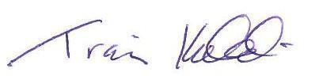

**Traci Kirkland**

**Head of Charity**