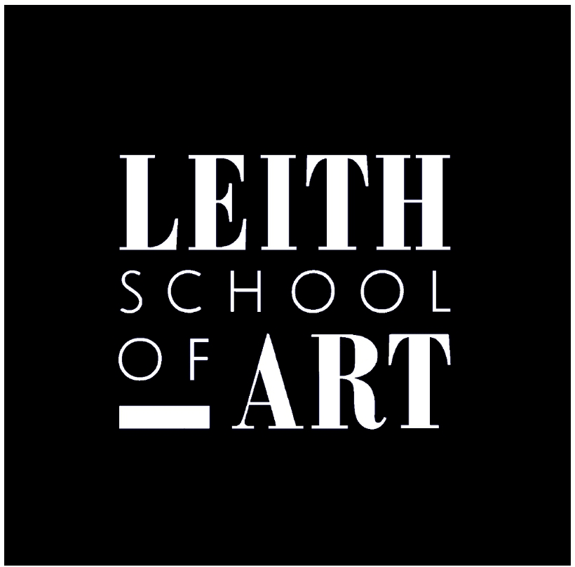
Job Title: Fundraising & Development Lead
Job Application Form

Guidance
How to Apply
Please read and consider the JOB DESCRIPTION AND PERSON SPECIFICATION for this post before you start your application. We will prioritise applicants for interview who focus on the requirements outlined in the job description and person specification.
Please complete all sections of this form and return by email to: Recruitment@LeithSchoolofArt.co.uk or printed copy to Leith School of Art, 25 North Junction Street, Edinburgh EH6 6HW.
Closing date for applications: Sunday 29th January 2023
Interviews for this post will be held week beginning 13th February 2023

Referees
- One referee must be your current employer; the other can be a previous employer or a referee from an unpaid or voluntary position you have held.

Returning the form
- Please return your completed application form electronically by email or in hardcopy by post, by the closing date. If it arrives late, we will not be able to consider your application.
- If you require any further advice on any of the above, please telephone 0131 554 5761 or email: Enquiries@LeithSchoolofArt.co.uk

Fundraising & Development Lead
Job Application Form
--- CONFIDENTIAL---

SECTION 1: Personal Information

Please provide us with accurate contact information for you.

Title: (Please specify - e.g. Ms/Mr/ Miss/Mx/Dr/Prof)

Full name

Preferred Pronouns (optional)

Address for correspondence:

Home Phone

Mobile Phone

Work Phone (only if we can contact you at this number)

E-mail address

NOTICE PERIOD: When would you be able to take up the post?

SECTION 2: Employment History

Please give details of posts held, starting with the most recent. There are several boxes below; use a different one for each post you are describing, copy and paste as many boxes as you need to describe your employment history. This section can include unpaid (voluntary) posts.

Each box asks for further detail about the post you held. Please make sure you describe your work as succinctly as possible.

Year | Post | Employer | Description | Reason for Leaving

Year | Post | Employer | Description | Reason for Leaving

Year | Post | Employer | Description | Reason for Leaving

Year | Post | Employer | Description | Reason for Leaving

SECTION 3: Qualifications and Training

There are several boxes below; use a different one for each qualification or training course you are describing, starting with the most recent.

Copy and paste as many boxes as you need to cover all of your qualifications and relevant training.

Year awarded | Award name/title | Details of awarding body or institution | Description
Year awarded | Award name/title | Details of awarding body or institution | Description
Year awarded | Award name/title | Details of awarding body or institution | Description
Year awarded | Award name/title | Details of awarding body or institution | Description

SECTION 4: Personal Statement

In the box below, please tell us how your experience, skills and qualifications meet the requirements of the job description and person specification. Please focus your response on the abilities and/or competencies required for this role, giving evidence of your experience to date, on no more than 2 sides of A4.

SECTION 5: Referees

Please give details of two people who can comment on your suitability for this post. One referee should be your current employer; the other can be a previous employer or a referee from an unpaid or voluntary position you have held. Referees will not be contacted prior to interview.

First Referee (Current Employer)
Name
Job Title
Organisation
Address
Phone
Email
Relationship to candidate

Second Referee
Name
Job Title
Organisation
Address
Phone
Email
Relationship to candidate

Can we contact your current employer prior to any conditional offer of employment? | ☐ Yes | ☐ No

SECTION 6: Permission to Work in the UK

Part A – Permission to work in the UK
Do you require a work permit (i.e. document issued from UKBA) to enable you to work in the UK? ☐ Yes ☐ No

SECTION 7: Declaration

I confirm that the information I have given is correct and complete.
I understand that any false statements or omissions may render me liable to dismissal without notice or in some instances, referral to the police, if they become known after appointment.
I consent to Leith School of Art checking any information that I am unable to personally verify.
I understand and agree that data contained in the application form will be used and processed for recruitment purposes. I understand and agree that should I become an employee, the information will also be used for employment related purposes. I agree to Leith School of Art holding and processing this information.

Signed Dated

The Leith School of Art is a Company Limited by Guarantee and having Charitable Status.
Registered in Scotland at 25 North Junction Street, Edinburgh.
Registered No.111089. Scottish Charity Number SCO07456

