Candidate Information

Senior Project Officer, Scottish Canals

Salary: | Grade G: £28,499- £33,918
Hours: | Full-time hours are 37.5 hours per week divided as follows:  30 hours per week based within the Placemaking team at Scottish Canals. Falkirk Wheel, Lime Road, Tamfourhill, FK1 4RS (with option of homeworking)  - 7.5 hours per week based within Strategic Partnerships at Sustrans Scotland (with option of homeworking)
Contract: | Permanent
Disclosure: | PVG Scheme membership is not required
Bases: | The post-holder will be based in Falkirk at the Falkirk Wheel, Lime Road, Tamfourhill, FK1 4RS with flexibility to work from home a proportion of the time. You may be required to work at various Scottish Canals locations where appropriate. Occasional travel to Sustrans Scotland’s offices in Edinburgh or Glasgow will be required.  The post-holder will work with Scottish Canals for at least four days a week. Up to one day a week may be spent with Sustrans Scotland (at home or office based), in order to undertake continuing training and development and to collaborate with other colleagues.
Travel: | This role will involve regular travel most weeks. The focus of this role is Scotland wide and in particular the Scottish Canals area; however, we may occasionally need you to travel further during the course of your work, including occasional visits to Sustrans Offices and overnights stays.
 | A key part of being the Charity that makes it easier to walk and cycle is that most colleagues cycle, walk, wheel or use public transport for the majority of their work journeys. We support this with National Standards Cycling Training payment of bicycle mileage and covering the cost of public transport.

Project Specific Information
The post holder will be based within Scottish Canals and facilitate a strategic approach to active travel infrastructure development and delivery in in the environs of Scotland’s Canals, working to shared priorities agreed between Scottish Canals and Sustrans. The post holder will be line managed by Sustrans and task managed on a day to day basis by a key contact in Scottish Canals. The post holder will provide support in the development and delivery of active travel policies and proposals as set out within Scottish Canals’ Corporate Plan, Annual Business Plan and related documents. The post-holder will work across Scottish Canals departments and in partnership with external organisations to identify and develop opportunities for investment in active travel. The post-holder may also assist with research to demonstrate demand for investment in active travel infrastructure.

Where this role sits in the Sustrans Scotland structure:

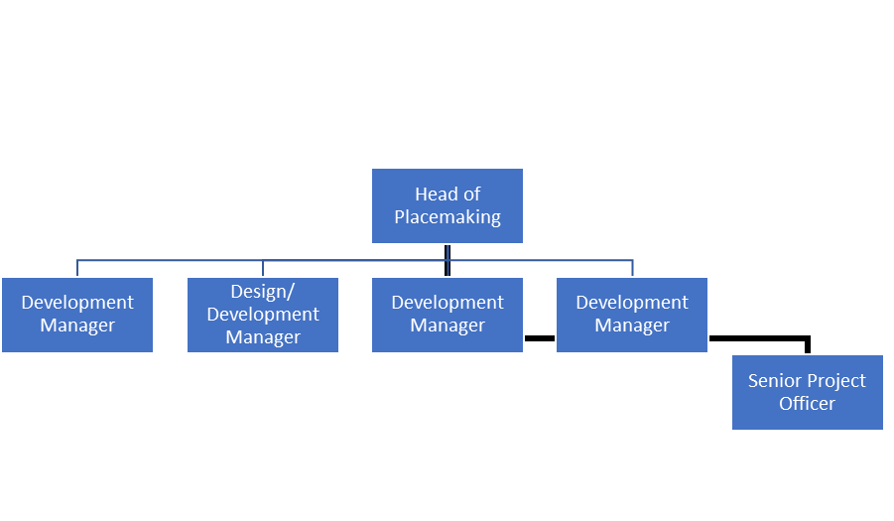
Where this role sits in Scottish Canals structure:
Green and yellow highlighted posts are not employed by the CNPA but their link to the organisation is through the Infrastructure Manager

The post-holder will be task managed by the Head of Plcamaking at Scottish Canals, and line managed by the National Partnerships Manager, Strategic Partnerships and Business Development at Sustrans Scotland. Placemaking is part of the People , Safety and Governance Directorate in Scottish Canals
Job Description - About the Role

Overview:
The purpose of this role is to help deliver Scottish Canals shared priorities for Placemaking and active travel across the canal network.
The post holder will deliver an Active Travel Strategy (with a dedicated workstream for young people) which integrates with the National Cycle Network. This will inform a joint programme of infrastructure and strategic investment priorities which improve community connectivity for those walking, wheeling or cycling

Where this role sits in the structure | Reporting to the Head of the placemaking team at Scottish Canals, and reporting into the National Partnerships Manager, Strategic Partnerships and Fundraising, at Sustrans Scotland for line management  Sustrans Scotland: Working closely with Strategic Partnerships and Business Development Team, Network Development team, Policy and Communications team, Places for Everyone team, Behaviour Change team, and the Engineering, Design and Assurance team.  Scottish Canals: the role will sit as part of the Placemaking team with close links to Engineering, Sustainability, Estates and Operations.  This role does not have direct line management responsibility.

Key Responsibilities:
This role is a Senior Project Officer, Active Travel Strategy. Responsibilities may include:
Delivery of the Project:
- To work strategically to develop active travel initiatives in the environs of Scotland’s Canals, for example assisting the development of active travel strategies/ development plans/ project delivery processes to direct investment into active travel (e.g. network development and prioritisation)
- To plan and deliver high quality active travel projects, including initiating and supporting delivery of new/improved infrastructure
- Identify and develop funding opportunities for active travel projects, including liaising with funders to discuss potential projects and submitting funding applications
- To assist with Bike Life research to demonstrate demand for investment in active travel infrastructure
- To facilitate community / public engagement to ensure a collaborative approach to projects and their communication
- To work across council departments and in partnership with external organisations to identify opportunities to align policy aims and increase investment in active travel
- To influence through sharing knowledge, expertise and evidence, including facilitating access to opportunities for support, training and knowledge from other teams within Sustrans
- To prepare reports and present project updates and outcomes to a variety of audiences, which may include funders, local authority and Sustrans staff, elected members, as well as to wider audiences (e.g. conference presentations)

We don’t expect anyone to be an expert in all these areas and as long as you meet the person specification we can train you in any gaps.

Person Specification
The following criteria sets out the method by which the skills, knowledge and experience will be assessed against. Our website has a useful guide about how to make a great job application.
 | Application Form | Interview
Specific experience required
Project management
Partnership working and relationship-building
Working with or in local authorities
Community engagement
Skills and Abilities
Excellent verbal and written communication skills and presentation skills
Ability to work independently and make decisions with minimal supervision
Ability to be a team player
Competent in using GIS (geographic information system) mapping (Preferable)
Strategic thinking
Qualifications/ training required
Educated as appropriate to person specification
Specific knowledge required
National and international best practice in design and promotion of cycling, walking and wheeling
Knowledge of the funding context for active travel in Scotland
This document does not form part of the contract of employment but does outline our expectations. If we need to amend this document in the future, we will consult with the post holder before doing so.

Everyone at Sustrans
Our values guide us in everything we do:
- Including everyone
- Having the courage to question
- Acting local, thinking big
- Getting things done, together
- Always learning.
- Sustrans has clear health and safety policies and it is essential that all our colleagues follow these. Very often our teams come into contact with young people through schools work or community engagement so it is everyone’s responsibility at Sustrans to comply with our Safeguarding policies.
- One of our key strategic goals is to be a charity “for everyone”, building a more diverse and inclusive Sustrans. We recognise there is much more we can do to bring together diverse life experiences and voices to enable us to more fully understand, access and represent the communities we work in. Everyone at Sustrans should support this goal and follow our Equality, Diversity and Inclusion policies and procedures.
- Sustrans asks that all our employees develop their skills, knowledge and experience through training and personal development activities. Sustrans will support you with clear objectives and a supportive management culture - our teams tell us that one of the great things about working for Sustrans is the learning and knowledge sharing opportunities.
- It is very important that our colleagues are happy and able to work with IT systems - we use Microsoft programmes and other databases every day (we will train you on our bespoke systems)
- It is also important that everyone at Sustrans supports and follows with the charity’s guidance on branding/key messages and contributes towards raising Sustrans’ profile.
- Everyone at Sustrans is required to work their contracted hours and record their time – if extra hours are worked then we can take time off in lieu.
- We ask that everyone in Sustrans helps us to develop new opportunities for funded work and builds excellent relationships with our delivery partners and stakeholders.
Two of our values are we get things done, together and we’re always learning. Managers often require their teams to get involved in activities that are outside of their job descriptions as we feel this is one of the ways you can learn on the job, develop new skills, make new contacts and progress your career with Sustrans.

