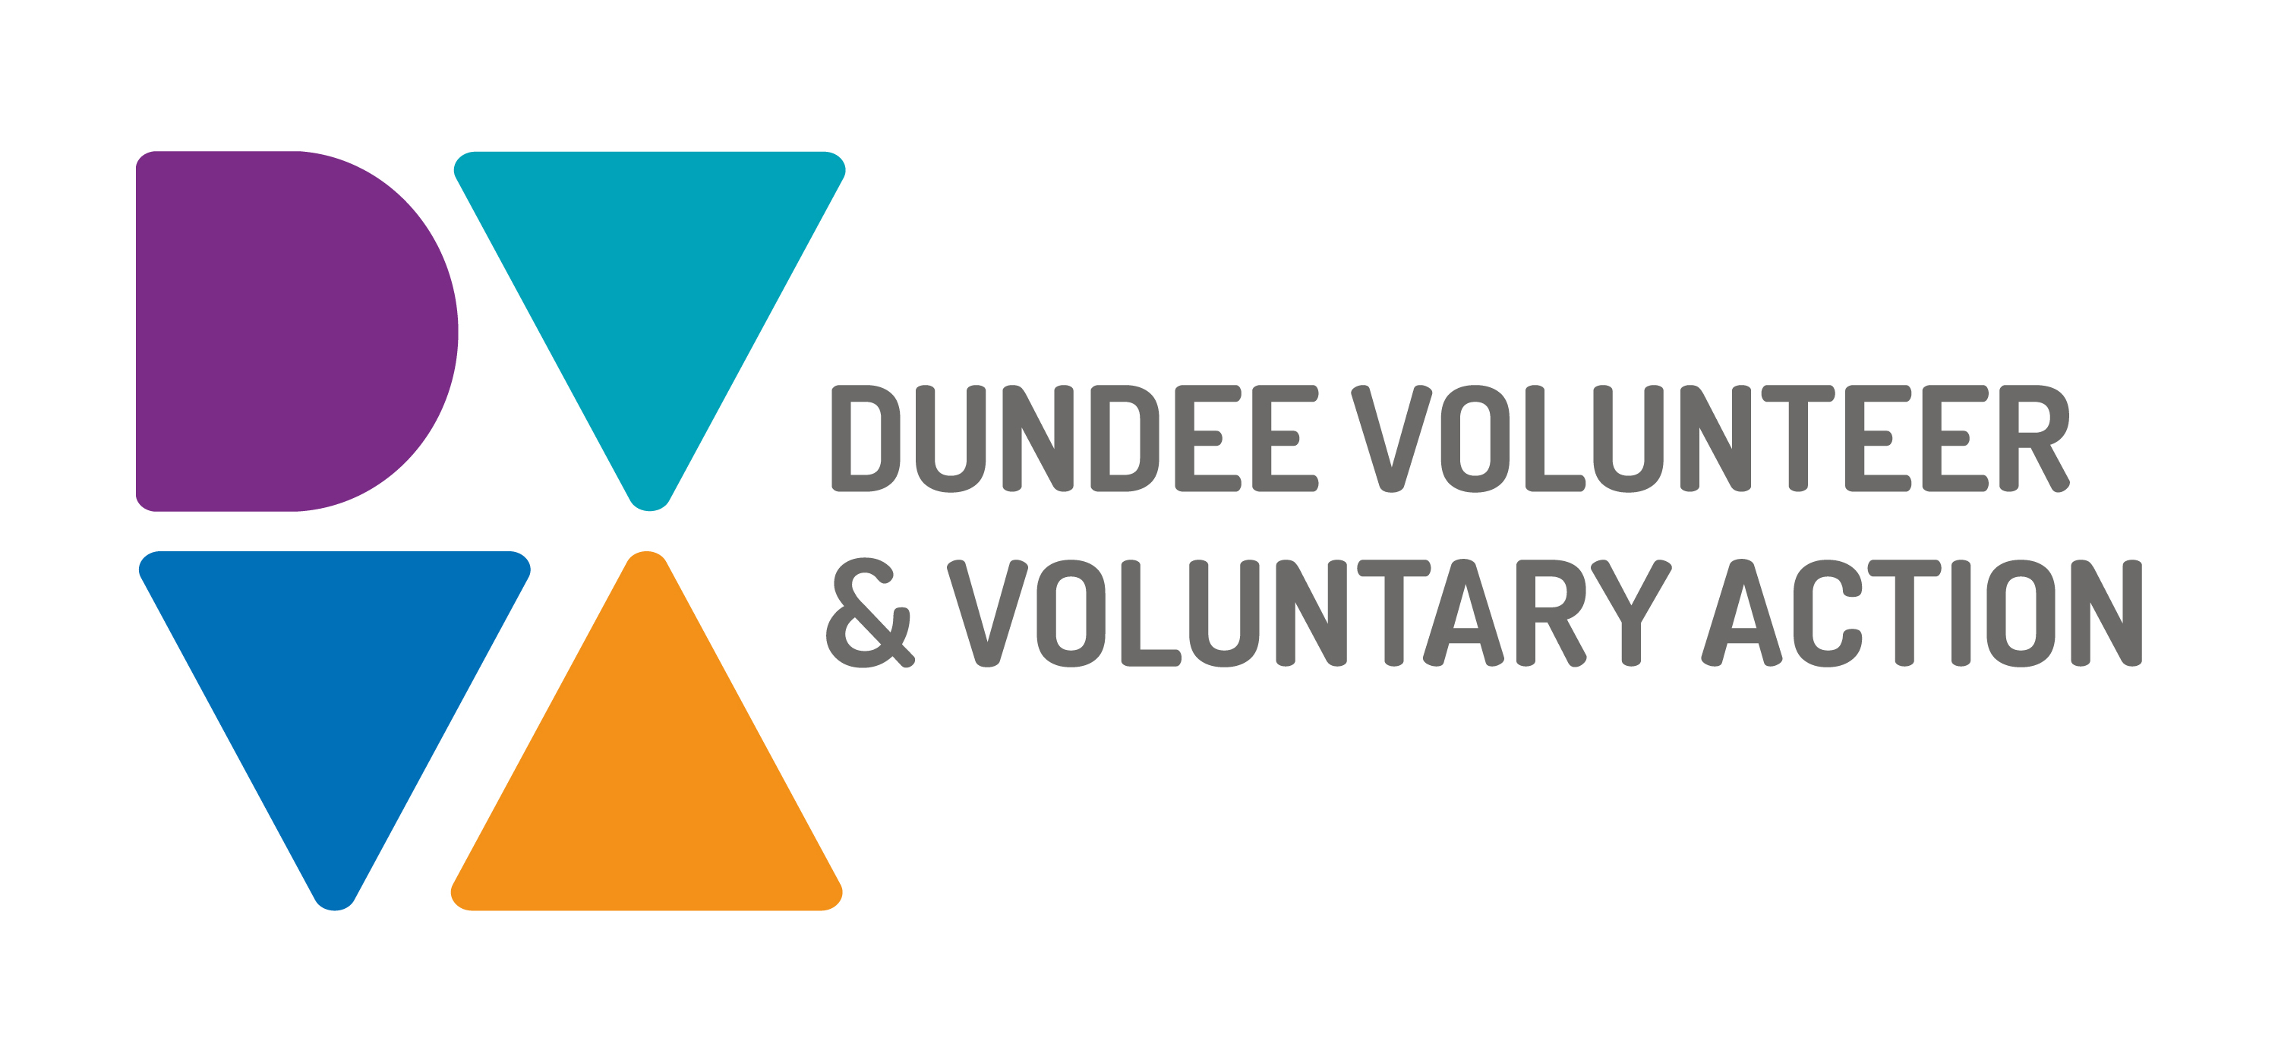
Job Description and
Person Specification

POST TITLE: Human Resources Manager

DURATION: Permanent

HOURS OF WORK: 28 hours per week (0.8 FTE), to be worked in accordance with DVVA Conditions of Service

SALARY: Grade 5 - £28,917 - £32,130 FTE

PURPOSE OF POST: The HR Manager will manage our people and ensure that our human resources policies, procedures and databases are effective, efficient, and aligned to overall DVVA strategy and values.

MAIN DUTIES:
- To develop HR policies and procedures that align with the organisation’s goals and values, encourage staff development and mitigate disputes. Regularly monitor and review all policies and procedures and implement changes or improvements where necessary.
- To manage and develop our HR database. Ensuring records are up to date and held in line with GDPR.
- Advise and support managers on a broad range of HR issues, particularly in relation to employee relations issues such as absence, discipline, grievance and performance management.
- Lead on a staff learning and development plan as part of our Workforce Strategy. Develop a training matrix and ensuring appropriate training courses are effective and are accessed by staff.
- Provide expert advice and guidance on the resolution of employee relations matters in line with HR policy, legislation and best practise, ensuring concerns are addressed consistently and timely.
- Continue to seek improvement to the HR service provided and efficiency by implementing new ideas and methods and continue to seek ways of both improving contribution to the organisation’s goals and enhancing the reputation of the organisation.
- Set up & monitor processes which ensure that candidates and employees enjoy a seamless journey through the employee lifecycle
- Contribute to the strategic development of DVVA through discussion with the senior management team. Advising on areas of development within the workforce strategy.
- Producing HR reports on a regular basis for the senior management team and the trustees.
- Lead on the promotion of health and safety within DVVA, ensuring compliance with relevant legislation and training is accessed by staff where required and policies and procedures are regularly reviewed and updated where necessary.
- You will be excited to take the lead on change-management tasks and be able to demonstrate that such challenges will not phase you.
- You will be responsible for the line management of the Office Manager.

OTHER DUTIES
The job description is a broad picture of the post at the date of preparation. It is not an exhaustive list of all possible duties as it is recognised that jobs change over time. Should the duties change radically then the post and grading will be reviewed.

CONDITIONS OF SERVICE
- These are set out in the organisation’s staff handbook.
- All staff meeting the qualifying criteria may join a defined contribution pension scheme provided by TPT Retirement Solutions.
- The organisation has an equal opportunities policy and seeks to be an equal opportunities employer.

ANNUAL LEAVE: 21 days per annum on appointment increasing each year by 1 day to a maximum of 25 days, plus 6 public holidays, plus 5 days Christmas closedown. Pro-rata for part-time staff.

LOCATION: There may be an option for the post to be a blend of home and office working in future. Our main office is based in Dundee city centre and we also have community locations in Lochee and Whitfield.

TRAINING: Staff may make application to pursue appropriate training.

JOB DESCRIPTIONS are reviewed from time to time.

Person Specification

 | Essential | Desirable

Professional/Educational Qualifications
Qualified to degree level plus 3 years experience | x
CIPD Level 5 status | x
Knowledge and Experience
Experience as an HR Manager | x
Excellent knowledge and understanding of Employment Law | x
Experience of working with personal and sensitive data, in compliance with GDPR regulations. | x
Track record of designing and developing comprehensive policies, guidance and plans | x
Good knowledge of the HR policy and legislative environment. | x
Significant HR system experience with the ability to quickly learn, use and develop the HR system | x
Knowledge of health & safety legislation and experience working within its remit | x
Knowledge of Disclosure Scotland (PVGs, Disclosures) | x
Experience of managing staff | x
Experience in the design, delivery and evaluation of training courses / workshops | x
Project management experience |  | x
Experience in change management |  | x
Experience of working in the voluntary sector |  | x

Skills and abilities
Excellent communication skills, both oral and written | x
Excellent organisational skills | x
Strong interpersonal skills, with the ability to establish and maintain internal and external relationships effectively | x
Proficient with Microsoft 365 software, including Outlook, Teams, Excel and Word. | x
Practical, logical and innovative approach to problem solving | x
Proven skills in influencing, communication and working collaboratively with internal and external colleagues, building professional networks to enhance organisational profile | x

Personal Qualities
Self-motivated, and able to motivate others | x
Highly innovative and experienced in designing new systems and processes | x
Committed to continuous professional development | x
Flexible approach with an ability to meet deadlines | x
Commitment to equal opportunities | x

Additional Job-Related requirements
Satisfactory basic disclosure check | x

