20th January 2023

Dear Applicant

Thank you for considering Angus Independent Advocacy (AIA) as a prospective employer.

We are currently recruiting for the following posts:

- Families Independent Advocacy Worker
- Independent Advocacy Worker (Sessional)

AIA strive to provide accessible, independent advocacy within Angus for individuals who face barriers to having their voice heard and safeguarding their rights. The underpinning principles for Independent Advocacy are:

- Independent advocacy is loyal to the people it supports and stands by their views and wishes.
- Independent advocacy ensures peoples’ voices are listened to and their views taken into account.
- Independent advocacy stands up to injustice, discrimination and disempowerment

AIA looks forward to hearing from you if are committed to working alongside us to ensure that individuals are able to have their voices heard here in Angus.

Kind regards,
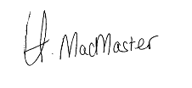

Chief Executive Officer

