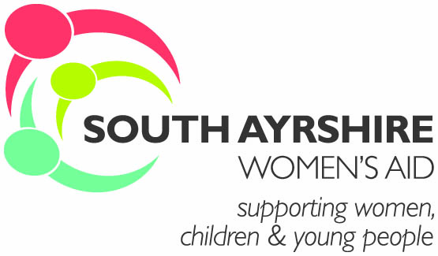

Summary Terms & Conditions of Employment

This summary is for guidance only and is not contractual.

Salary | The salary is £26,424 PA (Under Review)  Paid on the 27th of every month by bank transfer.
Place of employment and Hours of work | Based at 28 Sandgate Ayr you may be required to work at any other site within South Ayrshire as directed by the Manager.  The hours for this post are 30 per week inclusive of lunch breaks. Lunch breaks are unpaid, and all staff are expected to take a minimum half hour lunch break.
Holiday entitlement | Your holiday year begins on 1st April and ends on 31st March each year.  You will receive a paid holiday entitlement of 32 days inclusive of public holidays. You will also accrue one extra holiday on completion of a full holiday year up to a maximum of five extra days.  2 fixed at Christmas, 2 at New Year, 2 May Days and the Easter weekend.
Pension Scheme | SAWA intends to offer all employees the opportunity to join the group pension scheme as and when specified by Government legislation.
Mileage Allowance | You may need to use your own car for business use. The mileage allowance is 45p a mile.  You must have car insurance for business use. (this is the employee’s responsibility to obtain this insurance)
Probation | There is a 6-month probationary period.
Sickness Provision | During your probationary period you will be entitled to Statutory Sick Pay for absence due to sickness. Thereafter SAWA operate a contractual sick/injury pay scheme which provides payment during periods of certified sickness in any 12-month period as detailed below:  Less than 26 weeks: Statutory Sick Pay only.  More than 6 months and less than 2 years: 4 weeks full pay and 4 weeks half pay.  More than 2 years and less than 3 years: 9 weeks full pay and 9 weeks half pay.  More than 3 years: 16 weeks full pay and 16 weeks half pay
Pre-employment Checks: All applicants are required to complete a declaration of criminal conviction and noncriminal conviction form. All posts require an enhanced PVG check.

