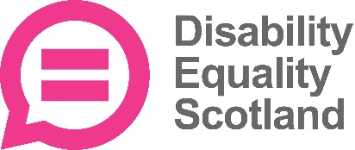
EQUAL OPPORTUNITIES MONITORING FORM

Disability Equality Scotland is committed to equal opportunities to ensure that no job application receives less favourable treatment on race, religion, gender, marital status, age, disability or sexuality.

Please fill in this form so that we can monitor the implementation of our equal opportunities policy. The answers that you give will be treated in the strictest confidence and will only be used for statistical monitoring. This page will not be attached to the application form during the short listing and interview process.

Disability / Long term condition

Do you have any of the following conditions which have lasted, or are expected to last at least 12 months? Please tick all that apply

Deaf, deafness, hard of hearing or deafblindness
Blindness or other vision impairment
A Physical Disability
A Learning Disability
A mental health condition
A long term illness
Prefer not to answer
Other – Please write

Gender

Male Female Non-binary Own gender identity

Prefer not to answer

Age Range

Under 25 25-34 35-49 50-65 Over 65

Religion

None Church of Scotland Roman Catholic Other Christian
Muslim Buddhist Sikh Jewish Hindu Pagan
Prefer not to answer If other religion or belief, please write
Sexual Orientation

How would you describe your sexual orientation? (please tick one box only)

Straight Gay/Lesbian Bisexual Prefer not to answer
If other, please write

Ethnic Group

White

English Welsh Scottish Northern Irish Irish
British Gypsy or Irish Traveller Prefer not to answer
Any other white background, please write

Mixed / multiple ethnic groups

White & Black Caribbean White & Black African White & Asian
Prefer not to answer
Any other mixed background, please write

Asian or Asian British

Pakistani Indian Bangladeshi Chinese
Prefer not to answer
Any other Asian background, please write

Black / African / Caribbean / Black British

African Caribbean Prefer not to answer
Any other Black/African/Caribbean background, please write

Other ethnic group

Arab Prefer not to answer
Any other ethnic group, please write

Please enclose the completed form with your application and send to
Lyn Pornaro, Chief Executive Officer, Disability Equality Scotland recruitment@disabilityequality.scot

