**Disability Equality Scotland**

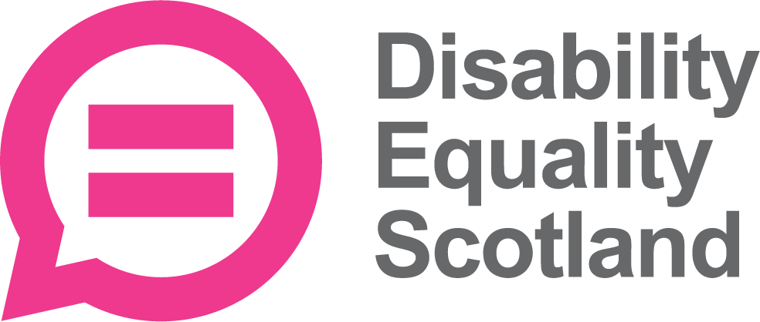

**Information about our Training and Development Worker Job**

**Easy Read**



Copyright images © Photosymbols / Canva Prepared by Disability Equality Scotland

|  |  |
| --- | --- |
| A confident looking woman with a walking aid. Behind her is a green circle with radiating lines, to show 'new'. | **The job**  We want a new Training and Development Worker. |
| A pile of money. | The salary will be 23 thousand pounds per year.  Because this is not a full time job, the actual pay will be 13 thousand and 8 hundred pounds per year. |
| A clock. | The job is for 21 hours each week. |
|  | The job can be worked from our offices in Glasgow City Centre.  Or it can be worked from your home.  Or a mix of both these places. |
| A photo of James Davidson. | Your manager will be our Communications and Research Manager – James Davidson. |
| A calendar page showing 17 February. | The closing date is  5pm on 17 February 2023.  This means you must get your application form to us before then. |
| A group of smiling people, some of whom have visible disabilities. The Disability Equality Scotland logo. | **Who we are**  Disability Equality Scotland is a national organisation with 1 thousand 5 hundred members. |
| Reasonable Adjustments - a wheelchair user next to a ramp.  She is next to images of an easy read document, a stopwatch showing a period of time, and there is a speechbubble saying 'I need..' | We work to get full access for disabled people and to make sure they are a part of change happening. |
| 4 people talking in a group. | We speak for:   * people with any type of impairment * disability organisations * groups who share our values |
| a group of people of different ages.  One is a wheelchair user and one person has a guide dog. | We want people to have equal access to buildings and the outdoors.  We want all people to have equal chances to be independent and have full, enjoyable lives. |
| A man with his thumb up next to a list of green ticks. | **About this job**  The Training and Development Worker will:   * work on our Easy Read Training package * train groups of people online in how to write Easy Read documents * help our Easy Read Workers to write Easy Read documents * help our website tell more people about Easy Read |
| A person specification document with subtitles 'knowledge', 'experience' and 'skills'. | **Qualifications and Experience that you must have** |
| An A4 certificate with a seal mark and a signature. | You must have a qualification that shows you can train other people. |
| An Easy Read leaflet. | You must have some experience of Easy Read documents. |
| A group of smiling people with their arms protectively around one smiling woman. | You must have experience of **equality** projects. |
| A disabled man pointing to himself, next to a law document called 'Equality Act'. | **Equality** means treating everyone fairly. |
| 3 people using British Sign Language to sign 'BSL'. A collection of speech bubbles with different languages in each one. A large print document. A braille document with a hand. | You must have experience of **Inclusive Communication.**  **Inclusive communication** means things like:   * British Sign Language * documents in a different language * Large Print * braille * Easy Read |
| A person specification document with subtitles 'knowledge', 'experience' and 'skills'. | **Skills and Knowledge that you must have** |
| A woman using a computer at her desk. | You must be able to **analyse** information.  **Analyse** means to take apart information and read it in new ways. |
| A man smiling as he works at a computer. | You must be able to use these computer tools:   * Word * Excel * PowerPoint * Project Manager * Publisher * WordPress |
|  | You must be very good at:   * organising yourself * working with others * speaking to others |
| An Easy Read report. | You must be very good at writing things like reports and emails. |
| A woman holding a checklist with green ticks on some boxes. | You must be very good at:   * sorting out which of your tasks need to be done first * meeting deadlines calmly and on time * working **under pressure** |
| A finger pointing to a watch. | **Under pressure** can mean:   * sometimes needing to hurry up * sometimes needing to sort a problem out quickly * sometimes needing to meet someone else’s deadline |
| A woman next to a flipchart smiling. | You must be very good at explaining tricky things by talking. |
| A young man thinking. | You must be able to:   * work with changes that happen during project work * be ready to work in a different way or at a different time if needed |
| A man looking at a screen with Zoom grid and other people on screen. | You must be able to work:   * by yourself * as part of a team |
| A man in a wheelchair with his thumb up and a green tick on his clipboard. | You must be:   * enthusiastic * keen to stick with the job |
| A map of Scotland and a calendar and clock. | You must be free to:   * work in the evening and weekends a very small number of times * travel around Scotland from time to time, but not often |
| A woman with her thumb up next to a list of green ticks. | **The main parts of this job** |
| The new Training and Development Worker will be in charge of:   * working on their own to start and finish projects * making and sharing Easy Read training * making surveys to see how it went * making the information easy to understand and good enough to share * writing reports and coming to meetings |
| A man scratching his head while he reads a document. | **What might be hard about this job**  This job is mostly working on your own to:   * make the training course * use the training course to train groups * collect and look at the feedback * write reports |
| A woman at a table looks busy, with lots of paperwork around her. | This is a job that needs a lot of energy and working around any problems that happen.  There may be lots of things needing doing at the same time.  There may be a few deadlines close together. |
|  | This is a job that needs lots of very good communication skills.  There are lots of different people to talk with:   * our staff team * our partners * our funders * our stakeholders |
| A group of people smiling, some of whom have visible disabilities. There are a range of ethnic backgrounds and ages. | We welcome applications from people who come from different backgrounds and have different life experiences. |
| 3 smiling people sat behind an interview table. | If you are disabled and you have all the experience and skills that are listed above, you will definitely be given an interview. |