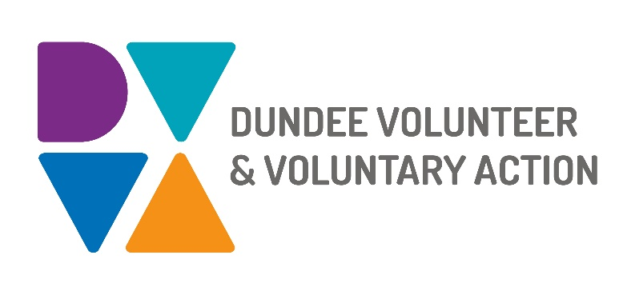
Job Description and
Person Specification

POST TITLE: Engagement Worker - Whole Family Wellbeing Fund

DURATION: Fixed Term, 1 year

HOURS OF WORK: 35 hours per week, to be worked in accordance with DVVA Conditions of Service

SALARY: Grade 3 – £21,757 – £24,174

PURPOSE OF POST:

The Whole Family Wellbeing Fund is a national fund allocated by the Scottish Government as part of its commitment to support implementation of the findings of the Independent Care Review.

The Scottish Government aims to ensure that every family that needs support gets the right family support at the right time, to fulfil children’s rights to be raised safely in their own families, for as long as it is needed.

The aim of the Engagement Worker - Whole Family Wellbeing Fund is to work with Dundee communities and organisations, building capacity and supporting applications in to the Whole Family Wellbeing Fund in line with the fund criteria.

The role involves understanding the local landscape and engaging with communities to asses needs and identify gaps in service provision, assisting in the development of sustainable initiatives together with local partners. This will be done in a way that seeks to achieve the overall aims of the Whole Family Wellbeing Fund.

PRINCIPAL WORKING CONTACTS:

- Fund Development Manager - Whole Family Wellbeing Fund
- DVVA Staff & Volunteers
- Staff of local Third Sector organisations in Dundee
- Experts by experience
- Members of the community
- Dundee City Council partners

MAIN DUTIES:

Community engagement

- Develop effective working relationships with community workers, key organisations and communities to promote involvement and coordinated models of working across Dundee

- Engage with communities and key partners through consultations, and awareness, learning and training events

Organisational Development and Capacity Building

- Provide opportunities for communities to develop their own capacity and enable them to create positive and sustainable change, based on models of good practice and coproduction

- In coproduction with communities and key partners, develop and support new areas of work and/or opportunities, leading to enhanced service provision

- Contribute to the development and delivery of networking, learning and development opportunities to help organisations and groups adhere to good practice standards

- Contribute to the delivery of opportunities for networking and shared-learning

- Provide guidance and advice on best practice

OTHER DUTIES
The job description is a broad picture of the post at the date of preparation. It is not an exhaustive list of all possible duties as it is recognised that jobs change over time. Should the duties change radically then the post and grading will be reviewed.

CONDITIONS OF SERVICE
- These are set out in the organisation’s staff handbook.
- All staff meeting the qualifying criteria may join a defined contribution pension scheme provided by TPT Retirement Solutions.
- The organisation has an equal opportunities policy and seeks to be an equal opportunities employer.

ANNUAL LEAVE: 21 days per annum on appointment increasing each year by 1 day to a maximum of 25 days, plus 6 public holidays, plus 5 days Christmas closedown.

LOCATION: Our main office is based in Dundee city centre and we have community locations in Lochee and Whitfield.

TRAINING: Staff may make application to pursue appropriate training.

JOB DESCRIPTIONS are reviewed from time to time.

Person Specification

 | Essential | Desirable

Professional/Educational Qualifications
Qualified to degree level or minimum 3 years practical relevant experience
CLD Qualification
Knowledge and Experience
Experience of work within the Third Sector

Local priorities and issues faced by communities/ individuals

Establishing and maintaining effective working relationships

Community engagement and development

Social inclusion and equality

Planning, target setting, monitoring and evaluation

Development work with voluntary and community groups

Cross-sector collaboration

People-led and asset-based approach

Creation, delivery/facilitation and evaluation of awareness/information/training sessions

Skills and abilities
Excellent communication skills, both oral and written
Excellent organisational skills with the ability to handle multiple tasks simultaneously
Strong interpersonal skills, with the ability to manage internal and external relationships effectively
Advanced IT skills, including in the use of Microsoft Office

Networking and partnership work

Ability to engage with a wide range of stakeholders

Ability to identify needs of specific groups

Ability to work within a team as well as on own initiative

Personal Qualities
Self-motivated, enthusiastic and committed
Innovative and experienced in designing new systems and processes
Flexible approach with an ability to meet deadlines
A commitment to equal opportunities for all, tackling disadvantage and promoting diversity

Additional Job-Related requirements
Satisfactory Basic Disclosure check
Flexible working which may include evening and occasional weekend work
Driving Licence and access to a car

