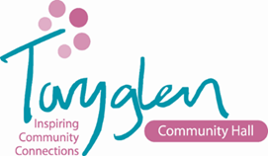
Toryglen Community Hall

Equal Opportunities Monitoring Form

Toryglen Community Hall is committed to ensuring equality of opportunity in the recruitment and selection of staff and volunteers. To assist with the monitoring of this procedure, we invite applicants to complete this form, which will be kept separate from your application form and will not form part of the selection process. Should you chose not to complete this form, your application will not be affected.

Position: Community Development Worker

GENDER AND SEXUAL ORIENTATION

Female Male Other
Lesbian Gay Bisexual Transgender Heterosexual

AGE

Under 21 22 - 34 35 - 49 50 - 64 65+

DISABILITY

Do you have a recognised disability as outlined in the Equality Act 2010, that is, a physical or mental impairment which has a substantial and long-term adverse effect on your ability to carry out normal day-to-day activities?
Disabled Please state what that disability is:
Not Disabled

ETHNIC ORIGIN

Individuals should determine with which of the undernoted categories they most closely associate themselves having regard to their ethnic or cultural background:
White – Scottish Asian - Indian Black-Caribbean
White – Other British Asian – Pakistani Black – African
White – Irish Asian – Bangladeshi Black – Other
White – Other Asian – Chinese Other
Asian – Other

WHERE DID YOU SEE THIS POST ADVERTISED? ………………………………………........................................................

