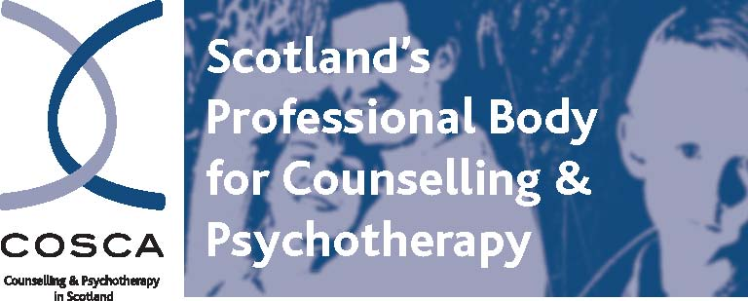

COSCA (Counselling & Psychotherapy in Scotland)
16 Melville Terrace | Stirling | FK8 2NE
t: 01786 475 140 f: 01786 446 207
e: info@cosca.org.uk w: www.cosca.org.uk

APPLICATION FORM
CV’s are not accepted.

Please complete in black ink or typescript. Continue on the back page or attach further sheets if there is insufficient space in any section on this form.

If you submit your application by email and are selected for interview, you will be required to sign your submitted application form at the interview.

POST TITLE: | ADMINISTRATOR

SURNAME: | INITIALS OR NAME:
ADDRESS:

EMAIL:

TELEPHONE  HOME: | WORK:

Details of two referees. One referee should be your present or most recent employer. Please indicate in what capacity you know the referees:

Name:  Address:  Email:  Tel:  Capacity in which known to you: | Name:  Address:  Email:  Tel:  Capacity in which known to you:

May we approach these referees in the event that you are offered this post?
YES □ NO □ YES □ NO □

EDUCATION/TRAINING/QUALIFICATIONS

Type of Qualification  (Degree, Diploma, SVQ etc.) | Subject or brief description of areas covered and grade awarded | Duration of Course | Date of Completion

EMPLOYMENT (Please give details of your employment over the last 10 years, in reverse order with your most recent post first)

From/To: | Name and Address of Employer | Position Held/  Summary of  Duties | Main Achievements | Reason for  Leaving

WHEN COULD YOU TAKE UP THE APPOINTMENT?

PLEASE GIVE YOUR REASONS FOR APPLYING FOR THIS POST, WHY YOU FEEL SUITED TO IT AND WHAT SKILLS, KNOWLEDGE AND EXPERIENCE YOU WOULD BRING TO IT.

REFER CLOSELY TO THE JOB PROFILE AND PERSON SPECIFICATION AND ENSURE YOU GIVE EVIDENCE FOR HOW YOU MEET THE NECESSARY REQUIREMENTS OF THE POST.

Do you have authorisation to legally work in Scotland?

YES □ NO □

(Please note that evidence of a valid National Insurance Number will be requested from all short-listed candidates at interview stage.)

How did you hear about this post?

I hereby declare that to the best of my knowledge the information given on this form is true and correct and can be treated as part of any subsequent contract of employment. I accept that providing deliberately false information could result in my dismissal.

Signed:
Date:

PLEASE RETURN THIS FORM, BY EMAIL OR BY POST, TO:

Brian Magee
Chief Executive
COSCA (Counselling & Psychotherapy in Scotland)
16 Melville Terrace
Stirling
FK8 2NE
Tel: 01786 475140
Email: brian@cosca.org.uk
Website: www.cosca.org.uk

Please mark all correspondence as Private and Confidential

Application forms of unsuccessful candidates will be kept for a maximum of six months before being confidentially disposed of. Application forms of employees will be kept and stored as personnel records. Information given may be used for legitimate reasons related to your employment. You may have supervised access to any data held about you if you wish.

