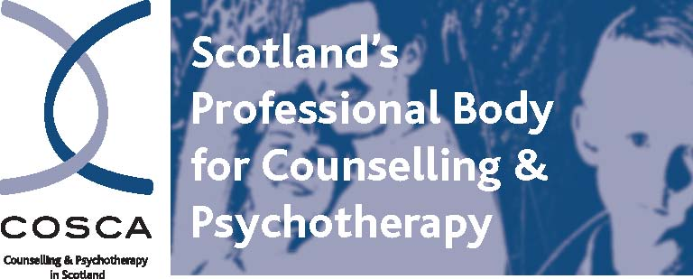

COSCA (Counselling & Psychotherapy in Scotland)
16 Melville Terrace | Stirling | FK8 2NE
t 01786 475 140 f: 01786 446 207
e: info@cosca.org.uk w: www.cosca.org.uk

COSCA (Counselling & Psychotherapy in Scotland)

Administrator

SALARY: £25,563 - £26,130 (SJC 21-22 pts)

RESPONSIBLE TO: Chief Executive

HOURS: Full time (35 hours per week)
ANNUAL LEAVE: 25 days plus 9 public holidays per annum

PENSION: 6% of salary contributed by COSCA to pension

BASED AT: COSCA’s office in Stirling.

POST PROFILE

JOB PURPOSE:

The Administrator, based in the COSCA office in Stirling, is responsible for the general secretarial, administrative and membership work of the organisation and ensuring the smooth running and operation of office systems and procedures.

MAIN AREAS OF RESPONSIBILITIES

The Administrator’s responsibilities include:

- providing effective secretarial, administrative and membership services
- ensuring the smooth running and operation of office systems and procedures
- assisting with health and safety and GDPR procedures
- maintaining confidentiality where appropriate

Specific Areas of Responsibility

The Administrator will:

- carry out general office duties e.g., photocopying, bulk mailings, e-shots, phone answering and mail duties, maintaining stationery supplies and office equipment, filing, operating the petty cash system, shredding, checking payments, maintaining cleaning materials and catering supplies, attending to the security of the office premises and personal data when appropriate, backing up databases and all relevant documents etc.
- prepare written materials, including the design of leaflets, documents, minutes and/or reports of meetings etc.
- maintain central hard copy and digital filing systems, and maintain and develop COSCA’s databases and directories including: membership; the COSCA Register of Counsellors and Psychotherapists, accredited trainers; supervisors; COSCA validated courses; Recognition Scheme; and member organisations
- provide administrative support related to COSCA’s membership system, including the assessment of membership applications and fees, membership renewals, references, arranging membership audits and assessing evidence submitted, drafting reports and documents related to the membership application assessments carried out for meetings of COSCA’s Corporate Affairs Group, Board etc.
- manage and up-date COSCA’s main and other websites e.g. research website
- assist with the preparation, dissemination, development and up-dating, and stock control of COSCA’s training and promotional materials
- when required, enter student information onto course databases and issue course completion certificates to training providers
- assist with carrying out all relevant administration and preparation of course handbook orders for despatch
- provide personal administrative support to the Chief Executive and maintain related files and documents e.g. contracts, leases, grant applications, Companies House and OSCR filings etc.
- provide administrative support for COSCA’s Board, Corporate Affairs Group, standing policy groups, course and accreditation panels, committees and ad hoc groups
- provide the administrative support needed for the process of the accreditation of individual practitioners, trainers and the validation of courses.
- make booking, catering and administrative arrangements for meetings of COSCA’s Board, Annual General Meetings, meetings in the office, and other COSCA meetings and events
- assist with the preparation of Board papers, attend Board meetings and prepare and distribute draft minutes of Board meetings following approval by the Chief Executive
- assist in the organisation of COSCA conferences, seminars, and training events and attend and contribute to COSCA meetings and events as appropriate
- attend and contribute to COSCA staff meetings
- abide by the policies and procedures in the COSCA Staff Handbook and the COSCA Conditions of Service
- provide administrative support to the Chief Executive, Development Officers, Course Validation Secretary and Bookkeeper as appropriate
- work closely with COSCA’s Assistant Administrator, Course Validation Secretary and the Bookkeeper in carrying out their responsibilities
- assist with COSCA’s compliance with company and charitable legislation, regulations, and requirements, including OSCR, Companies House, the Professional Standards Authority for Health and Social Care and the Scottish Government
- undertake other duties appropriate to the grade as required

Authority:
The Administrator is expected to work on their own initiative within COSCA’s overall policies, aims and objectives as set out by the Board and as contained within COSCA’s Annual Development Plans. All expenditure outside the travel budget must be approved in advance. The organisation of events, applications to outside bodies for funds, contact with Parliamentary Ministers, government officials, and business and charitable trusts from whom it is intended to seek funding will be subject to agreement from the Chief Executive.

Accountability:
The Administrator is accountable to the Chief Executive who is responsible for support, advice, supervision and annual appraisal. They are expected to have their annual work programme approved and to produce progress reports as requested.

PERSON SPECIFICATION

The Administrator will have the following skills, knowledge and experience:

Essential Criteria
- an interest in counselling, psychotherapy, counselling skills and the work of COSCA
- a recognised qualification in business administration and/or office management or equivalent qualification
- European Computer Driving Licence certification or equivalent qualification
- a high level of written and verbal communication and organisational skills
- a high standard of computer and IT skills and knowledge
- proven experience of office management and systems and structures that will support office administration
- knowledge of health and safety legislation and GDPR
- the ability to work independently with the minimum of supervision and to use initiative where relevant
- the ability to work in a team setting with colleagues and to have a friendly, positive, flexible, approachable and courteous approach to others
- the ability to work collaboratively with a wide range of external stakeholders including members, volunteers and the public
- the ability to carry out general secretarial, administrative duties
- ability to work under pressure and keep to deadlines, willing to learn and to share knowledge, skills and experience with others
- reliable and willing to adapt to organisational changes
- proven experience of current versions of Microsoft Office, One Drive, PowerPoint, Access and Excel packages, email systems, and other relevant computer packages
- the ability to set up and maintain databases, online registers and directories
- the ability to maintain and up-date COSCA’s websites
- the ability to plan and attend meetings, and to produce accurate minutes/notes of meetings
- the ability to handle a complex workload and to meet tight deadlines
- knowledge of company and charitable legislation and regulations

Desirable Criteria

- A full current car driving licence and access to a car for use at COSCA events and external meetings

Conditions:
The post is full time (35 hours per week). COSCA conditions of service apply. The current salary is £25,563.

Annual Leave:
The annual leave period is from April to March.

The post holder will be entitled to 25 days plus 9 public holidays, 5 of which are fixed - 25 and 26 December, 1 and 2 January and Easter Monday – in a full year.

The office is also normally closed between Christmas and New Year. These are given as additional holidays.

6% contributory pension available.

Brian Magee
Chief Executive
COSCA (Counselling & Psychotherapy in Scotland)
February 2023

