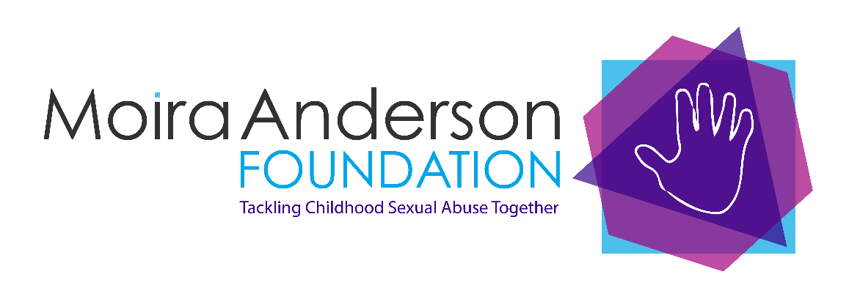

Job Description & Person Specification

Job Title: Manager
Service: Moira Anderson Foundation – Glasgow Hub
Terms of employment: April 2023 – March 2026 (continuation of contract dependent on future funding)
24.5 hours per week – days to be agreed

Salary: £32,217 (pro rata £22,551)

Pension: Excellent terms – After a postponement period of 3 months, dependent on eligibility, we will pay 8% of basic salary, employee contribution of minimum 1%. Opt out available

Benefits: Death in service benefit – after postponement period

Annual Leave: 23 days per annum, rising one per year (after first year) to a maximum of 26, plus 12 public holidays – pro rata

Responsible to: Board of Trustees
Reporting to: Director

Job Description

Purpose of Job: The new Glasgow Hub service, based in the City Centre, will provide support and therapeutic services for people living in Glasgow. Services will be delivered from our Buchanan Street premises and in identified GP practices across the city. You will be responsible for the overall management and future development of services as well as having managerial responsibility for the staff team and sessional therapists.

You will work closely with MAF’s Positive Steps Project Coordinator and maintain established partnerships with the Links Worker Programme in Glasgow as well as developing new partnerships.

Key Tasks:

- To oversee the delivery of quality therapeutic services including support, integrated therapy, and complementary therapies, ensuring the views of clients are respected

- To participate in the recruitment of project staff

- To develop and agree work plans/targets with project staff

- To provide support and supervision to project staff

- To recruit, monitor and support a pool of therapists

- To ensure that all new therapists understand the MAF’s objectives and targets. To implement all processes necessary to achieve the objectives and targets

- To ensure that professional standards in relation to training, performance, screening and updating of professional membership are adhered to by therapists.

- To ensure implementation of client assessment, evaluation and review processes

- To ensure implementation and further development of monitoring and evaluation systems

- To oversee delivery of the Hands on Health self-management programme

- To oversee facilitation of the peer support service, ensuring relevant activities and information sessions are delivered

- To create and maintain work targets in conjunction with the Director

- To undertake professional networking, establish, and maintain effective relationships with key internal and external stakeholders e.g., funders (inc the Scottish Government), statutory and voluntary agencies

- To organise and deliver promotional events/activities as agreed by the Director, ensuring services are promoted to a wide audience and reach those most in need

- To contribute appropriately to development of the MAF’s business planning process, identifying future funding opportunities, completing funding applications, liaising with the Director, Treasurer and Finance Manager etc.

- To provide monthly reports to the Director and Board of Trustees

- To provide information and reports as required to funders and other stake holders

- To ensure the future development and delivery of the project

- To monitor the project budget and ensure it is spent appropriately, liaising with the Director/Finance Manager/Treasurer

- To undertake any additional relevant tasks as delegated by the Director

Person Specification

Qualifications & Experience:

Relevant professional management qualification to degree level (or similar). Relevant experience will be considered (essential)

Minimum 3 years’ experience of working in the public, private or voluntary sector and experience of health care setting/complementary therapies (essential)

Minimum 2 years’ experience of managing and supporting staff. (essential)

Minimum 3 years’ experience of completing funding applications and providing evaluation reports to Funders (essential)

Minimum 3 years’ experience of project/service development at a community level (essential)

Experience of inter-agency working and networking at local level (essential) and national level (desirable).

Knowledge & Background:

Knowledge of the voluntary sector, particularly funding opportunities and processes (essential).

In-depth understanding of Child Protection issues and the health needs of adult survivors of childhood sexual abuse (essential)

Knowledge and understanding of the benefits of complementary therapies that may help affected clients (essential)

Knowledge and understanding of the benefits of stress management/personal development training programs (essential)

In depth knowledge of the support needs of vulnerable individuals (essential)

Awareness of NHS structures locally and nationally (essential)

A background in managing services and recruiting and managing staff (essential)

Skills Required:

Planning, facilitation, and organisational skills of a high order. Ability to deliver presentations to internal and external stakeholders
Co-ordination and communication skills for building networks and forming partnerships with relevant organisations
Development skills to ensure the ongoing development of the project, and service delivery
Excellent communication skills (written and verbal) and effective I.T. competencies
Marketing skills to promote the charity. Good PR awareness, to contribute to newsletters, leaflets, brochures, posters, etc, as directed by the Director
Recruiting, interviewing and selection skills to recruit and retain staff
Excellent interpersonal skills to build relationships internally/ externally with other agencies
Monitoring skills to evaluate services delivered and client feedback, to report to funders and Trustees

The successful candidate will be required to become a member of the PVG scheme or undergo a PVG scheme update if already a member.

The Moira Anderson Foundation is an Equal Opportunities Employer and a Real Living Wage employer. We encourage applicants with diverse backgrounds and experience to apply. If you have any specific access requirements, please let us know and we will do our best to meet your needs.

For an informal conversation regarding this post please contact Gillian Urquhart at gillianurquhart@moiraanderson.org or call 01236 602890

