

Role Profile – Chef

Reports To: Facilities Manager

Role Purpose: You will be responsible for the planning and cooking of a varied and nutritious diet for the young people, taking into account best practice in nutrition for in schools. You will be required to maintain a clean and safe kitchen.
You will be required line manage the Kitchen Assistant and carry out relevant administration including staff training, Development Discussions and recruitment..

All roles within Sight Scotland and Sight Scotland Veterans are expected to work to our values and Our Ways of Working framework:
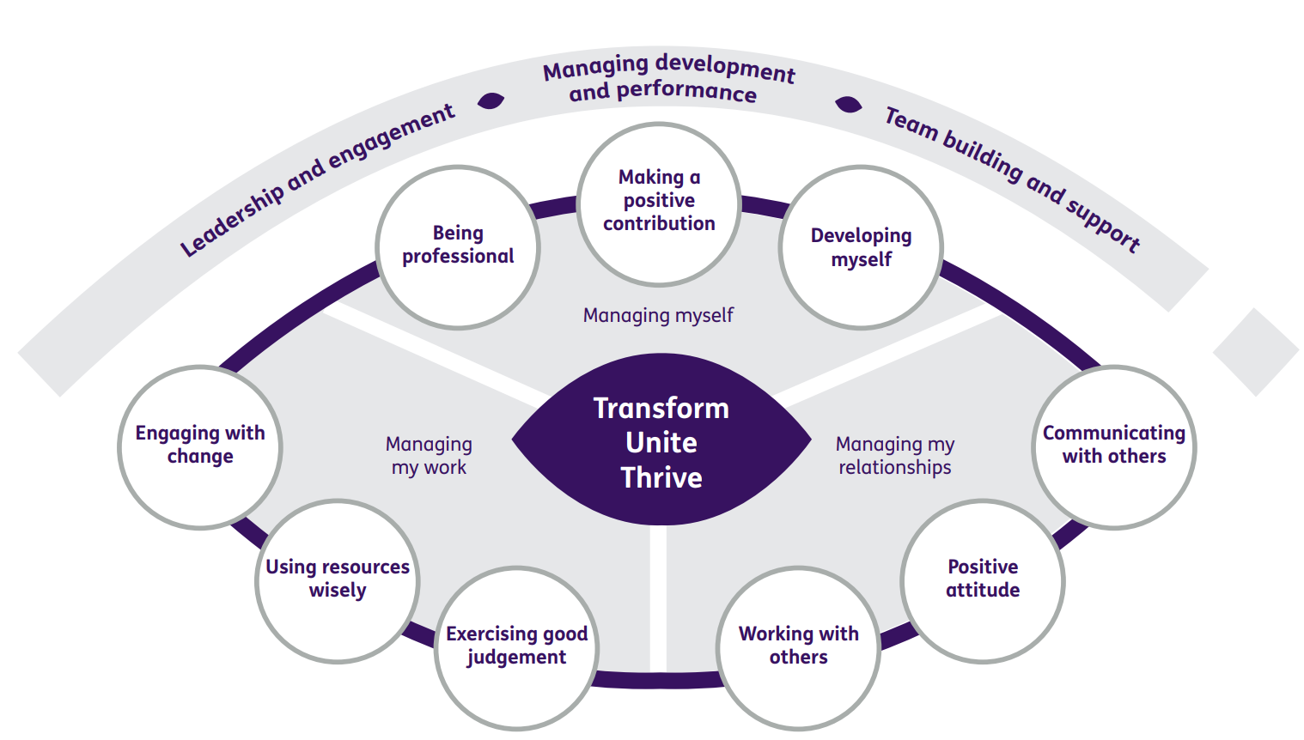

Our Ways of Working - Managing my Work
The main responsibilities and accountabilities of this role are:
- Provide high quality food for service users within the agreed budget.
- Direct and deploy staff in preparing & serving consistent & high quality food.
- Provide training to expected standards and quality of general food preparation, cleaning, health & safety requirements, particularly regarding the operation of equipment, and Food Safety
- Plan menus taking into account;
  - Health Promoting School
  - Hungry for Success Guidelines
  - National Nutrition Guidelines
  - Specific Diet requirements
  - Specific Culture requirements
  - Allergen legislation
- Source, order, receive, and check quality and invoice of stock.
- Ensure all recipes are up to date and being followed by staff.
- Ensure proper storage & labelling procedures.
- Maintain cleaning schedules.
- Liaise with the Facilities Manager with regard to function and additional catering requirements.
- Ensure Food Hygiene and Health & Safety recommendations are complied with.
- Ensure all Food Hygiene & Health and Safety records are completed and accurate
- Report any malfunction of equipment or fittings that require maintenance or cannot be kept to standard through normal cleaning procedures.
- Attend appropriate service user consultation meetings.
- Line manage kitchen staff (Kitchen Assistant) under the guidance of the Facilities Manager
- Participate in the selection, appointment, induction and training of catering staff.
- Deal with unsatisfactory performance and conduct of staff.
- Participate in setting & monitoring appropriate performance objectives and standards for staff through probation review & appraisals.
- Setting up and clearing of the dining rooms.

General

- Demonstrate awareness of Sight Scotland policies and procedures.
- Participate in staff/pupil meetings if required.
- Attend appropriate In - Service Trainings.
- Participate in the discussions about, and help implement the School Development Plan.
- Ensure clear lines of communication within the team.
- Maintain confidentiality in all matters relating to the pupils including their care and welfare, as set out in the Confidentiality Policy. Failure to comply may result in disciplinary action.
- Undertake any such duties as may reasonably be required by the Facilities Manager.

Our Ways of Working – Managing Myself and Managing my Relationships
To do this role, you will:

- Hold an elementary Food Hygiene Certificate and have an understanding of food hygiene and health & safety
- Have experience of leading a team
- Have experience of preparing & serving food in a large scale environment.
- Have experience of working in a catering kitchen
- Have experience of line managing staff and developing good working relationships
- Have experience of HACCP
- Be able to maintain a flexible approach to working practices & willingness to learn new skills.
- Be able to work on own initiative with limited supervision.
- Have good verbal & written communication skills
- Be able to maintain clear & accurate records
- Be able to prioritise work and meet deadlines.
- Be able to ability to maintain confidentiality and be sensitive to the need of young people
- Have knowledge of COSHH

It is desirable that you will have:

- An Intermediate Food Hygiene Certificate
- A SVQ Level 2 Professional Cookery
- A SVQ Level 3 Hospitality, Supervision & Leadership
- Previous experience of working with young people in a school environment.
- Understanding of the National Nutritional Guidelines in relation to schools.
- Understanding of the healthy living award scheme.
- Knowledge of the challenges that young people may experience in relation to nutrition
- Understanding of Allergy Awareness.

On a day to day basis you will work with different people and teams, these could be:
- School pupils
- Sight Scotland colleagues
- Senior Staff

Requirements of this role are:

- You are a member of the PVG scheme (paid for by Sight Scotland)
- You will have a 6 month probation period
- That you participate in all staff training and development and maintain your own professional development
- You will wear the appropriate PPE in accordance with current guidance for the role.
- You will follow Sight Scotland’s guidance, policies and procedures relating to your own health and safety and that of colleagues and service users at all times
- You will uphold the principles of Sight Scotland’s Dignity at Work and Equal Opportunities policies at all times, working in a way which supports an inclusive work environment that is respectful of differences.

What we can offer you:
- Generous annual leave entitlement which increases after 4 years’ service
- Generous pension scheme
- Discounts for Carers
- Access to learning and development opportunities
- Employee Perks through the Employee Assistance Programme
- Cycle to Work scheme
- And many more, please visit our website for more information

This job profile is not exhaustive. The duties of the post holder may be reviewed from time to time and the employee may be called upon to work in other locations within Sight Scotland.

