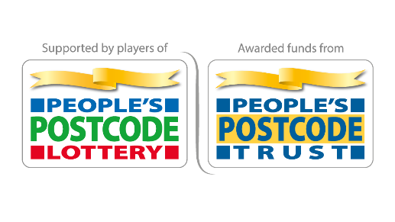
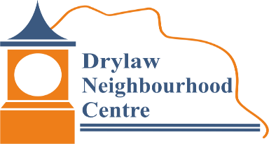
In Partnership with

Draft
Social Link Worker
Salary £18,200 (based on £31,850 full time equivalent)
Part time post 20 hours per week (Worked over 3-4 days). The post is funded until 31 December 2023. We particularly welcome applications from freelance contractors, who would be in a position to start as soon as possible.
27 days holiday and public holidays pro rata
Employer Drylaw Neighbourhood Centre (DNC) Board of Trustees. To discuss this post please contact Jason Whitefield - info@drylawnc.org.uk, or call 07305 097 731.
Responsible for Identifying and attracting older people to DNC to take part in activities and develop opportunities for older people.
To apply please send a CV and covering letter to: Chairperson, Drylaw Neighbourhood Centre, 67b Groathill Road North, Edinburgh EH4 2SA.
Closing date: 13 March 2023
_________________________________________________________________________
What makes us who we are Drylaw Neighbourhood Centre is a charity based in Drylaw, Edinburgh. We run projects that build people’s confidence and help them to achieve positive changes within their community. Currently we run Drylaw Neighbourhood Centre, a supported community gardening scheme, and several community groups and a youth work programme.
Our charitable aims and objectives are:
● to develop the capacity and skills of people living in socially and economically disadvantaged areas in such a way that they are better able to identify, and help meet, their needs and to create active, flourishing communities
and
- to run a community centre, primarily for the benefit of the Drylaw, Telford and other communities in North Edinburgh.
_________________________________________________________________________
Social Link Worker
Job Description
What a Social Link Worker does
You will run at least four new older people’s groups per week and ensure people are not socially isolated and can socialise in the warmth and safety of DNC for circa 12 hours per week. You will also recruit volunteers to contribute to the running of these groups and encourage older community members to make connections and friendships in the community. These groups will offer a warm meal, a warm and welcoming space and provide opportunities for older people to access support and advice services.
You are a problem solver whose attention to detail is as strong as your appreciation of the bigger picture. With great communication skills you will be able to interact with a variety of stakeholders whilst continually prioritising centre needs with wider organisational objectives.

Role Description
As a Social Link Worker your role is:
● To provide person-centred opportunities that are responsive to the needs and interests of identified older people in the community
• To support those individuals to identify issues that affect their ability to live well such as cost of living
• To link individuals to local and national support and advice services and activities in their community
• To support individuals to help them make connections in the Drylaw, Telford and North Edinburgh community
Duties
● Arrange groups and hot meals for individuals in Drylaw Neighbourhood Centre
● Encourage and enable individuals to travel to DNC to attend groups
● Plan, arrange, implement and provide groups and hot meals to identified individuals which meet their needs
• Provide through good conversations for individuals who may be experiencing complex social circumstances and build non-dependant relationships and trust with them
• Enable people to identify personal outcomes and priorities to improve their health and well-being, to overcome any barriers to addressing these and where appropriate, to link people to relevant local and national support services and activities in third sector
• Implement effective pathways for accessing the DNC Social Link Worker project to ensure people face minimal barriers and are offered opportunities within an appropriate timescale
• Build excellent working relationships and develop effective pathways to a range of statutory services, advice services, particularly around cost of living and issues around fuel poverty
• Develop excellent working relationships with local advice agencies and service providers
• Provide appropriate feedback to DNC management committee
• Work closely colleagues to ensure local data is effectively used for ongoing monitoring and evaluation of the programme.
• Develop and deliver reports in an agreed timeous manner to enable evaluation and further learning.
• Undertake any other duties as deemed appropriate by DNC management committee
Team work
• Effectively communicate, engage and inspire volunteers across the project, and foster collaboration and team work throughout the organisation, including involvement in meetings as required
• Undertake activities that will allow DNC to respond to opportunities that arise from additional funding, service trials or pilots and other innovative projects related to the Social Link Worker Project
• To work as part of the wider team to ensure projects are delivered effectively, including stakeholders
• Team work including taking part in the induction of volunteers and supporting other team members including offering constructive challenge where appropriate
Person Specification
Requirement | Essential | Desirable
Experience
Performing administrative tasks and duties | X
Ability to manage budgets for meals and activities | X
Ability to provide meals and activities |  | X
Experience of managing logistics to help people access opportunities |  | X
Experience of working autonomously in a space open to the public |  | x
Experience of working with community-based organisations and understanding of the current voluntary sector environment | X
Experience of supporting people in the cost of living crisis |  | X
Experience of organising community groups | X
Experience of recruiting and working with volunteers | X
Knowledge, Skills and Abilities
Good written and verbal communication skills | X
Excellent influencing, negotiating and interpersonal skills | X
Ability to work collaboratively with a wide range of people including volunteers and vulnerable people | X
ICT skills - ability to use databases, social media and contribute to web content | x
Good problem-solving skills and awareness of risk assessments | X
Ability to take initiative and identify, prioritise and plan activities independently | X
Commitment to challenging discriminatory or disrespectful behaviour | X
Understanding of building safety and maintenance requirements | x
Ability to contribute to strategic target-setting and development planning | x
Ability to organise and facilitate meetings | x
Awareness of Charity Governances structures | x
Personal Qualities
Commitment to principles of equality and respect for others | x
Passion for social change in the local community | x
Awareness of the social and economic issues faced by community centres |  | x
Good understanding of the needs of the local community | X
Flexibility with working hours | x
A commitment to inclusion of older people in the local community | x

