

Job Description

Role Title: | Activity Worker
Department: | Sight Scotland Veterans
Reports to: | Deputy Centre Manager
Pay Grade: | 10-14
Type of Contract: | Part time - Permanent
Normal place of work: | Linburn Centre
Line Manager? | No
Budget Holder? | No
Criminal Record Check/PVG required? | Yes
Driving license for UK driving required? | Yes

Who we are

Sight Scotland Veterans provides support to all veterans in Scotland who are experiencing changes to their sight, regardless of the cause, or what point you are at. We aim to ensure that veterans and their families and carers have access to the support that they need, when they need it.

Our Activity Hubs provide innovative and person-centred services and support to veterans struggling with sight loss. The services aim to reduce isolation while improving independence and confidence to live well with a visual impairment now and in the future through the provision of a large variety of activities including woodwork, kitchen skills, IT skills, archery. Whilst participating in these activities, veterans have many opportunities to meet with other veterans with sight loss.

The services also offer veterans access to information and support in a welcoming environment through drop in and information sessions with the wider Sight Scotland Veterans teams and other external organisations.

What this job is about

This job is important to us, as it aligns with the Charity’s aim to create and support accessible opportunities for veterans with sight loss, who access our activity hubs. The service continues to grow as we extend our reach to even more veterans.

This role will help support veterans with sight loss to engage in and benefit from the activities, comradeship and peer support within the Activity Hub environment and also community settings. It will be key in facilitating current activities whilst identifying new activities and opportunities that veterans with sight loss can engage with.

The role requires an outgoing and organised personality who is able to motivate and encourage veterans to try new things, ensure accessibility and support participation in these. They will also work closely with the Centre Officers team to ensure that support is person-centred and allows veterans to achieve positive outcomes when accessing the service.

The job also involves recognising and supporting the organisation of other events/activities that may encourage social and peer support opportunities. This role also requires driving or escorting duties when required, therefore a driving licence is essential.

The role will work closely with our Activity Hub in the West of Scotland and with our Support Hub team to build upon veterans access to activities across the country.

What we want you to be responsible and accountable for

- To facilitate a range of activities, whether hub or community based, and assist in the development of a creative and responsive activities programme which promotes independence and wellbeing.
- To provide driving/escorting duty if/when required and drive within the requirements of current road traffic legislation
- Be involved in the day-to-day delivery of the service ensuring the highest standard of service is delivered in a person-centred manner.
- To enable veterans to maximise the benefit and enjoyment they gain from attending the Activity Hub.
- To deliver a service where individuals can maximise their existing skills and abilities and develop new ones.
- To encourage maximum independence whilst providing a supportive environment
- To maintain any necessary paperwork/databases
- To contribute to staff meetings and participate in supervision with the Deputy Manager/Senior Centre Officer
- To maintain and develop positive working relationships with colleagues across Sight Scotland Veterans and our sister charity Sight Scotland.
The current duties of the role require a criminal records check or membership of the PVG scheme through Disclosure Scotland.

How we would like you to achieve this

- By working with a positive and motivated outlook .
- By maintaining a determined approach with a desire to create opportunities for others
- By keeping complete, confidential, up-to-date records, in line with policies and procedures, monitoring requirements and best practice.
- By working in accordance with safeguarding policies and procedures.
- By working in accordance with policies and procedures
- By undertaking training to ensure up to date knowledge and skills.
- By participating in supervision and line management, as agreed according to pieces of work undertaken.
- By ensuring high professional standards that are in line with the strategic vision, ethos, and values of Sight Scotland Veterans.
- By being a positive representative of Sight Scotland Veterans.

Who you will be working with

- Veterans
- Families
- Carers
- Colleagues and Volunteers
- Other Sight Scotland Veterans services
- Other Sight Scotland services
- Senior Staff
- Outside Agencies

The budget you will hold

- N/A

The experience and skills you need to have to do this job/

Essential:

- SVQ level 2 Health and Social Care or equivalent (or willingness to work towards.)
- Current driving licence with a D1 licence or a willingness to undertake a D1 test.
- Good IT skills with a knowledge of Microsoft office packages.
- Ability to use electronic and paper administrative and record keeping systems.
- Excellent time management skills to plan, prioritise and manage workload.
- Ability to work calmly under pressure.
- Ability to adapt to change and respond positively to non-routine situations.
- Ability to plan and organise activities in a work setting and the local community.
- Ability to work on own initiative
- Willingness and ability to maintain confidentiality
- Active listening skills

To do this role, it is desirable if you have:

- Recent experience of working with people in a social care or recreational setting.
- Experience of working with people with visual impairments.
- Awareness of Veterans issues.

Just so you know…

- The Charities have a set of Values & Our Ways of Working Framework, we ask you to work within, and these apply to everybody in the organisation irrespective of their role or job. You can find out more here: Our values. This means we want you to have:

  - The ability and willingness to understand others’ perspectives and to consider the impact of your actions on them and to adapt your actions as necessary;
  - The ability and willingness to learn and try new things, to be flexible and step outside of your comfort zone;
  - An open and honest way of communicating, ready to ask others for their ideas and to be open to hear and consider different points of view;
  - A pro-active approach to taking initiative and to driving forward ideas and projects designed to improve daily operations and deliver an exceptional visitor experience.

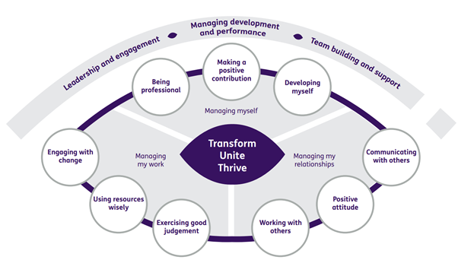

Department structure (this role outlined in red)

