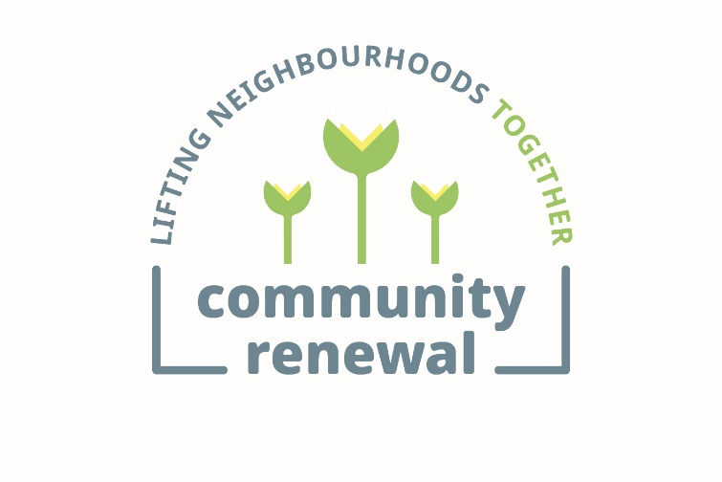

Job Description

Job Title | Community Nutrition and Climate Coordinate (Benefits Specialist)  Community Renewal Lifting Neighbourhoods Together team for Bingham, Magdalene & The Hays
Location | Bingham, Edinburgh
Salary banding | £28000  (Pay band £28000-£30999)
Benefits | Employer pension contribution.  36 days annual leave. 20% working from home if preferred and practical. Free Access to Health Assured Employee Assistance Programme and online Health Portal.  Loyalty scheme with up to 48 additional days leave.
Contracted hours and FTE hours | 22.5 hours (0.64 FTE)
Report to | Neighbourhood Manager

Role summary
This role will take a community development approach to stimulating, supporting and empowering community activities around growing, food and climate action in the Bingham, Magdalene and The Hays neighbourhood of Edinburgh. This includes recruiting and supporting volunteers and building trusted relationships with community activists and wider agencies/partners. Close coordination with a wider team providing community engagement and community casework will be needed including involvement in wider community engagement activities (e.g. events and outreach).

This role is ideal for someone at any stage in their career who wants to make change happen at a local level using a community development approach towards sustainably tackling poverty and embedding climate actions within a deprived neighbourhood.

IntroducING Community Renewal TRUST
Community Renewal is a dynamic and innovative organisation at the cutting-edge of work towards ending persistent poverty and inequity in Scotland. We work in deprived communities where we have been long-established to develop, deliver and share better approaches based around whole-person, whole-neighbourhood support. This means we always place people and communities in the lead: listening to them, identifying their strengths, supporting them on their terms, and building their capacity to flourish.

Community Renewal alleviates poverty by engaging and forming trusting relationships with individuals, whole families and whole communities together then supporting them by combining holistic case management (e.g. around income, work, health, wellness) with community development (e.g. forming new community activities/groups). This work is about testing change which can inform policy, be scaled up or replicated to achieve a much greater impact than our direct delivery alone. A set of core values guides all the work of Community Renewal:
- The most important element of any support relationship is listening to what the person wants deep down and working alongside them to achieve it
- We stick with people for as long as it takes
- Many people find it hard to articulate what they want at first and so need to be able to experience an environment of trust and safety in order to uncover buried aspirations – this cannot be rushed
- People don’t resist change – they resist being changed.
- People in deprived communities already know what is required to improve their lives – what they need is help with how to make it happen.
- Compassionate listening is a basic human need and is central to the way that we engage with people.
- Every individual and community has assets
- Sustainable transformation in communities is possible but needs a long term commitment.

A team of around fifty staff is delivers community services based around three key neighbourhoods: Muirhouse (Edinburgh), Bingham (Edinburgh), Govanhill’s Roma (Glasgow). The full Community Renewal Group consists of the lead charity Community Renewal Trust SCIO plus four subsidiaries: Caledonia Funeral Aid CIC, Community Renewal Rom Romeha (registered as Roma Life CIC), Pennywell Community Renewal Trust SCIO and Community Renewal Training & Consultancy Ltd.

INTRODUCING COMMUNITY RENEWAL LIFTING NEIGHBOURHOODS TOGETHER
Community Renewal Trust’s team based in Bingham and covering the surrounding deprived neighbourhood are the Community Renewal Lifting Neighbourhoods Together team.

Our work in the neighbourhood is innovative and has been supported to undertake cultural and system change through a major grant from National Lottery Community Fund (also called the Lifting Neighbourhoods Together programme). This post is part of Scottish Government’s Investing in Communities fund. The team also has posts funded by City of Edinburgh Council, and Edinburgh Health & Social Care.

The approach we take is to be proactive in going out and systematically engaging the community (through door knocking, community development and community events) to find people who can benefit from transformational support. The core of this support is in the form of our Holistic Assessment methodology: we will deeply and compassionately listen, connect them to the support they need, ensure we are building on their strengths and sticking with them and their neighbourhood as they lead their own transformation. Each Community Caseworker has a caseload of local community members whom they are seeking to improve in their income/money, work, skills, relationships, inclusion/isolation, while meeting their basic needs (such as housing and food).

All new staff receive training in our Listening Conversations and Holistic Assessment but ideally will be building on an understanding of engaging in therapeutic relationships with careful professional boundaries.

Our team consists of Community Facilitators (junior staff without a caseload), Community Caseworkers, Senior/Specialist Community Caseworkers, and a Neighbourhood Manager. The work is overseen by a Regional Director and CEO (plus finance, marketing and HR support).

Introducing the Neighbourhood
Bingham, Magdalene and the Hays are neighbourhoods totalling around 5,000 residents.

It is an area of Edinburgh between Portobello and Craigmillar, between Milton Road and Niddrie Mains Road. Our newly refurbished office is in Bingham, attached to the Community Centre. There is on site parking and the following buses are all within a 5 minutes walk: 4/44/113/5/2/21/49.

The local residents experience some of the very highest levels of deprivation anywhere in Scotland. The unemployment rate is double the Edinburgh average, almost a quarter of residents are thought to use some anxiety/depression medication, children have significantly worse educational outcomes and over a third do not have enough money to live on. Yet, after several years of focussed community development activities, there are some shoots of hope, with a growing number of community groups and regular community events have been created. The LNT programme has a real prospect of sustainably transforming the lives of people in the area.

objectives

Support community projects around growing, food and climate change (approx. 60% of your time)
Objectives:
- Recruit and train new volunteers and community activists to engage in new or existing community activities including those related to community growing projects, community food projects and community climate change projects. Community Renewal Trust policies related to volunteering must be followed.
- Support volunteers in the local community with holistic support to transform their lives. Where possible this should follow Community Renewal’s Holistic Assessment methodology in which you will receive training.
- Co-lead with Places for People the weekly Hays Pantry to secure healthy affordable food using a volunteer-led dignified model.
- Deliver on other required activities of the Investing in Communities grant from Scottish Government (such as participation in Community Wealth Building meetings).
- Seek to link community growing and community food projects to provide more local healthy food
- Work with local schools to engage children and parents in these local community activities.
- Support Community Renewal Trust to oversee partnership grants to other community projects as part of the Investing in Communities project.
- Work with a small group of community members to build their understanding of climate change.
- The post holder must be able to evidence at least some direct evidence of increase community activities’ capacity increasing as a result of their work.
- The post holder must be able to evidence at least some direct or indirect evidence of impact on improved wellness and child poverty as a result of their actions.

It is noted that the groups that are expected to be support (subject to change) include:
Hope Café, Bingham Community Gardeners, The Hays Pantry, Bingham Guerrilla Gardeners, Magdalene Growers, and a new People’s Shed for reuse/recycling.

Community Engagement (approx. 20% of your time)
Objectives:
- Conduct effective and systematic Listening Conversations following the Community Renewal Trust’s proven methodology resulting. This must include at least fortnightly sessions of door knocking.
- Support the delivery of community events with the aim of engaging new clients and meeting other strategic aims.
- Take joint and several responsibility in keeping the office welcoming and inclusive for community members, volunteers and staff at all times.
- Ensure that community members who do not need/want formal case management (i.e. through the Holistic Assessment) can be briefly supported with information.
- Use these above community engagement objectives to systematically engage new clients onto the team’s caseload who can benefit most from transformational case management.

Reporting and monitoring (approx. 10% of your time)
Objectives:
- Use the team’s paperwork and databases (no technical expertise needed) this must include basic monitoring data.
- Proactively and effectively collect feedback (including complaints) to support our congoing quality improvement across the organisation.
- Proactively write up and share internally case studies demonstrating learning from both successes and failures.
- Collect qualitative and quantitative data including related to climate goals (e.g. increased local food provision) and community members (e.g. increased volunteer wellbeing) as required for Investing in Communities fund reporting.

Communications and Relationship Development (approx. 10% of your time)
Objectives:
- Use care in liaison with local partners to ensure trusting relationships are formed with all community members, community groups and local stakeholders/agencies.
- Careful and professional use social media and other communication channels to engage local community members.
- Development, under the coordination of the Regional Director, strong and trusted relationships with local third sector and public sector partners with delivery in neighbourhoods in which we deliver integrated services.
- Develop and maintain a strong working relationship with the Marketing and Communications Manager, following their lead on branding, external communications, marketing and internal communications.
- Engage effectively and proactively in team meetings and organisational activities to share insights/learning and build connections.

Other requirements
Objectives:
- Complete objectives set in Performance Review, Probation Reports, our Competency Framework and/or Appraisal Reports.
- Deliver agreed for which you are responsible which were agreed in our internal regular Quality & Learning meetings (or similar).
- At all times conform to organisational policies and practices around data management, H&S, safeguarding, loneworking, equalities, environmental management, and business continuity.
- Carry out other duties as reasonably requested.

Personal and Professional Development
Demonstrating a track record of continuous learning and personal/professional development is a requirement of this role and evidencing that this is being actively progressed must be evidenced at every appraisal. The post holder has responsibility to actively participate in sessions organised by the organisation including training in compliance/regulatory processes and meetings in which learning and improvement is discussed for the purposes of quality management. The post holder is responsible for collecting feedback from people they support both to demonstrate their own strengths and to understand how to improve what they do. This evidence of both types of feedback about their work is required for every appraisal.

Key professional development of particular relevance to this role includes: leadership skills; coaching skills; understanding of benefits/housing advice; understanding of employment advice and employer engagement; skills to building resilience and self-management.

Role requirements/person specification
Essential Expertise | - Evidence of at least some expertise around community development, building community activism or supporting community projects.  - Evidence of at least some expertise around effective volunteering  - Evidence of understanding about people’s lives in deprived communities such as Bingham, Magdalene or The Hays.
Desirable expertise | - Evidence of expertise in community development community development, building community activism and supporting community projects.  - Evidence of expertise supporting volunteer recruitment, training and support.  - Evidence of expertise around sustainable growing/gardening.  - Evidence of expertise using social media related to community activities.  - Evidence of expertise in community climate initiatives.  - Evidence of expertise in community growing and food initiatives.  - Evidence of expertise in nutrition’s role in wellness especially within deprived Scottish communities.  - Evidence of expertise in collecting, recording and analysing data, monitoring information and feedback.  - Evidence of experience working in deprived neighbourhoods similar to Bingham, Magdalene and The Hays.  - Evidence of experience working in a third sector environment.  - Evidence of experience working with relevant partner agencies (e.g. money advice, mental health charities, community groups etc).
Essential Qualifications | - None (but basic literacy and computer literacy will be essential)  - An English language test may be required before induction (due to the technical nature of the role)
Desirable Qualifications | - Benefits or welfare rights training/qualifications  - Climate change or similar training/qualifications  - Community development or similar training/qualifications  - Information advice and guidance or similar training/qualifications

