

Job Description

Role Title: | Sporting and Partnerships Worker
Department: | Support Hub, Sight Scotland Veterans
Reports to: | Veterans Community Lead
Pay Grade: | Proposed pts. 20 -22
Type of Contract: | Full time - Permanent
Normal place of work: | Home Working – community-based role
Line Manager? | No
Budget Holder? | No
Criminal Record Check/PVG required? | Yes
Driving license for UK driving required? | Yes – with own transport required

Who we are

Sight Scotland Veterans provides support to all veterans in Scotland who are experiencing changes to their sight, regardless of the cause, or what point you are at. We aim to ensure that veterans and their families and carers have access to the support that they need, when they need it.

The Support Hub is a new support service aimed at providing responsive, person-centred support to veterans struggling with sight loss. The team was created to further engage with and increase opportunities for veterans living with sight loss across the country.
The ‘centre without walls’ is part of the new Support Hub service working to increase access to sporting opportunities within veterans own local communities, build upon the comradeship that the veterans community are used to and grow partnerships with other organisations.

What this job is about

This job is important to us, as it aligns with the Charity’s aim to create and support accessible sporting opportunities for veterans with sight loss, in local communities. It will work closely with the Support Hub team to build upon the support already provided within our activity centres, taking this into local communities and will help create new opportunities for veterans to engage with us. The role will be key in identifying sporting opportunities that veterans with sight loss can engage with, ensuring accessibility and supporting participation in these. Another key part of the role is building positive and sustainable partnerships that benefit veterans and their families within their local areas. The job also involves recognising and supporting the organisation of other events/activities that may encourage social and peer support opportunities.
Volunteers provide vital support across Sight Scotland Veterans teams and will be an important part of the Support Hub Team. This role will play a large part in ensuring that our volunteers have a welcoming introduction into the service and provide ongoing support to volunteers within their roles.
What we want you to be responsible and accountable for

- Be involved in the day-to-day delivery of the service ensuring the highest standard of service is delivered in a person-centred manner.
- To create and maintain ongoing, beneficial partnerships with the aim of increasing opportunities to veterans with sight loss.
- To work with the Sight Scotland Veterans team and partners to increase sporting opportunities in local communities.
- To engage with veterans and their families in their local communities – informing them of opportunities available to them and supporting their engagement in these.
- To work with the veterans community to identify and develop opportunities for veterans and families to come together which encourage comradeship and peer support.
- To research additional support provision within local areas or projects.
- To work closely with the Support Hub and larger Sight Scotland Veterans team to provide the right support to veteran and their families

The current duties of the role require membership of the PVG scheme through Disclosure Scotland.
How we would like you to achieve this

- By working with a positive and motivated outlook which encourages participation from others.
- By maintaining a determined approach with a desire to create opportunities for others
- By keeping complete, confidential, up-to-date records, in line with policies and procedures, monitoring requirements and best practice.
- By working in accordance with safeguarding policies and procedures.
- By working in accordance with policies and procedures
- By undertaking training to ensure up to date knowledge and skills.
- By participating in supervision and line management, as agreed according to pieces of work undertaken.
- By ensuring high professional standards that are in line with the strategic vision, ethos, and values of Sight Scotland Veterans.
- By being a positive representative of Sight Scotland Veterans.

Who you will be working with

- Veterans
- Families
- Colleagues and Volunteers
- Other Sight Scotland Veterans services
- Other Sight Scotland services
- Senior Staff
- Outside Agencies

The budget you will hold

- N/A

The experience and skills you need to have to do this job/

Essential:

- A minimum SVQ 2 level qualification (or equivalent) in Health & Social Care, Health and Fitness (or similar), or experience of delivering forward facing support services at a similar level.
- Experience of creating sustainable and effective partnerships which benefit service users.
- Experience/knowledge of co-production and working closely with service users to guide service delivery.
- Experience of working within an outcome-focussed environment
- Ability to plan and organise activities.
- Strong listening and communication skills, with understanding and empathy
- An ability to build constructive relationships and engage sensitively with people.
- Have strong problem-solving skills and an ability to work calmly under pressure.
- Have the ability to work independently and as part of a team.
- Good IT skills with a good knowledge of Microsoft office packages.
- Ability to use electronic and paper administrative and record keeping systems.
- Excellent time management skills to plan, prioritise and manage workload.
- Ability to work calmly under pressure adapt and adapt to non-routine situations.

Desirable:

- Experience of working with people with visual impairments.
- Experience of organising or leading sporting activities or other events.
- Experience of carrying out risk assessment processes.
- Experience of supporting/supervising volunteers
- Awareness of Veterans issues.
- Evidence of professional development beyond initial training.

Just so you know…

- The Charitikes have a set of Values & Our Ways of Working Framework, we ask you to work within, and these apply to everybody in the organisation irrespective of their role or job. You can find out more here: Our values. This means we want you to have:

  - The ability and willingness to understand others’ perspectives and to consider the impact of your actions on them and to adapt your actions as necessary;
  - The ability and willingness to learn and try new things, to be flexible and step outside of your comfort zone;
  - An open and honest way of communicating, ready to ask others for their ideas and to be open to hear and consider different points of view;
  - A pro-active approach to taking initiative and to driving forward ideas and projects designed to improve daily operations and deliver an exceptional visitor experience.

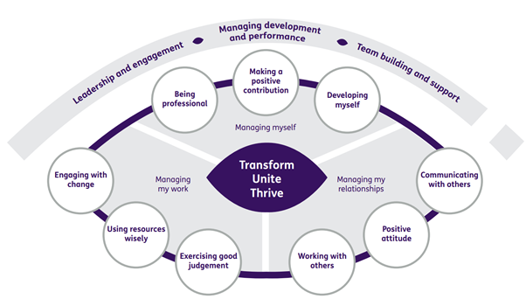

Department structure (this role outlined in red)

