

Job Description

Role Title: | Digital Activities Worker
Department: | Support Hub, Sight Scotland Veterans
Reports to: | Veterans Community Lead
Pay Grade: | Pts. 16-18
Type of Contract: | Full time – Permanent (although part time would be considered)
Normal place of work: | Hybrid Working from Head Office or Hawkhead. Home working will also be considered.
Line Manager? | No
Budget Holder? | No
Criminal Record Check/PVG required? | Yes
Driving license for UK driving required? | No

Who we are

Sight Scotland Veterans provides support to all veterans in Scotland who are experiencing changes to their sight, regardless of the cause, how it affects you or what point you are at. We aim to ensure that veterans and their families and carers have access to the support that they need when they need it.

The Support Hub is a new support service aimed at providing responsive, person-centred support to veterans living with sight loss. The team was created to further engage with and increase opportunities for veterans living with sight loss across the country.
The ‘Digital Hub’ is part of the new Support Hub service working to increase access to a variety of digital opportunities for veterans which will build upon the comradeship that the veterans community are used to, whilst offering a wide range of activities and information sessions for veterans and their carers or families to take part in.
What this job is about

This job is important to us, as it aligns with the Charity’s aim to create and support accessible opportunities for veterans with sight loss. The service grew as a result of Covid-19 changing our approach to ensure that veterans had the support that they needed during lockdown. Veterans told us how much they enjoyed this approach and how beneficial it was to them, and we are keen to build and grow this to reach even more veterans and carers.
The role will work closely with the Support Hub team to build upon the support already provided within our activity centres, taking this into the digital forum. The role will co-ordinate and lead on the various group sessions, ensuring that veterans, families, carers and stakeholders receive support which meets their needs. The role will be key in identifying and organising digital activities that veterans with sight loss can engage with, ensuring accessibility and supporting participation in these. Another key part of the role is identifying information sessions that will be beneficial for veterans and their families to engage in. The job will also involve working closely with the larger Sight Scotland Veterans team and other external organisations to co-ordinate their facilitation in some of these sessions.
Volunteers provide vital support across Sight Scotland Veterans teams and will be an important part of the Support Hub Team. This role will play a large part in ensuring that our volunteers have a welcoming introduction into the service and provide ongoing support to volunteers within their roles.
What we want you to be responsible and accountable for

- Be involved in the day-to-day delivery of the ‘Digital Hub’ service ensuring the highest standard of service is delivered in a person-centred manner.
- To organise and deliver groups within the Digital Hub service, which will include a variety of activities, information sessions and peer support sessions, including others.
- To source and coordinate other opportunities for veterans and their families that can be provided via the Digital Hub.
- To make appropriate assessment of new referrals where required, to determine the suitability of the service before agreeing support.
- To signpost or refer individuals to additional or different support as required.
- To work closely with the larger Sight Scotland Veterans teams and other external organisations and partners to increase the variety of sessions offered.
- Facilitation of sessions that results in all participants feeling that they have received a quality service.
- Keep records of participation which allows for monitoring of feedback and demand of sessions to allow for changes.

The current duties of the role require a criminal records check or membership of the PVG scheme through Disclosure Scotland.
How we would like you to achieve this

- By working with a positive and motivated outlook which encourages participation from others.
- By maintaining a determined approach with a desire to create opportunities for others
- By keeping complete, confidential, up-to-date records, in line with policies and procedures, monitoring requirements and best practice.
- By working in accordance with safeguarding policies and procedures.
- By working in accordance with policies and procedures
- By undertaking training to ensure up to date knowledge and skills.
- By participating in supervision and line management, as agreed according to pieces of work undertaken.
- By ensuring high professional standards that are in line with the strategic vision, ethos, and values of Sight Scotland Veterans.
- By being a positive representative of Sight Scotland Veterans.

Who you will be working with

- Veterans
- Families
- Colleagues and Volunteers
- Other Sight Scotland Veterans services
- Other Sight Scotland services
- Senior Staff
- Outside Agencies
The budget you will hold

- N/A

The experience and skills you need to have to do this job/

Essential:

- SVQ 2 level qualification (or equivalent) in Health & Social Care or similar, or experience of delivering forward facing support services at a similar level.
- Ability to plan and organise activities for a digital setting.
- Driving licence with own transport
- Ability to identify difficulties or issues for people involved within the digital groups and support and encourage in an appropriate manner.
- Good IT skills and ability to use Word/Excel/Teams/Zoom.
- Experience of working within an outcome-focussed environment.
- Strong listening and communication skills, with understanding and empathy.
- An ability to build constructive relationships and engage sensitively with people.
- Have strong problem-solving skills and an ability to work calmly under pressure.
- Have the ability to work independently and as part of a team.
- Ability to use electronic administrative and record keeping systems.
- Excellent time management skills to plan, prioritise and manage workload.

Desirable:

- Experience of working with people with visual impairments.
- Experience of organising or leading digital activities.
- Awareness of Veterans issues.
- Experience of supporting/supervising volunteers
- Experience of engaging with service users over telephone/Teams/Zoom.
- Evidence of ongoing professional development.
Just so you know…

- The Charities have a set of Values & Our Ways of Working Framework, we ask you to work within, and these apply to everybody in the organisation irrespective of their role or job. You can find out more here: Our values. This means we want you to have:

  - The ability and willingness to understand others’ perspectives and to consider the impact of your actions on them and to adapt your actions as necessary;
  - The ability and willingness to learn and try new things, to be flexible and step outside of your comfort zone;
  - An open and honest way of communicating, ready to ask others for their ideas and to be open to hear and consider different points of view;
  - A pro-active approach to taking initiative and to driving forward ideas and projects designed to improve daily operations and deliver an exceptional visitor experience.

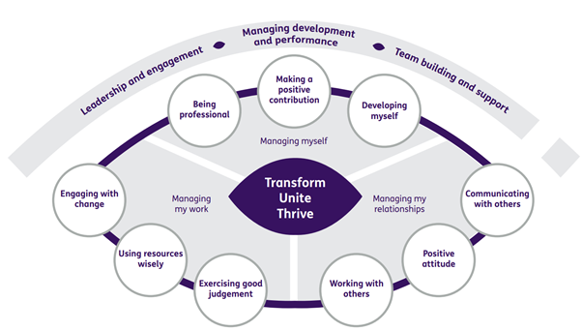

Department structure (this role outlined in red)

