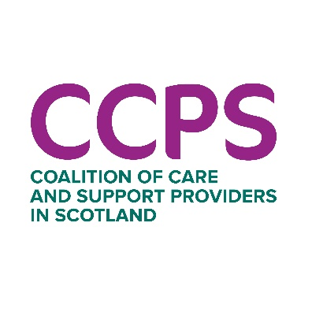

Communications & Parliamentary Officer
Full time, permanent
£32,442
About CCPS
The Coalition of Care and Support Providers’ mission is to identify, represent, promote and safeguard the interests of third sector and not-for-profit social care and support providers in Scotland, so that they can maximise the impact they have on meeting social need.
We are at the heart of influencing Scotland’s radical social care reform agenda. It’s a busy landscape right now, with great opportunities to make a tangible difference for more than a quarter of a million people supported every year by our membership of more than 90 not-for-profit social care and support providers.
We want to see a social care sector in Scotland where individuals and families can realise their own aspirations, and thrive, through support which is rooted in human rights and meaningful relationships. And we want social care to be designed collaboratively, delivered locally and accessible equitably to everyone who needs it.
As an organisation, we want to live these values with integrity in how we work with each other, with our members, and with our partners.
The job
The first few months of 2023 have seen CCPS grow its profile and influencing work, and we now want to build on this with a particular focus on parliamentary engagement and supporting communications work.
Getting legislative reform right will be essential if we are to deliver on the sector’s hopes for change and realise the rights of children, families and adults across our communities.
Alongside the parliamentary brief, you’ll develop and expand our communications, with a particular focus on digital communications and media engagement. Helping to build our voice, implement our brand and contribute to quality improvement, you will be part of a small communications team, line managed by the Head of Communications & Engagement.
Your background
You’ll come with a strong interest in politics and policy, and experience of parliamentary engagement and how Holyrood works. You’ll bring expertise and skills in communications, particularly in digital communications and media engagement.
Over your career you’ll have gained a thorough understanding of social media platforms and how to grow audiences online, alongside an open-ness to learning about developments in digital and a creative and inclusive approach to digital engagement. You’ll be able to draw on experience of writing articles and press releases, working with journalists and securing media coverage for organisations or projects.
Underpinning all of this, you’ll be a strongly values-led professional with an inclusive and respectful approach to listening, telling people’s stories and supporting others to have their voices heard. You’ll enjoy getting involved in contributing to internal communications and being a positive, collaborative member of a small team.
The benefits
Like many organisations, CCPS is working to update its ways of working, policies, and procedures in light of experiences through the pandemic. The successful candidate will have the opportunity to shape these with us in 2023.
Benefits include:
• Permanent, 35 hours per week contract with a salary starting at £32,442
• Joining a high performing and kind team doing meaningful and influential work
• Staff are currently working in a flexible, hybrid way between home and office and we are about to create new policies on ways of working. However, given the nature of this role, the post-holder will be expected to be a regular presence in the Scottish Parliament at Holyrood. Regular working from the CCPS office in Edinburgh and some attendance at meetings outside Edinburgh will also be required.
• 36 days of annual leave including 11 bank holidays (6 set bank holidays)
• The opportunity to join a Group Personal Pension Plan with an employer contribution of 6% and a minimum employee contribution of 4%.

How to apply
The full job description is set out in this pack.
Applications are invited by CV and covering letter by 9am on Monday 20 March. In your covering letter please ensure that you address the key skills, knowledge and experience as set out in the job description as we will use this to support shortlisting. Please keep covering letters to no more than three sides of A4. CVs without such a covering letter will not be accepted. Please email your CV and covering letter to info@ccpscotland.org
Interviews are scheduled to take place on Thursday 30th or Friday 31st March in Edinburgh. We are happy to accommodate online interviews for any shortlisted candidate currently unable to meet in person, as well as discussing other adjustments that might support you in the process. We will talk this through with you if you are shortlisted.

