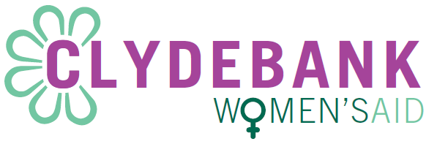

As part of Clydebank women’s aid three stage recruitment process, we would like to invite you to provide a letter to tell us about yourself and explain why you would like to work with Clydebank women’s aid.

Points to consider –
- Your values, attitudes, skills, interests/hobbies and what is important to you.
- Understanding of domestic abuse, our work, and women’s position in society
Please note to keep the process as fair as possible, we ask that all letters that have been typed are provided within no more than two pages of A4 paper in font size 12 with line spacing of 1.15. For any handwritten letters please limit this to three pages of A4 paper.

Please return your letter to recruitmentclydebankwa@gmail.com by Monday 13th of March 2023 before 1pm. If handwritten, Please return to Clydebank Women’s Aid Office (77 Whitecrook street, G81 1QW).

Application packs will be sent out on Friday the 17th of March 2023 to successful first round applicants (Letter request stage). The closing date for stage 2 will be Tuesday 11th April 2023 @ 9am.
Interviews will take place on Saturday the 22th of April 2023.

Name:

Address:

Telephone number: Home:
Email Address:

Application for the post of Support Worker/Collective Manager:

Application Number: (Please leave blank for CWA use).

Name:

Address:

Telephone number: Home:
Email Address:
Application Number_______
Post of Support Worker/Collective Manager

Application Number_______
Post of Support Worker/Collective Manager

