

Role Profile – Customer Service Representative

Reports To:
Customer Service Supervisor
Role Purpose:
You will provide high quality customer service and commercial administrative support to key stakeholders of the Scottish Braille Press. Your duties will include client communications, sales quotations, order processing, invoicing, credit control and purchase ordering. You will be expected to always project a professional company image and to follow company and customer procedures.

All roles within Sight Scotland and Sight Scotland Veterans are expected to work to our values and Our Ways of Working framework:

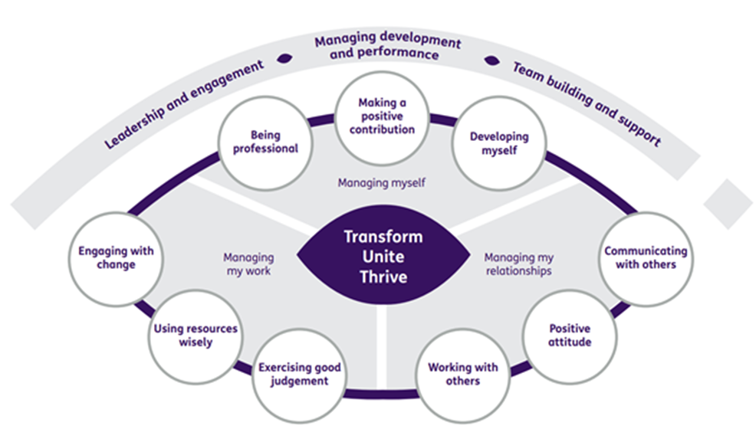

Our Ways of Working – Managing my Work
The main responsibilities and accountabilities of this role are that you will:
- Receive and reconcile deliveries to site, ensuring that all items are accurately recorded.
- Liaise regularly with customers and other staff members to ensure their requirements are being met and respond to any communications promptly
- Actively maintain customer relationships and follow-up sales quotations to maximise conversion to orders.
- Process customer orders using order processing systems and produce customer reports promptly and accurately as per customer Service Level Agreements
- Maintain client databases to ensure customer communications are tracked and data is up-to-date and accurate at all times.
- Ensure all non-conformities, complaints and incidents are logged and investigated fully and that customer responses are appropriate.
- Carry out quality and control checks by customer to meet contractually agreed standards and reporting requirements e.g. reconciliation.
- Prepare and produce management information reports and statistics, as and when required.
- Assist with stock management and research competitive prices for goods and services.
- Raise electronic purchase orders in the accounting system and after approval, promptly place orders with suppliers to ensure adequate stock levels are maintained for continuity of production.
- Ensure customer contract work is accurately recorded, priced, and invoiced, including preparation of supporting data for customer invoicing.
- Ensure payments for other services e.g. book sales, are processed via other payment systems e.g. Streamline.
- Administer the petty cash ensuring sufficient float is available for operational purposes and that it is kept secure at all times.
- Actively manage aged debt through proactive credit control utilising sales trading and aged debtor reports.
- Assist in updating department procedures and process maps as required
- Support management in training new staff.
- Carry out administrative duties: e.g. emailing, logging and distributing Scottish Braille Press mail, maintaining filing systems, securely disposing of documents as per retention periods.

Our Ways of Working – Managing Myself and Managing my Relationships
To do this role, you will have:
- Good written and verbal communication skills.
- Good numeracy skills.
- Good working knowledge of Microsoft Office and database applications.
- Previous experience of customer account handling in a commercial customer service office environment.
- Experience of order management and delivery reconciliation.
- Experience organisation and customer service skills with a friendly and confident telephone manner with the ability to build and maintain positive working relationships with a wide range of customers, stakeholders and colleagues at all levels of the organisation.
- Good time-management skills, be able to prioritise workload and multi-task and process large volumes of documents to meet deadlines.
- Experience of data collection and proven analysis and problem-solving skills.
- Fast and accurate keyboard skills (c. 40 wpm).
- Ability to read 10pt text, work with hardcopy and digital documents and have clear handwriting.

To do this role, it is desirable if you have:
- Recognised qualification in keyboard and computer skills e.g. European Computer Driving Licence/ PC Passport.
- Customer Service and/or Business & Administration SVQ level 3 or equivalent.
- Knowledge of alternative formats.
- Experience of finance systems including purchase order processing, sales order processing and stock control.
- Experience of using CRM databases.
- Experience of working with clients in the financial sector.

On a day-to-day basis you will work with different people and teams, these could be:
- Colleagues
- External clients
- External providers
- Other Sight Scotland services
- Senior staff
- Members of the public

Requirements of this role are that you will:
- Be subject to a successful Police Act Disclosure and Identity and Adverse Finance check.
- Have a 6-month probation period.
- Participate in all staff training and development and maintain your own professional development.
- Be willing to work reasonable overtime which may often be at short notice.
- Maintain confidentiality and data protection in all aspects of client, staff and agency information.
- Maintain the highest levels of customer service.
- Wear the appropriate PPE in accordance with current guidance for the role.
- Follow Sight Scotland’s guidance, policies and procedures relating to your own health and safety and that of colleagues and service users at all times.
- Uphold the principles of Sight Scotland’s Dignity at Work and Equal Opportunities policies at all times, working in a way which supports an inclusive work environment that is respectful of differences.

What we can offer you:
- Generous annual leave entitlement
- Generous pension scheme
- Access to learning and development opportunities
- Employee Perks through the Employee Assistance Programme
- Cycle to Work scheme
- And many more, please visit our website for more information

This job profile is not exhaustive. The duties of the post holder may be reviewed from time to time and the employee may be called upon to work in other locations within Sight Scotland.

If you require this document in an alternative format, please email people@sightscotland.org.uk

