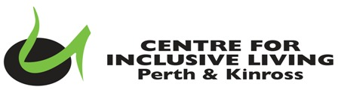
CILPK Administrator Person Specification

Experience or quality | Essential | Desirable
Confident use of Microsoft & google programmes such as google workspace, google docs and forms | ✓
Able to initiate, plan and complete tasks | ✓
Experience of digital communication and its use in a work context | ✓
Communication skills with people in a wide range of circumstances | ✓
Ability to work unsupervised and using initiative | ✓
Experience of general administration duties | ✓
Experience of minute taking and maintaining communication with a varied membership | ✓
Manage social media accounts, website platform and mailing contact lists | ✓
Experience of website maintenance and development |  | ✓
Knowledge/Experience of Disability related issues |  | ✓
Experience of organising and managing small projects and events |  | ✓
Experience of managing accounts/invoices/bookkeeping |  | ✓

