

Organisational Profile

March 2023

www.communityenterprise.co.uk

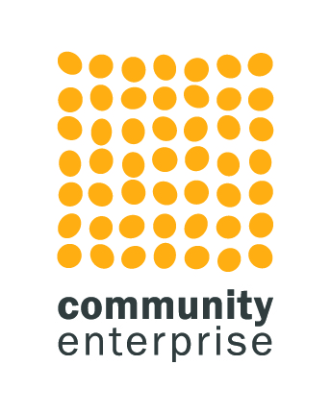

**Contents**

1. Background to the Organisation 3

1.1 Broader Context 3

1.2 Our Services 3

1.3 Company Details 4

1. Background to the Organisation

1.1 Broader Context

Community Enterprise is one of Scotland’s leading social enterprise and community development consultancies and support providers. We provide support to third sector groups across Scotland and work with communities to build and sustain projects for the benefit of local people.

Community Enterprise has been working in Scotland for over 30 years. We have an expert team of 20 consultants and support staff and 10 accredited associates with a range of experience in the private, voluntary and public sectors. We take pride in the high quality of support we offer. We work with around 200 clients a year and build up close, and often long term, coaching relationships to help implement plans. In 10 years of post-project evaluations, 93% of clients have scored us between 8 and 10/10.

We are a social enterprise ourselves. 100% of our profits are re-invested in supporting the further growth and development of voluntary and community organisations. To do this we earn income from consultancy services.

We are involved in a range of national contracts including Just Enterprise, the government funded social enterprise development programme. We have delivered regional social enterprise support contracts (in South Lanarkshire, Perth and Kinross, Edinburgh and currently West Lothian). We are contracted by the National Lottery Community Fund and by the Robertson Trust to deliver business support to their grant holders. We delivered the business support as part of the Scottish Government funded Adapt and Thrive programme to over 1000 beneficiaries and are currently running a national community support programme for sustainable communities called Accelerate.

Our core work, however, is with community based organisations rooted in a geographical community seeking to create sustainable development and regeneration – our strapline is ‘helping people make good things happen’.

Every programme and organisation is different, and we spend time at the beginning of the process to become fully aware of the aspirations and intended aims, objectives, and outcomes of any development. We use this to develop a tailored approach to the support we provide.

1.2 Our Services

Our focus is on developing sustainable communities through resilience using techniques including social enterprise, innovative fundraising and community empowerment. We have developed four cross-fertilising divisions.

**The Group’s Services and Divisions**

Our focus is on developing sustainable communities through resilience using techniques including social enterprise, innovative fundraising and community empowerment. We five developed four cross-fertilising divisions.

1. Our **development team** develops enterprise, communities and organisations including strategic thinking, market research, business planning, evaluations, organisational reviews, community plans and investment readiness.

Our over-arching website has information about all our divisions, but this is a link directly to the work of the [development team](https://communityenterprise.co.uk/what-we-do/development).

1. We operate the first and biggest social enterprise strategic marketing and **creative design and branding agency**, called [Bold](http://www.bold-studio.co.uk). Now in its tenth year of development, its services include branding, design and print, web design and build and creative marketing strategy.
2. We deliver a social enterprise **digital agency**, soon to be launched as Breeze Digital. This will support the practical digitization of the sector from digital strategy to digital service design.
3. We are a strategic part of the sustainable third sector and provide **strength and capacity to the sector**. We were founding members of Social Enterprise Scotland, founding subscribers of the Voluntary Code for Social Enterprise and members of various national networks. We currently design and manage the [social enterprise support map](https://sesupportmap.scot/) and organise workshops and training and have a fast evolving research arm.
4. We try **new things**. We established a national on-line e-commerce site for social enterprises and are interested in how the digital space can develop the third sector. We currently operate a project called [Creative Natives](https://creativenatives.org.uk/) which changes the lives of young care leaves through creativity.

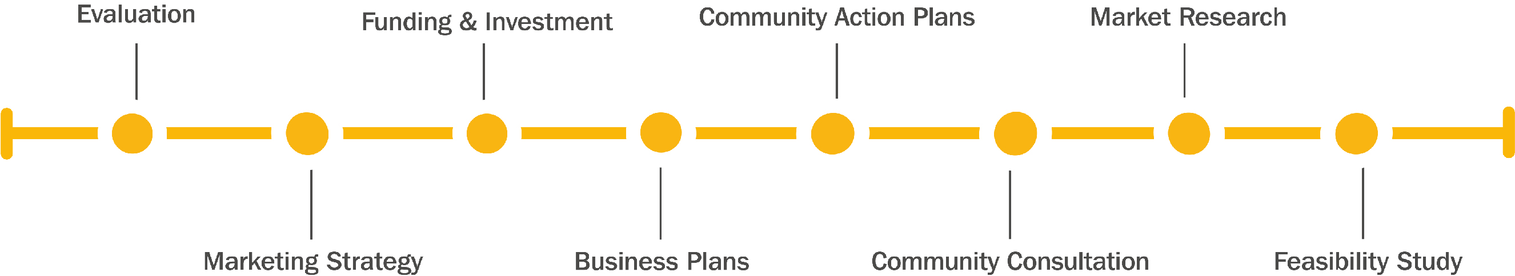

1.3 Company Details

|  |  |
| --- | --- |
| Company Structure | Community Enterprise is a company limited by guarantee with charitable status. CEL Trading is a company limited by shares that is a wholly owned subsidiary of Community Enterprise Ltd.  CEL Trading is the legal entity that is submitting a tender for this work. |
| Registered Address | Suite 14, Fleming House, Fleming Road Kirkton Campus Livingston EH54 7BN |
| CEL Trading Company number | SC142050 |
| Community Enterprise Ltd | Charity Number : SC006992  Company Number : 107265 |
| VAT number | 939 5323 95 |
| Insurance | We have full Public Liability and professional indemnity insurance up to £5m brokered by Keegan and Pennykid with Royal and Sun Alliance. We have £10m of employer’s liability, £5m of public liability and £5m of professional indemnity. |
| Website | www.communityenterprise.co.uk |
| Twitter | @CommEnterprise |

