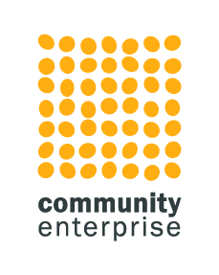

Research and Project Support Worker

Job Title Research and Project Support Worker

Job Purpose To support the development team to deliver research projects and other documents and reports.

Accountable to Development and Impact Manager
Main Duties

- contribute to the achievement of Community Enterprise’s overall organisational objectives and targets. These are centred on initiatives which support the sustainability of organisations with a social purpose.

- work as a member of the Development Team, providing support to pieces of research and also to a range of projects for a wide variety of existing and new clients.

- specifically, support will include undertaking:

        - Background and desk research
        - national and local policy research and analysis
        - demographic research and analysis
        - case studies
        - market research including trends
        - survey design and analysis
        - stakeholder interviews
        - researching funding avenues
        - some draft section writing for reports
        - occasional participation at community consultation events to support colleagues

- collaborate with co-workers engaged in other Community Enterprise ventures and interests to ensure a joined up, added value approach

- assist with Community Enterprise marketing and communications – including social media and events

- such other tasks as may be required which are consistent with the duties and responsibilities of the post

Person Specification Experience, aptitude, values, fit with the team and a sensitivity to the enterprising third sector are more important to us than formal qualifications. This post needs someone who can combine research skills with a practical and proactive approach to a range of project requirements.
Ideally, we’re looking for someone who is;
      - Able to gather information intelligently and analyse data
      - Focussed on positive and valuable outcomes for our clients
      - Confident, self-motivated, proactive and organised
      - Willing to learn and with an interest in the Third Sector
      - Able to problem-solve and use their initiative
      - Personable, with a good telephone manner
      - Attentive to detail
      - Strong in communication skills, including written, verbal and presentation skills
      - An excellent team player and willing to share skills and learning with co workers
      - Able to cope with competing demands and prioritise tasks
      - Proficient in the use of technology and willing to learn new ways of working as needed- (Canva, Surveymonkey, Mural as examples)
      - Experienced in a range of social media platforms
      - Willing to travel across Scotland occasionally for attendance at community events or project site visits
      - Willing to get involved in other areas of the organisation when there are capacity issues, as we all do working in a small team

Remuneration £24,000

Location Hybrid working arrangements with a base in Livingston. Travel throughout Scotland may be required occasionally. Full driving license is an advantage but not essential.

