Disability Equality Scotland

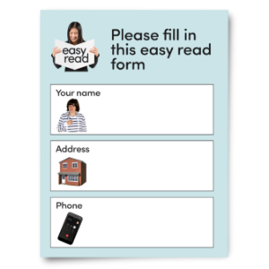
Job Application Form

Easy Read

Copyright images © Photosymbols. Prepared by Disability Equality Scotland
 | This form is for people who want to work for Disability Equality Scotland.
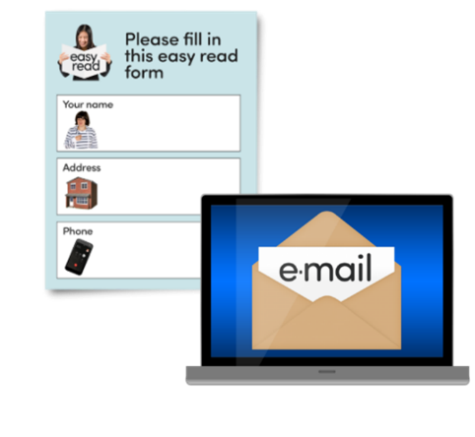 | Please fill in this form.  When it’s filled in you can email it to recruitment@disabilityequality.scot
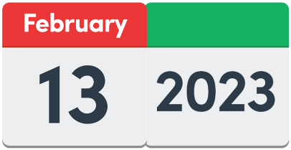 | Send it back to us by  Monday 24 March 2023 by 5 pm
Which job at Disability Equality Scotland are you applying for?
Type the job here:

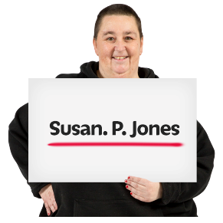 | Your full name:
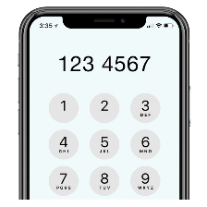 | Your phone number:
 | Your email:
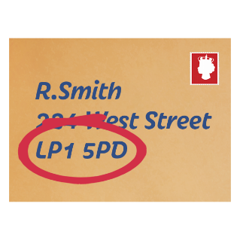 | Your post address and postcode:
Education – where you studied
Tell us about:
- your schools
- your college
- your university
The space will grow as you type.

Qualifications – what awards and courses you have done
Tell us about:
- your certificates
- your awards
- your courses
The space will grow as you type.
Your job at the moment

Tell us about your job at the moment.

Or tell us about your last job if you do not have a job right now.

Tell us:
- who your boss is
- when you began the job
- what tasks you do
- how much you are paid

The space will grow as you type.

Your computer skills

Tell us about your computer skills.

Tell us:
- what you can do
- which computer tools and programmes you know well

The space will grow as you type.

Making sure that Disability Equality Scotland is fair to disabled people who want to work with us
We will give an interview to disabled people who have the right skills.
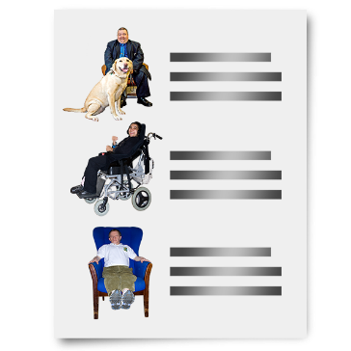 | If you get the job, you will join the Protection of Vulnerable Groups Scheme.
 | Do you have a disability and want to have an interview?
Yes | ☐
No | ☐

What kind of support do you need to have an interview?
Tell us here:

References
Tell us 2 people who know you as a staff member well.
They cannot be your family.
We might ask them to tell us about your work skills and strengths.
Person 1
Name:
Email:
Phone number:
If we offer you an interview, can we contact Person 1?
Yes | ☐
No | ☐

Person 2
Name:
Email:
Phone number:

If we offer you an interview, can we contact Person 2?
Yes | ☐
No | ☐

Your supporting statement
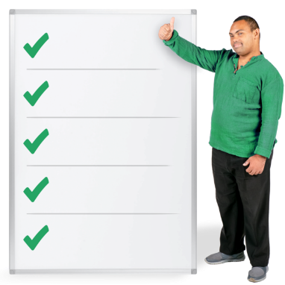 | This is the part where you can write about:  - why you want this job  - why you would be good at the job  - how your skills and experience match the list of things we want – the list is called our Person Specification.  You can find our Person Specification document in the pack of documents we sent you.
Type or write below.
Write as much as you want to.
The box will grow as you type.

My Supporting Statement

 |  | Please sign your name here:
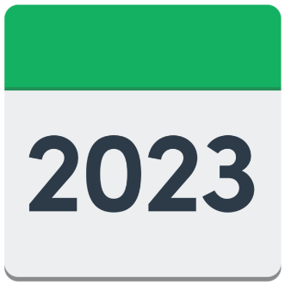 |  | Today’s date:

Copyright images © Photosymbols. Prepared by Disability Equality Scotland

