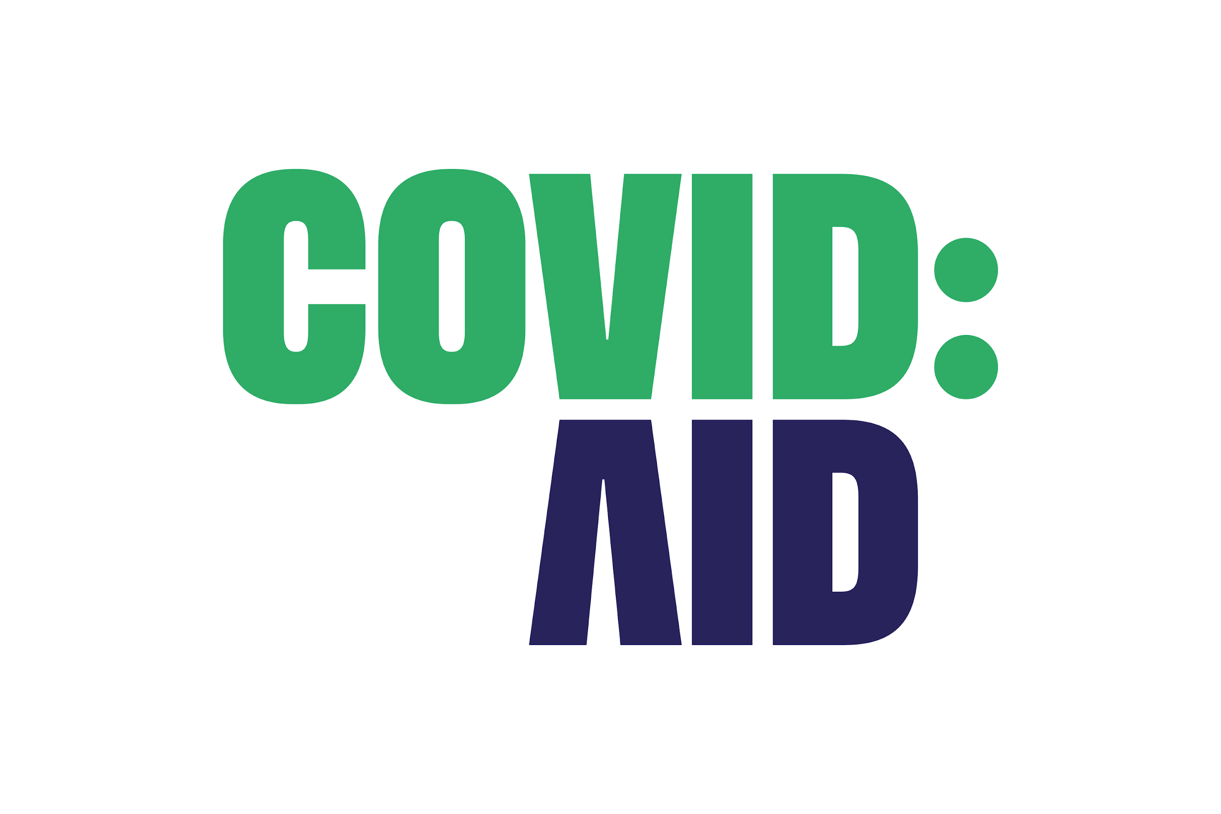

Freelance Digital Community and Services Manager (part-time)

**Role:** Freelance Digital Community and Services Manager

**Hours:** 15 hours per week

**Length:** 3 month freelance contract (then 1-month rolling freelance contract)

**Rate:** £17 per hour (equivalent to £127.50 per 7.5-hour day)

**Location:** Remote (UK charity)

## About Covid aid

[covid aid](https://covidaidcharity.org/) is the UK’s national charity dedicated to supporting all those significantly affected by Covid-19, building and supporting a community and providing a voice.

We launched in May 2021 and have quickly become established as the UK’s leading Covid-19 charity, growing significantly month on month. We are looking to continue this growth as we equip ourselves to help people in the longer term across a variety of Covid-related issues including Long Covid, grief and bereavement, financial hardship, and more.

## The Role

We have launched a successful an online community, with over 1400 members, and are looking for an outstanding freelancer who can allow us to grow this community through engagement and the deployment of experts and those with lived experience. The person we are looking for will have an understanding of the Community North Star metric, and follow the SPACES model.

Our platform will allow users to speak to each other and provide peer support. It also has capabilities to create groups, offer courses, and host streamed events.

The successful candidate will have the technical skills to help experts, charity ambassadors, and other individuals make the most of these capabilities. Through promotion of groups, courses, and events on our other digital channels we will reach our monthly audience, meaning that we can provide support to an ever-increasing and diverse audience of individuals who have been significantly impacted by Covid-19.

The role is 15 hours a week, we would expect that this would be worked over several days but this can be flexible to incorporate other commitments. This will include a short regular meeting with the executive director as well as a fortnightly meeting with volunteers/trustees.

The initial contract length is for three months, rolling on monthly after this. (With covid aid or the freelancers to provide a notice period of one month prior to departing role.)

## Responsibilities

Responsibilities to include though not necessarily be limited to:

* Develop and test new and existing community engagement programs.
* Community posting.
* Community engagement across digital channels and platforms.
* Source and maintain good relations with experts and those with lived experience.
* Management of community contributors. (including those providing advice and services)
* Answer specific support queries from visitors.
* Build and manage a list of responses to standard support queries.
* Planning, producing, and technical delivery of online events such as talks, panel discussions, sessions, and workshops.
* Editing and uploading video, written, and other content to digital channels such as YouTube.
* Contribute to and update a community growth plan and overall strategy.
* Manage community maintenance, administration, and operations.
* Other maintenance.
* Monthly analytics report.
* Develop policies in partnership with Head of Operations.
* Any other tasks as relevant to the role.

## Person Specification

Necessary

* Previous community management experience
* Technical knowledge of hosting Zoom and other online streaming events
* Basic video production skills (and own software)
* Basic graphics skills (we use Canva)
* Strong writing skills
* Ability to engage with a wide audience
* Charity experience (ideally healthcare)

Desirable

* Previous community management experience
* Knowledge of DivvyHQ/Trello/Slack
* Brimming with ideas and enthusiasm

## Apply

To apply for this freelance role please email [hello@covidaidcharity.org](mailto:hello@covidaidcharity.org) with your CV. You can also contact us with any questions you may have.