
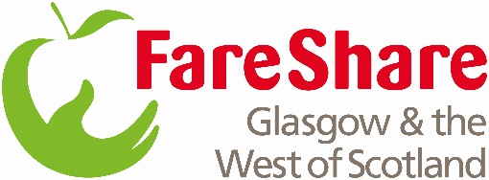
FareShare Glasgow and the West of Scotland

C1 Driver and Depot Operative

Reporting to: FareShare Glasgow Management Team

Location: Glasgow and the West of Scotland Depot

Operating Hours: Monday – Friday, 8am-5pm (Flexibility will be required)

Shift Pattern: 35 hrs pw,

Salary £22,330 - £24,811 (review pending) It is Move On policy for candidates to start on point one of the salary scale.

FareShare Glasgow & The West of Scotland is run by Move On, a charity that believes we all need support at different times in our lives. For too many people a lack of opportunities is a barrier to reaching their full potential. We want to change that..As a FareShare C1 Depot Driver and Operative for FareShare Glasgow you will collect and deliver food from and to our food partners across Glasgow and the West of Scotland, as well as deliver food from our Regional Centre based at South Street, to our charity members within Glasgow and the West.
Main responsibilities
This role sits in the FareShare Operations Team and will have responsibility for collecting surplus food both on schedules and short notice. Your timely collection and delivery will ensure that more surplus food can be distributed on to charities and community groups.
- To Load the vehicle where required and check your vehicle for roadworthiness.
- To Understand the schedule and route that has been planned and calculated for you.
- Be ready to meet our food partners and charities when you collect or deliver food and/or non-food.
- Slight flexibility with start and finish times as per need and driver regulations. Working hours will ordinarily be Monday to Friday 8am until 5pm each day weekend work may be required.
- Drive safely, responsibly and within the law, reporting any incidents that may affect the vehicles roadworthiness.
- Be courteous and demonstrate FareShare’s equality and diversity policy.
- Complete all necessary paperwork.
- Support depot team in preparing orders for collection and delivery.

Candidate Specifications
- Driver age at least 25 years
- Full clean UK driving licence with at least a 7.5 Tonne / C1 class licence entitlement
- A valid DQC (CPC card) and digital tachograph card
- Physically capable as heavy lifting will be involved
- Eligibility to work in UK
- Commitment to gain Level 2 Food Safety Qualification
- Forklift Truck Licence preferred but full training can be given to right candidate

Skills and Attributes
- Safe and courteous driver
- Strong customer service and communication skills
- Must possess a positive and professional attitude
- Able to take initiative and use common sense
- Can stay clam under pressure
- Team player willing to adopt a flexible approach to daily tasks and activities
- Commitment to FareShare’s Equality & Diversity ethos
- Prompt and works independently

