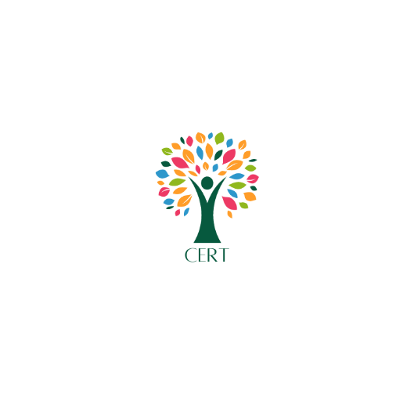

Multiply Progression Tutor

Clackmannanshire Economic Regeneration Trust (SCIO) – CERT – is a small, innovative charity established to help Clackmannanshire to become a vibrant place to live where people are happy, healthy and where opportunities, connections and support are available for all. CERT have recently completed the delivery of a major Pre Employability programme in Clacks and are now contracted to deliver the Multiply programme in Clacks as well as part of Positive Moves, the Shared Prosperity Fund People and Skills programme.

MULTIPLY is a UK Government initiative to boost people's ability to use maths in their everyday life and work, or go on to achieve qualifications which open doors to further learning or employment. In Clackmannanshire Multiply will deliver support to participants across a range of characteristics and locations and at different levels. Recognising that poor numeracy skills are often an integral part of wider core skills gaps such as literacy and communications, CERT are delivering the Multiply programme in a holistic manner so that its participants are provided support to address all these areas.

Working alongside the Positive Moves programme, where appropriate, participants on Multiply will be supported in their journey towards stable employment.

CERT are looking to recruit a passionate and dedicated individual to work within this holistic Multiply programme, who can inspire and motivate a diverse range of adult learners in community settings around Clackmannanshire and where appropriate help them progress to employment.

The Multiply Progression Tutor will deliver non-certified and certified (SQA) courses which aim to increase confidence and competence in everyday life in numeracy, maths, literacy and communication. The role will involve engaging with residents of Clackmannanshire who have a wide and diverse range of numeracy levels to provide them with skills and confidence with numbers which will enrich their lives and support their onwards development.

The programme will include courses and one to one tutoring for parents, those seeking to improve their money management, those with experience of criminal justice, those in community settings, those who are care experienced and others. These will be delivered through workshops with small groups, up to 10, and through one to one sessions.

The postholder will provide a holistic, person centred approach to support the development and progression of the individual to move towards employment (if appropriate) and onwards to further education and training.

The post is full time, based in Alloa. It is 35 hours per week. Flexibility is sought in hours. This may include working at daytime, evenings and weekends to suit the successful postholder and the client needs’.

The post is fixed term until 30 March 2025.

Responsibilities of our Multiply Progression Tutor
- Provide engaging and interactive 1-1 and small group tuition sessions to support learners in accordance with the MULTIPLY programme.
- Engage and deliver high quality personalised small group related sessions, including financial wellbeing to people aged 19+ without formal qualifications, which enables learners to develop their mathematical and other skills.
- Produce good quality action plans with individuals. Where appropriate this will include a more holistic approach to progression to employment and other positive outcomes.
- Gather evidence, maintain and collect academic records, data and report on learners participation, success and progression. Report on outcomes based on the UK shared Prosperity Fund MULTIPLY programme. This will be delivered in part through the Hanlon CRM system and the Outcome Star
- Provide appropriate and effective initial assessment, information, advice and guidance to learners, supporting their access onto the course and routes for progression.
- Undertake Assessments of participants to a level 2 SQA award
- Provide consistent motivation and mentoring support to service users with complex and sometimes challenging needs, empowering them to achieve their employment and training goals.
- Identify suitable supports and specialist services that will be of help to the participant and help them to access these.
- Effectively manage a caseload of service users; ensuring ambitious performance targets and project objectives are met this will include weekly contact with participants
- Contribute and fully comply with quality improvement, health and safety, equality and diversity and safeguarding systems.
- Work within the CERT team to support the delivery of other CERT programmes and in particular to support those you are working with to maximise their potential from CERT’s programmes.

Multiply Progression Tutor

Person Specification

What we’re looking for in our Multiply Progression Tutor:

- A love and enthusiasm for supporting learning
- Expertise in working closely with adult learners to support their needs which includes assessing learners and creating detailed action plans and recording progression.
- Experience and rapport with the client group of adult learners who may have limited numeracy and other core skills
- Experience of working with those who are unemployed and economically inactive to help them to progress towards employment and other positive outcomes
- Ability to deliver, under supervision, certified and non certified workshops and 1 to 1 supports at times to suit learners needs which may include daytime, weekend or evening classes.
- Work experience where numbers were a substantial part of the role
- Experience of gathering evidence, maintaining and collecting academic records, data and reporting on participants activity, success and progression.
- A growth mindset towards learning and teaching practice for learners and willing to improve practice through self reflection.
- Ability to handle a large case load of individuals who are at different stages of their journey and need varying supports
- Invests in the learners wellbeing and health in a social and emotional capacity.
- An enthusiastic, engaging individual who is committed to creating innovative workshops to facilitate higher order thinking skills.
- A commitment to the residents of Clackmannanshire to support their development and growth
- A strong term player
- Excellent written and verbal communication skills

Required qualifications:
- Educated to degree level
- Hold a National 5 in Maths
- Accreditation to be an SQA assessor or a commitment to undertake the RQF Level 3 award in Assessing Vocationally related achievement within 6 months of appointment (paid by CERT)

24th March 23

