

Job Description

Role Title: | Driver
Department: | Sight Scotland Veterans
Reports to: | Deputy Centre Manager
Pay Grade: | 10
Type of Contract: | Part time - Permanent
Normal place of work: | Linburn Centre
Line Manager? | No
Budget Holder? | No
Criminal Record Check/PVG required? | Yes
Driving license for UK driving required? | Yes

Who we are

Sight Scotland Veterans provides support to all veterans in Scotland who are experiencing changes to their sight, regardless of the cause, or what point you are at. We aim to ensure that veterans and their families and carers have access to the support that they need, when they need it.

Our Activity Hubs provide innovative and person-centred services and support to veterans struggling with sight loss. The services aim to reduce isolation while improving independence and confidence to live well with a visual impairment now and in the future. The services offer veterans access to information, support, meaningful activity and social engagement in a welcoming environment.

What this job is about

This job is important to us, as it aligns with the Charity’s aim to create and support accessible opportunities for veterans with sight loss, who access our activity hubs.

The key aspect of the role requires you to be responsible for safely transporting veterans with sight loss, to and from the activity hub. Our driving team play a huge part in ensuring that the veterans can attend the Activity Hubs and are times required to provide some support to ensure veterans can access the vehicles. The role will require an adherence to health and safety with regards to routinely checking the fleet to ensure there are no issues, and reporting this to the leadership team.
As the welcoming face of Sight Scotland Veterans, you will often be the first contact the veterans have each day, and as such are an important representative for the organisation. The veterans enjoy chatting with the driving team whilst on the vehicles and a welcoming and friendly personality is an asset within the role.

What we want you to be responsible and accountable for

- To be responsible for safely transporting veterans in the minibus or car to and from the Activity Hub or other locations, as required.
- To undertake any driving duties necessary to the functioning of the organisation as agreed with the Deputy Manager.
- To take responsibility for Health & Safety in relation to the minibus or car including ensuring, that all passengers use appropriate seatbelts / restraints during all journeys and that all passengers are assisted in a safe fashion when boarding / exiting the minibus or car.
- Ensure that the minibus or car is driven with due care and attention in accordance with current road traffic legislation.
- Take responsibility for the routine maintenance of the minibus or car, including cleaning the vehicles and ensuring the Deputy is informed as soon as possible of any problems in relation to the vehicles.
- Ensure all wheelchair clamps are present and functioning in the minibus.
- Any other reasonable driving or ancillary duties that may be required.

The current duties of the role require a criminal records check or membership of the PVG scheme through Disclosure Scotland.

How we would like you to achieve this

- By working with a positive and motivated outlook
- Be eligible to drive a minibus (hold a D1 Licence)
- Hold a clean current driving licence
- Be a good listener, courteous, tactful.
- Have the ability to work with and support colleagues.
- Have the ability to build positive professional relationships at all levels
- Have the ability to adapt to change and respond positively to non-routine situations
- Demonstrate good problem-solving skills
- Be flexible and have a patient approach to changing circumstances on a daily basis
- By working in accordance with policies and procedures
- By undertaking training to ensure up to date knowledge and skills.
- By participating in supervision and line management, as agreed according to pieces of work undertaken.
- By ensuring high professional standards that are in line with the strategic vision, ethos, and values of Sight Scotland Veterans.
- By being a positive representative of Sight Scotland Veterans.

Who you will be working with

- Veterans
- Families
- Carers
- Colleagues and Volunteers
- Other Sight Scotland Veterans services
- Senior Staff

The budget you will hold

- N/A

The experience and skills you need to have to do this job/

Essential:

- You are eligible to drive a minibus (hold a D1 Licence)
- Previous experience of driving as part of your role
- You have demonstrable knowledge of relevant Health and Safety regulations
- You have a clear understanding of the Highway Code
- Availability to work a split shift pattern
- Flexibility – when required

Desirable:

- Experience of working with people with visual impairments.
- Awareness of Veterans issues.

Just so you know…

- The Charities have a set of Values & Our Ways of Working Framework, we ask you to work within, and these apply to everybody in the organisation irrespective of their role or job. You can find out more here: Our values. This means we want you to have:
  - The ability and willingness to understand others’ perspectives and to consider the impact of your actions on them and to adapt your actions as necessary;
  - The ability and willingness to learn and try new things, to be flexible and step outside of your comfort zone;
  - An open and honest way of communicating, ready to ask others for their ideas and to be open to hear and consider different points of view;
  - A pro-active approach to taking initiative and to driving forward ideas and projects designed to improve daily operations and deliver an exceptional visitor experience.

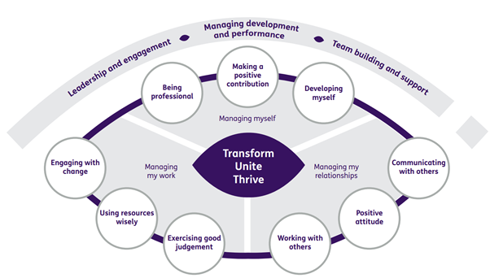

Department structure (this role outlined in red)

