

Job Description

Role Title: | Financial Wellbeing Worker
Department: | Support Hub Sight Scotland Veterans
Reports to: | Financial Wellbeing Lead
Pay Grade: | Pt 24-26
Type of Contract: | Fixed 12 months
Normal place of work: | Blended or Home job share considered
Line Manager? | No
Budget Holder? | No
Criminal Record Check/PVG required? | Yes – enhanced PVG – Adults
Driving license for UK driving required? | Yes

Who we are

Sight Scotland Veterans provides support to all veterans in Scotland who are experiencing changes to their sight, regardless of the cause, or what point you are at. We aim to ensure that veterans, their families and carers have access to the support that they need, when they need it.

The Support Hub is a new service aimed at providing a responsive, person centred support to veterans with sight loss. The team was created to further engage with and increase the wellbeing of veterans living with sight loss across the country.
The ‘financial wellbeing service’ is part of the Support Hub with the aim to support veterans with tailored financial assessment, information and grant provision; helping veterans to maximise their income and maintain independence.

What this job is about

This role is an important part of the charity’s aim to provide financial advice and support to veterans with sight loss. It will work closely with the wider Sight Scotland Veterans teams to build on the support already provided. The role will be key to helping veterans live as independently as possible by providing tailored support around benefits, entitlements and any other relevant financial advice. This will include offering Financial Wellbeing Health Checks to ensure veterans and their families are accessing the financial support and any entitlements available to them. The role will also be required to provide support to access Grants offered by Sight Scotland Veterans and other external agencies. The role will also offer referral/signposting into other relevant supports which will benefit veterans and their families/carers. The successful candidate will work closely with the Financial Wellbeing Lead to ensure the larger teams are provided opportunities to access consistent information and upskilling opportunities around supporting veterans in local communities with their financial wellbeing.

What we want you to be responsible and accountable for

- Be involved in the day to day delivery of the service ensuring the highest standard of service is delivered in a person-centred manner.
- Provide tailored financial information and advice, financial health checks and assessments and support access to/and applications for internal and external grants and other types of financial support.
- Maintain an overview of the financial support available to veterans of all ages and ability and support individuals to access these.
- To work with the Sight Scotland Veterans team and partners to increase financial wellbeing for veterans.
- Provide regular information updates and case studies on financial wellbeing for use on the charity’s website and newsletter
- To create and maintain ongoing, beneficial partnerships with the aim of ensuring veterans get the best possible tailored support.
- Build and develop relationships with veterans and with sight loss, their families or carers to provide support, along with statutory authorities and other veteran organisations.
- Ensure adherence to OSCR and GDPR requirements.
- Ensure that appropriate systems are maintained for case recording, statistics, follow-up work and quality assurance purposes
- Escalate difficult issues, queries or complaints in a timely and appropriate way and take responsibility for any ongoing action to ensure the issue/query/complaint is resolved.
- To research additional support available to veterans within their local area.
- Be a role model and positive representation of Sight Scotland Veterans.

The current duties of the role require membership of the PVG scheme through Disclosure Scotland.

How we would like you to achieve this

- By working with a positive and motivated outlook which encourages participation from others.
- By maintaining learning and development and staying up to date with relevant information and changes in benefits and entitlements
- By maintaining a determined approach with a desire to create opportunities for others
- By keeping complete, confidential, up-to-date records, in line with policies and procedures, monitoring requirements and best practice.
- By working in accordance with safeguarding polices and procedures.
- By undertaking training to ensure knowledge and skills are kept up-to-date.
- By participating in supervision as per policy and procedure.
- By ensuring high professional standards that are in line with the strategic vision, ethos and values of Sight Scotland Veterans.

Who you will be working with

- veterans
- families and carers
- colleagues and volunteers
- Other Sight Scotland Veterans services
- Other Sight Scotland services
- Senior Staff
- Outside Agencies

The budget you will hold

NA

Experience and Skills you will need to have:

- Experience as a caseworker with direct involvement in advising clients on income maximisation or delivering welfare benefit advice.
- Experience of applying for grants, both internally and externally.
- Detailed knowledge of benefits and financial support available to adults with a disability.
- Experience of person-centred financial assessments and tailored onward signposting if required.
- Understanding of safeguarding and ability to manage safeguarding concerns effectively.
- Strong listening and communication skills, with understanding and empathy to help inform, challenge and influence effectively.
- Knowledge and understanding of GDPR compliance and ability to maintain confidentially, sensitively and appropriately.
- Experience of working in a person centred, asset based and outcome focused way, with an understanding of the impact of this approach.
- Proven ability to establish and work in partnership with third sector, statutory and business sectors.
- Ability to meet objectives, being a highly motivated self-starter who is outcome focussed, positive and thrives on challenges and work both independently and as part of a team.
- Excellent knowledge of IT, including all Microsoft packages.

Desirable
- Experience of working with individuals with visual impairments
- Knowledge of veteran’s issues
- Knowledge around financial support available to veterans with disabilities including armed forces compensation schemes.
- evidence of professional training beyond initial training.

Just so you know…

- The Charities have a set of Values & Our Ways of Working Framework, we ask you to work within, and these apply to everybody in the organisation irrespective of their role or job. You can find out more here: Our values. This means we want you to have:
  - The ability and willingness to understand others’ perspectives and to consider the impact of your actions on them and to adapt your actions as necessary;
  - The ability and willingness to learn and try new things, to be flexible and step outside of your comfort zone;
  - An open and honest way of communicating, ready to ask others for their ideas and to be open to hear and consider different points of view;
  - A pro-active approach to taking initiative and to driving forward ideas and projects designed to improve daily operations and deliver an exceptional visitor experience.

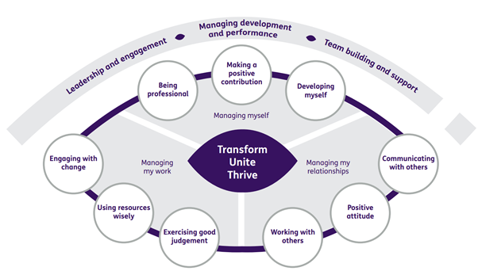

Department structure (this role outlined in red)

