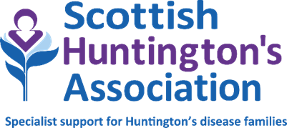

**APPLICATION FOR EMPLOYMENT**



**EQUAL OPPORTUNITIES STATEMENT**

The Scottish Huntington’s Association (SHA) is committed in it’s pursuit of equality of opportunity for all and to a pro active and inclusive approach to equality which supports and encourages all groups, promotes an inclusive culture and values diversity.

The SHA is therefore committed to a policy and practice which actively promotes equal opportunities in the provision of services, employment of staff and volunteers and in all of it’s activities and eliminates discrimination at all times.

The SHA’s objective is to provided equality of access to and provision of services so that no person receives less favourable treatment on the grounds of sex, disability, marital status, age, race (including colour, nationality, ethnic or national origin) sexuality, responsibility for dependants, political party, trade union membership or activity or who are disadvantage by conditions or requirements which cannot be shown to be justifiable.

**We do this through:**

* Promotion of equal opportunities
* Promotion of good relations between people of different racial groups, of different sex, disabled and non disabled groups
* Have due regard to eliminate discrimination on the grounds of race, sex, disability and all other grounds set out in this statement on equal opportunities
* Subject our policies to continuous assessment in order to examine how they affect all groups and to identify whether our policies help to achieve equality of opportunity and ensure there is no unintended bias
* Promotion of an inclusive culture, good practice and the development of best practices, policies and training
* Take positive action to support this policy
* Disseminate this policy widely amongst staff group, volunteers, and service users
* Consultation with service users
* Monitor of our existing service to ensure that specific services are made to the needs of groups covered by the policy
* Through assessment of clients needs on referral and during review to ensure those specific needs of clients/service users are equally and proactively pursued
* Training and development of staff volunteers in the application of equal opportunities is actively supported by the association
* All staff and volunteers are actively encouraged to endorse the values and principles statement of the Association
* The SHA requires all staff volunteers and members to work within the philosophy of the equal opportunities policy
* Promoting equal opportunities for everyone is a key priority of the association

1

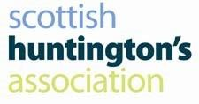**APPLICATION FOR EMPLOYMENT**

**STATEMENT OF VALUES & PRINCIPLES**

The Scottish Huntington’s Association (SHA) is a Scottish Voluntary Organisation which was formed to provide a Scottish support network and specialist advice for individuals and families living with Huntington’s Disease (HD). We aim to raise awareness through Information and Education.

The Scottish Huntington’s Association is committed to improving the quality of life for people living with or affected by HD in Scotland. We seek to uphold the following values and principles in all of our work.

Respect for the privacy and confidentiality of the individual and family living with HD



The right of HD individuals and families to exercise choice



Respect for the individual’s dignity and self worth



The promotion of non-discrimination regardless of gender, race, language, religion, disability or background



The involvement of users, carers and HD families in organisational and service planning and development



**These underpin the SHA Strategic Service Aims and Objectives which are the provision of:**

A range of care & support services for those living with HD



Emotional and practical support for people whose lives are affected by HD



Someone to talk to confidentially outwith the family environment



Liaison with other agencies to help empower individuals to obtain or access other relevant services



Specialist information and assessment advice on HD



Advice, education and training for professional care providers



The promotion of greater public awareness of HD



Group activities and discussion forums on all aspects affecting HD families



Social interaction and support from other families living with HD



Research updates on HD



Advice on HD Management



2