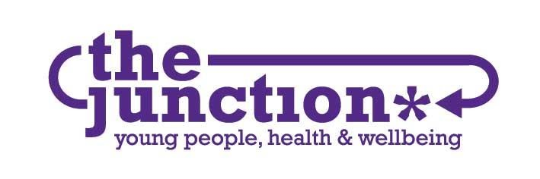

**JOB DESCRIPTION**

|  |  |
| --- | --- |
| **POST** | Director |
|  |  |
| **BASE** | 82 - 86 Great Junction Street, Edinburgh, EH6 5LL |
|  |  |
| **HOURS** | 28 hours |
|  |  |
| **CONTRACT** | Permanent |
|  |  |
| **SALARY SCALE** | £45,000 per annum full time, £36,000 pro rata |
|  |  |
| **MANAGEMENT** | Reports to the Chair, accountable to the Board of Trustees |

The Junction is an award-winning organisation established in 2005 which provides a wide range of health-related services, education, information and advice to young people in North-East Edinburgh. Everything we do is focused on helping young people to achieve their full potential. Our Mission is to work with young people to support their health and wellbeing by helping them to explore and make their own life choices.

The Junction was founded on the principle that services for young people based in the community should be accessible, connected and able to meet a range of needs. We do this by taking a holistic approach towards each young person engaging with The Junction, understanding that there are different factors influencing their lives and allowing them to engage at an appropriate level in their own time.

Aims

At The Junction, we are always improving and adapting to meet the needs of young people. We do this by:

*Support*

Our key purpose is to provide accessible, relational services to young people, and our holistic approach allows us to provide the best services. Support also extends to the staff and volunteers that provide services and the community we work in.

*Listen*

Listening to young people and involving them in our plans is priority and we extend this listening ear to staff, volunteers and others.

*Learn*

From our listening activities and other actions, we learn what works well and what needs to improve. Learning is a two-way and continuous process and involves sharing our learning with others.

Approach

We have four main approaches underpinning our values:

1. Holistic and flexible

To be supportive, holistic and universal, as we believe health issues are inter-related. To ensure we do this and to align our work with our values, this requires a flexible approach. This means everyone gets the right support at the right time.

1. Rights-based

We subscribe to the United Nations Convention of the Rights of the Child (UNCRC) and endeavour to honour all aspects of it, ensuring inclusion and social justice. This means empowering people to know and claim their rights and increasing the ability and accountability of individuals and institutions who are responsible for respecting, protecting and fulfilling rights. This relates to ourselves and others.

1. Assets-based

We build on the strengths, knowledge and experience of young people, staff and others in the community. We believe everyone is the experts in their own lives. This means young people are not passive users of services - they contribute to their support, the organisation and the local community.

1. Peer-based

Peer working is a way of working that seeks to see everyone as a whole person, support authenticity and working collaboratively to try and establish less hierarchical decision making. This is a challenging and exciting way of working that is constantly evolving.

**PURPOSE OF THE ROLE**

The Director role is a driving force within The Junction. Through strategic leadership, strong relationship building and inspiring our dynamic and hard-working team they are vital in delivering our Strategic Plan. Working with the Board of Trustees, the Director ensures responsibility of Financial and Operational leadership of our services.

Leadership:

* Establish and lead the strategic direction of The Junction to ensure its future success by developing and delivering a strategic plan that translates this vision into every area and service of The Junction.
* Demonstrate overall responsibility for the services provided by The Junction through leadership and good management of resources, staff, data and systems.
* Take responsibility for the governance and managing risks of The Junction through strong and effective relationships with the Board of Trustees.
* Ensure the development of The Junction’s services are aligned and within the context of policy frameworks and local strategies relevant to young people.
* Facilitate, embed and evaluate a peer-based working model within the organisation.

Relationships:

* Develop and maintain effective working relationships with all relevant local authority departments, local community groups and young people.
* Lead effective partnership work with other agencies and key stakeholders.
* Determine service targets and develop The Junction’s services in consultation with the Board, staff, young people and funders. This will include planning and implementing programmes based on young people’s needs.
* Supporting the 10 members of staff and managing internal relationships with a person-centred approach.

Operations:

* Oversee the implementation of The Junction’s operational plan.
* Implement the monitoring, review and evaluation of the ongoing effectiveness of the work carried out by The Junction.
* Ensure The Junction has robust monitoring systems and processes in place.
* Provide funders with the information required to fulfil The Junction’s funding obligations.
* Design and implement The Junction’s annual budget plan and oversee the effective financial management of the organisation.
* Use knowledge and experience of charity fundraising in Scotland to bring in new funding streams and maximise funding opportunities for The Junction.

**REPORTING RELATIONSHIPS**

The Director will report directly to the Board of Trustees.

The Director will have the following line management and supervision responsibilities:

* Project Worker Team Lead
* Counselling Team Lead
* Administrator
* Fundraiser
* Bookkeeper

Together with reporting duties, the Director will be responsible for providing general support to our 12 members of staff.

If you would like to find out more about The Junction, please visit us at <https://the-junction.org/>