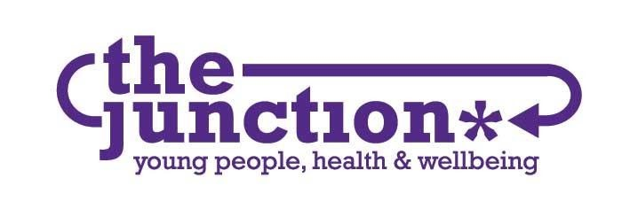

**Our Vision and Mission**

*The Junction’s Vision is for all young people to reach their full potential.*

The Junction contributes to this vision through our Mission:

*The Junction works with young people to support their health and wellbeing by helping them in exploring and making their life choices.*

**Beliefs and Values**

All our activities are based on our Beliefs and Values.

**We believe:**

* in social justice/inclusion and in the UN Convention on the Rights of the Child
* in taking a holistic approach to young people’s health and wellbeing
* young people are contributors rather than consumers
* in supporting rather than stigmatising
* young people are community assets and should be valued and respected
* young people can be the experts in their own lives
* services are there to serve people not the other way round
* in flexibility in response to issues
* health and wellbeing is a fundamental factor to young people achieving their full potential
* in building on the strengths of young people
* in using and contributing to evidence of what works

**We value:**

Equality and Diversity

Nurturing

Integrity

Community

Creativity

Transparency

Consistency

Collaboration

Objectivity and Open-mindedness