

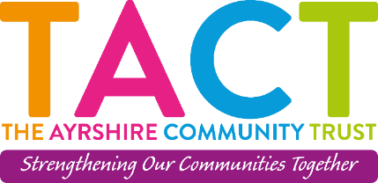
The Ayrshire Community Trust
Job Description:

Job title: Project Worker
Contract: Temporary Contract 18 Months with potential of extension depending on funding
Hours: 30 hours per week
Salary: £21,804 to £24,117 (depending on experience)
Please Note: Normal working week Monday-Thursday with occasional evening and weekend work
Location: 27 Vernon Street Saltcoats, KA21 5HE
Responsible to: Lead Employability Worker
Main purpose of the role: As Project Worker you will be required to create and deliver a structured programme of Employability related activities with administration duties.
Responsibilities and Job Specifics
As Project Worker, you will be responsible for:
- Delivery
- Quality
- Development
Delivery
- Assess individual learners’ progression needs
- Lead workshops sessions to prepare volunteers for progression e.g what opportunities are available, Volunteer Work Placements relevant to interests, etc
- Promote project to potential recruiters, partner services, placements and delivering presentations.
- Work 1:1 and in groups with Volunteers
- Monitor and record progress of individual learners up date online systems
- Support other team members
- Work to agreed targets and strategies
- Liaise with partner services to support the partnerships and learners progression

Quality
- Increase number of progression outcomes from current average
- Ensure reporting is of the standard and timeframe required
- Maintain professional relationships with staff, Volunteers and external companies
- Set a good example in terms of dress, punctuality and attendance
- Be proactive in matters relating to Health and Safety and Child Protection
- Report any concerns to Lead Employability Worker
- Administer and maintain resources
- Attend supervision, team meetings and staff days
- Obtain and review feedback from Volunteers regularly
- Up hold The Ayrshire Community Trust codes of conduct practices

Development

- Be Proactive and innovative in devising new routes of progression
- Review and develop current work experiences and practices
- Share new ideas and practices to enhance provisions
- Fully participate in creative meetings and discussions towards development
- Respond to team and organisational developments as required
- Develop new relationships with local organisations and Partners
- Initiate new strands of progression opportunities for Volunteers
- Support internal colleges and external partners in the developing and delivering of employability programme

Please note the closing date is Thursday 20th April at 5:00pm



