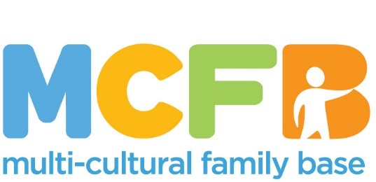

**50 Coburg Street, Edinburgh EH6 6HE**

**JOB DESCRIPTION**

**JOB TITLE Project Worker: Bright Choices Project**

**RESPONSIBLE TO Senior Project Worker: Bright Choices Project**

**JOB PURPOSE:** The successful applicant will have a good knowledge and understanding issues of Honour Based Violence and its impacts, and a commitment to protecting children and young people by recognising, assessing and responding to risk.

**MAIN DUTIES AND RESPONSIBILITIES**

* To provide a range of practical and emotional support to individuals and families identified as being vulnerable
* To work with individuals and families in their homes as well as in the community or at MCFB
* To work with adults, children, young people and their families to assess needs
* To provide one-to-one and group work support as appropriate to children, young people and adults
* To ensure that the needs and progress of all service users are evaluated and recorded
* To provide progress reports on the work
* To maintain accurate and up-to-date records in accordance with MCFB’s Confidentiality and Recording Policy and other relevant policies
* To undertake initial assessments of service user’s well-being and to regularly review support in order to measure the impact of the provision
* To facilitate Creative Nurture Group once a week for Bright Choices service users in collaboration with an Art Therapist
* To maintain communication with service users and to promote their involvement in the project
* To work at all times in a respectful, collaborative and open way with service users
* To liaise with statutory and voluntary agencies who provide services, including schools, health services, police and social work services
* To liaise with other agencies providing services to Black, Asian and Minority Ethnic communities
* To signpost service users to other agencies where appropriate
* To raise any potential child protection concerns with the CEO/Deputy or appropriate Duty Senior
* To promote the work of MCFB and disseminate information about available services
* In conjunction with the Senior Project Worker to report on the progress of the project for funders and others
* Any other relevant duties which may be necessary including if relevant, the supervision of volunteers, sessional staff and students ( either as a link supervisor or as a practice teacher if the worker has an appropriate Practice Learning qualification)