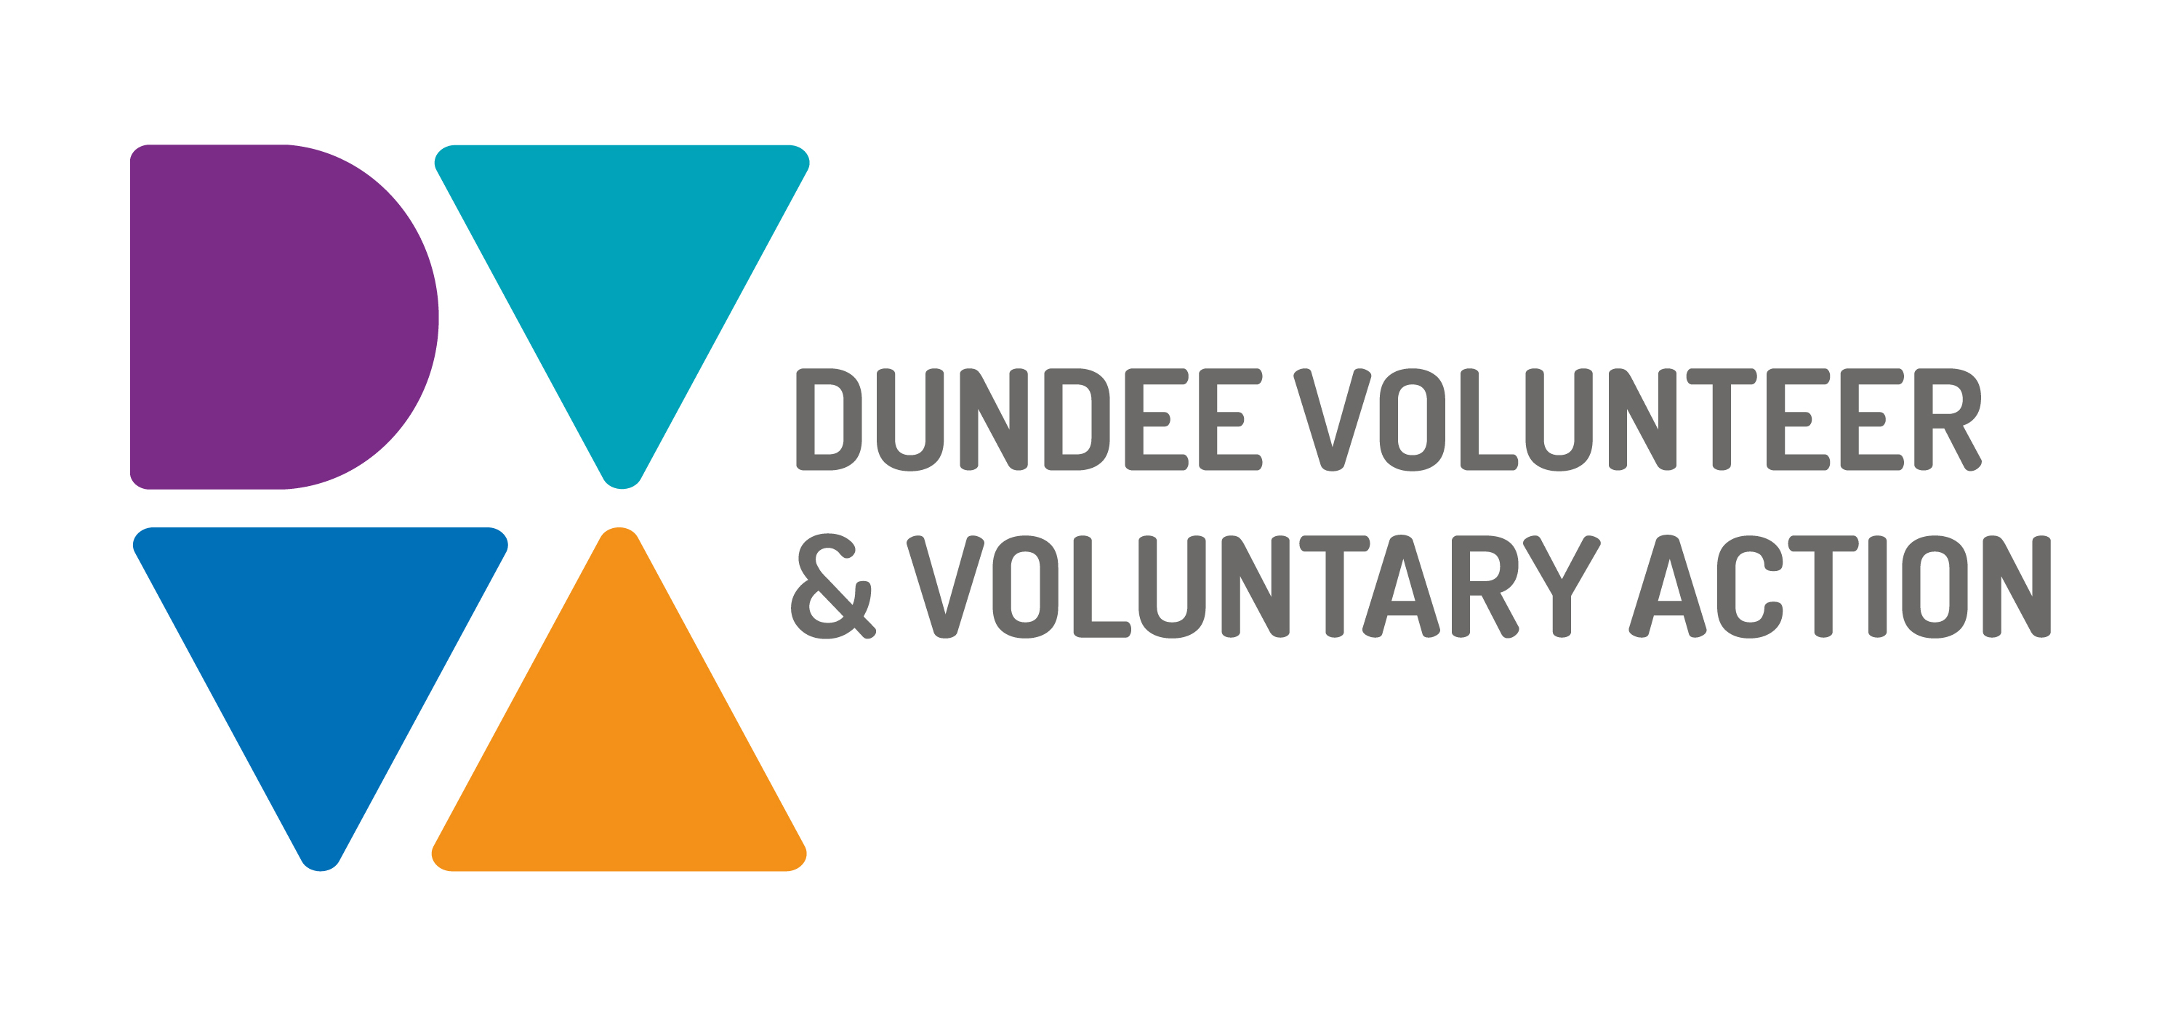
Job Description and
Person Specification

POST TITLE: People and Culture Manager

DURATION: Permanent

HOURS OF WORK: 28 hours per week (0.8 FTE), to be worked in accordance with DVVA Conditions of Service

SALARY: Grade 5 - £28,917 - £32,130 FTE

PURPOSE OF POST: The People and Culture Manger will be responsible for the development and implementation of DVVA’s People and Culture Strategy, aligned with the core values and commitments laid out in its Strategic Plan. To develop the talent of its workforce and provide HR advice to staff as and when required.

MAIN DUTIES:

Strategy
- To facilitate the development of and implementation of DVVA’s
People and Culture Strategic Plan.

Talent Development
- To grow and develop the talent base of the workforce through the
development of a training matrix for all staff to access across the organisation.

Organisational Development
- Continue to seek improvements for the workforce.
- Conduct a staff questionnaire annually to gauge job satisfaction and
Working conditions with all staff and managers with the intention of continually improving conditions and staff benefits.
- Contribute to the strategic development of DVVA, advising the Senior Management team on areas of development for the workforce.

People
- To develop policies and procedures in line with Employment Law,
Health and Safety Legislation and the organisation’s goals and values
- Regularly monitor and review all policies and procedures and
implement changes or improvements where necessary.
- Provide expert advice and guidance on the resolution of employee Relations.
- Advise and support managers on a broad range of workforce challenges such as, staff absence levels, discipline, grievance and performance management.
- Set up & monitor processes which ensure that candidates and
employees enjoy a seamless journey through the employee lifecycle
- Lead on the promotion of health and safety within DVVA, ensuring
compliance with relevant legislation and training is accessed by staff where required and policies and procedures are regularly reviewed and updated where necessary.

Senior Management Team Reporting
- Produce a weekly People and Culture Update for Senior Management Team and as quarterly report for the Trustees.
- To manage and develop the DVVA employee database. Ensuring
records are up to date and held in line with GDPR.

Line Management
- You will be responsible for the line management of the Office
Manager.

OTHER DUTIES
The job description is a broad picture of the post at the date of preparation. It is not an exhaustive list of all possible duties as it is recognised that jobs change over time. Should the duties change radically then the post and grading will be reviewed.

CONDITIONS OF SERVICE
- These are set out in the organisation’s staff handbook.
- All staff meeting the qualifying criteria may join a defined contribution pension scheme provided by TPT Retirement Solutions.
- The organisation has an equal opportunities policy and seeks to be an equal opportunities employer.

STAFF BENEFITS
- Pension Scheme 5%
- Annual leave – as set out below
- Flexible working arrangements
- Opportunities for hybrid working
- Access to the Discovery Credit Union
- Opportunity to Join Unite Union
- Looking to add more..

ANNUAL LEAVE: 21 days per annum on appointment increasing each year by 1 day to a maximum of 25 days, plus 6 public holidays, plus 5 days Christmas closedown. Pro-rata for part-time staff.

LOCATION: There may be an option for the post to be a blend of home and office working in future. Our main office is based in Dundee city centre and we also have community locations in Lochee and Whitfield.

TRAINING: Staff may make application to pursue appropriate training.

JOB DESCRIPTIONS are reviewed from time to time.

Person Specification

 | Essential | Desirable

Professional/Educational Qualifications
Qualified to degree level plus 3 years’ experience working in a similar role | x
Associate membership of the CIPD , or higher (MCIPD, FCIPD) |  | x
Knowledge and Experience
Experience developing policies and procedures | x
Good knowledge and understanding of Employment Law | x
Experience of working with personal and sensitive data, in compliance with GDPR regulations. | x
Experience of managing HR system in line with GDPR requirements. | x
Knowledge of health & safety legislation and experience working within its remit | x
Knowledge of Disclosure Scotland (PVGs, Disclosures) | x
Experience of managing staff | x
Experience in the design, delivery and evaluation of training courses / workshops |  | x
Experience of Project Mangement |  | x
Experience of working in the voluntary sector |  | x
Good working knowledge of Change Management and Continuous Improvement |  | x

Skills and abilities
Excellent communication skills, both oral and written | x
Excellent organisational skills | x
Strong interpersonal skills, with the ability to establish and maintain internal and external relationships effectively | x
Proficient with Microsoft 365 software, including Outlook, Teams, Excel and Word. | x
Practical, logical and innovative approach to problem solving | x
Proven skills in influencing, communication and working collaboratively with internal and external colleagues, building professional networks to enhance organisational profile | x

Personal Qualities
Self-motivated, and able to motivate others | x
Highly innovative and experienced in designing new systems and processes | x
Committed to continuous professional development | x
Flexible approach with an ability to meet deadlines | x
Commitment to equal opportunities | x

Additional Job-Related requirements
Satisfactory basic disclosure check | x

