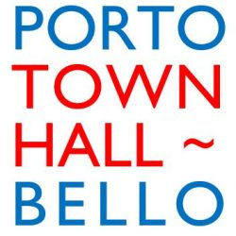

**Portobello Central**

Application Form

**Role: Portobello Town Hall Venue Manager**

The first page of this application form will be removed and not be seen by the recruitment team.

**First Name**

**Surname**

**Address**

**Email:**

**Telephone Number**

Please tell us if you consider yourself disabled. If so, are there any adjustments we need to make to enable your participation in this recruitment process?

Would you like to take the role as part of a job share?

Where did you find out about the job advert?

Are you eligible to work in a paid capacity within Scotland?

If successful, please tell us when you’d be able to start.

**Tell us about your relevant education, qualifications and training.**

|  |  |  |
| --- | --- | --- |
| **Awarding Institution** | **Qualification Gained** | **Renewal needed?** |
|  |  |  |
|  |  |  |
|  |  |  |
|  |  |  |
|  |  |  |
|  |  |  |

**Employment History**

Tell us about your key jobs over the last **five** years. These could be in a paid or voluntary capacity.

**Current job:**

|  |
| --- |
|  |

**Previous roles:**

|  |  |  |  |
| --- | --- | --- | --- |
| Employer | Role | Key Responsibilities | Reason for leaving |
|  |  |  |  |
|  |  |  |  |
|  |  |  |  |
|  |  |  |  |

In a few sentences, please tell us why you would like this role:

|  |
| --- |
|  |

On no more than two sides of A4 please tell us how your skills, qualifications and experience to date make you the right person for the job. We’d like you to draw on our job description for support here.

|  |
| --- |
|  |