

Job Description

Role Title: | Facilities and Fleet Administrator
Department: | Facilities
Reports to: | Facilities Manager
Pay Grade: | Pts. 21-24
Type of Contract: | Permanent
Normal place of work: | Head Office, Edinburgh
Line Manager? | No
Budget Holder? | No
Criminal Record Check/PVG required? | PVG
Driving license for UK driving required? | Yes - attends meetings in locations away from normal place of work, many of which are not readily accessible by public transport.

Who we are

The impact of vision loss is huge. Too often, it leads to people lacking or losing confidence and independence. People with vision loss are at higher risk of unemployment, isolation, mental health problems, and financial challenges. It can have an enormous emotional toll. But with the right support, people with vision loss can gain the skills to remain independent and active in their communities – to thrive. That’s why we’re here.

For 230 years, Sight Scotland and Sight Scotland Veterans has been supporting people impacted by vision loss. We believe we play an important role in continually shifting the conversation around sight loss, and contributing to achieving a fair, equitable society. Over the years, we’ve seen a positive shift in expectations, with individuals and communities increasingly empowered to live lives the way they choose, free of discrimination.

And we’ve had to transform too, so that our services reflect the times we live in and meet the changing needs of the people we support. We’re now looking at how we continue to evolve, considering how we contribute now and what we could do differently in the future.

What this job is about

The post holder will assist the Head of Estates and Buildings and Facilities Manager to ensure excellent standards of facilities management. Responsible for ensuring the smooth running of our fleet of vehicles. First point of contact in the Facilities Department. You will also act as a Fire Marshall and a nominated First Aider for the building.

What we want you to be responsible and accountable for

- Manage a fleet of vehicles;
  - Ensure all company vehicles have an MOT.
  - Ensure all company vehicles are serviced in accordance with manufacturer’s instructions.
  - Book company vehicles into garage for repairs as required.
  - Liaise with driver and insurance company in the event of vehicle accidents.
  - Keep insurance database up to date with fleet registration numbers.
  - Liaise with RAC regarding breakdowns and recovery of vehicles.
- Act as first point of contact in the Facilities Department.
- Be the main point of contact for calls/emails regarding Building and Estate maintenance, liaising with Facilities Manager and Maintenance Supervisor calling appropriate contractors when required.
- Monitor, respond to and update the online Facilities Helpdesk.
- Manage net2 access control system.
- Issue, amend and delete access fobs as required.
- Access and review CCTV when required.
- Manage the reception function at Robertson Avenue for the Sight Scotland / Sight Scotland Veterans Head Office and Scottish Braille Press joint reception.
- Provide reception cover when required.
- Issue purchase orders for supplies and works
- Process invoices coding to appropriate cost centers and expense heads
- Process credit card statements for Estates and Buildings Department
- Manage filing systems for the Estates and Buildings Department.
- Work across all Sight Scotland and Sight Scotland Veterans sites as required.
- Fire Marshall
- Trained first aider

How we would like you to achieve this

We would like you to:
- Work in a way that is wholly consistent with our stated organisational values and our Corporate Strategy
- Be forward thinking and always on the look out for improvements when managing the fleet
- Be inquisitive, willing to experiment and always seeking to strengthen results based on learnings
- Adopt a collaborative approach, working closely with stakeholders
- Be customer and audience focussed
- Be meticulous in forward planning

Who you will be working with

- Colleagues
- Other Sight Scotland services
- Senior Staff
- External visitors and contractors
- Members of the public

The budget you will hold

NA

The experience and skills you need to have to do this job/

Essential:

- Have substantial previous experience of office and / or facilities administration.
- Have substantial experience of managing a fleet of vehicles.
- Have excellent customer service skills.
- Have good time management skills.
- Be able to multitask.
- Be able to evidence excellent MS Office skills.
- Have strong organisational skills.
- Be able to communicate effectively (verbal and written) including having an excellent telephone manner.
- Have experience of working effectively as part of a team.
- Full driving licence.

Desirable:

- Recognised qualification in keyboard associated skills and office management techniques.
- Previous experience as a nominated First Aider and / or Fire Marshall.

Requirements of this role are:

- You are a member of the PVG scheme (paid for by Sight Scotland)
- You will have a 6-month probation period
- That you participate in all staff training and development and maintain your own professional development
- You will wear the appropriate PPE in accordance with current guidance for the role
- You will follow Sight Scotland’s guidance, policies and procedures relating to your own health and safety and that of colleagues and service users at all times
- You will uphold the principles of Sight Scotland’s Dignity at Work and Equal Opportunities policies at all times, working in a way which supports an inclusive work environment that is respectful of differences

Just so you know…

The Charites have a set of Values & Our Ways of Working Framework, we ask you to work within, and these apply to everybody in the organisation irrespective of their role or job. You can find out more here: Our values. This means we want you to have:

- The ability and willingness to understand others’ perspectives and to consider the impact of your actions on them and to adapt your actions as necessary;
- The ability and willingness to learn and try new things, to be flexible and step outside of your comfort zone;

- An open and honest way of communicating, ready to ask others for their ideas and to be open to hear and consider different points of view;

- A pro-active approach to taking initiative and to driving forward ideas and projects designed to improve daily operations and deliver an exceptional visitor experience.

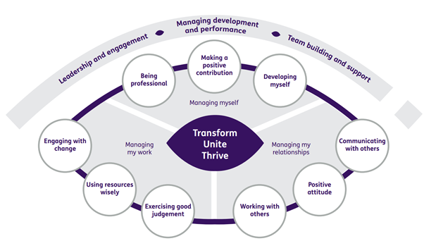

Department structure (this role outlined in red)