Role Profile – Activity Worker

Reports To:
Deputy Centre Manager/Centres’ Manager

Role Purpose:
You will work with our members to maximise the benefit and enjoyment they gain from attending the Centre.

You will assist in the planning, delivering and leading of activities which promote independence and support our members general wellbeing.

All roles within Sight Scotland and Sight Scotland Veterans are expected to work to our values and Our Ways of Working framework:

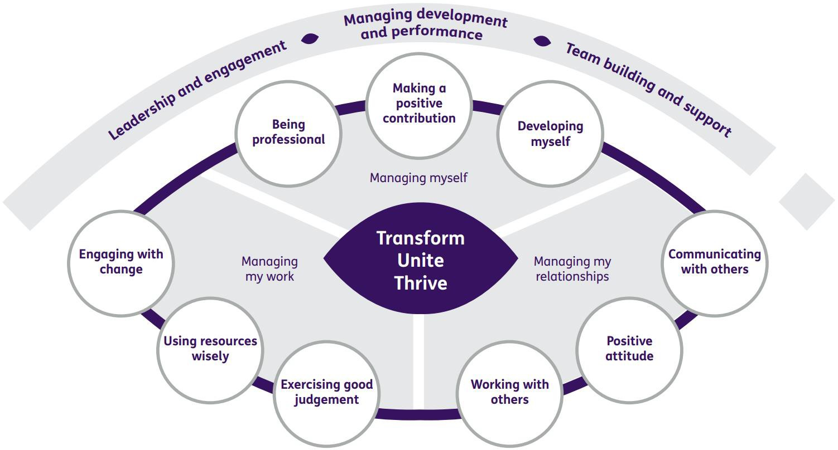

Our Ways of Working – Managing my Work
The main responsibilities and accountabilities of this role are that you will:
- Enable members to maximise the benefit and enjoyment they gain from attending the centre.
- Deliver a service where individuals can maximise their existing skills and abilities and develop new ones.
- Facilitate a range of activities, whether centre or community based, and assist in the development of a creative and responsive activities programme which promotes independence and wellbeing.
- Encourage maximum independence whilst providing a supportive environment
- Provide personal care when required, whilst maintaining dignity. This may include supporting those members who require assistance with toileting and at mealtimes. This will require use of appropriate equipment when necessary.
- Maintain all necessary paperwork/databases.
- Contribute to staff meetings and participate in supervision with the Centres’ manager and/or deputy.
- Ensure that a safe, clean and pleasant environment is always provided.
- Maintain written records and report to the manager/deputy any accident involving members or staff in accordance with Health and Safety procedures and guidelines.

Driving/Escorting duties:

- Responsible for the safe and timeous conveyance of members to and from the centre and other locations as required.
- Ensure that passenger and wheelchair restraint and lifting apparatus are used correctly to maximise member safety.
- To drive within the requirements of current road traffic legislation
- Escort members both on centre and on public/private taxi transport, where required.
- Liaise with colleagues and members to ensure that key information relating to member conveyance is promptly exchanged and is accurate and appropriate.

Our Ways of Working – Managing Myself and Managing my Relationships

To do this role, you will have:

- SVQ level 2 Health and Social Care (or willingness to work towards).
- Current driving licence with a D1 licence or a willingness to undertake a minibus licence test.
- Ability to read, assimilate and explain complex information quickly, verbally and in writing.
- Good IT skills with a good knowledge of Microsoft office packages.
- Ability to use electronic and paper administrative and record keeping systems.
- Excellent time management skills to plan, prioritise and manage workload.
- Ability to work calmly under pressure.
- Ability to adapt to change and respond positively to non-routine situations.
- Ability to plan and organise activities in a work setting and the local community.
- Ability to work on own initiative.
- Willingness and ability to maintain confidentiality.
- Active listening skills.

To do this role, it is desirable if you have:

- Experience of working with the older people in a support setting.
- Recent experience of working with people in a social care or recreational setting.
- Experience of working with people with visual impairments.
- Awareness of Veterans issues.
- Evidence of professional development beyond initial training.

On a day-to-day basis you will work with different people and teams, these could be:
- Families
- Colleagues and Volunteers
- Other Sight Scotland Veterans services
- Other Sight Scotland services
- Senior Staff
- Outside Agencies

Requirements of this role are that:
- You are a member of the PVG scheme (paid for by Sight Scotland Veterans)
- You will have a 6-month probation period.
- That you participate in all staff training and development and maintain your own professional development.
- You have a commitment to empowering visually impaired people to have choice and control over their lives.
- You will promote equality for all of our members.
- You have an understanding of the support needs of visually impaired people.
- You have knowledge of the SSSC Codes of Practice.
- A flexible approach to working hours is expected to reflect business needs.
- You will wear the appropriate PPE in accordance with current guidance for the role.
What we can offer you:
- Generous annual leave entitlement which increases after 4 years’ service
- Generous pension scheme
- Discounts for Carers
- Access to learning and development opportunities
- Employee Perks through the Employee Assistance Programme
- Cycle to Work scheme
- And many more, please visit our website for more information

This job profile is not exhaustive. The duties of the post holder may be reviewed from time to time and the employee may be called upon to work in other locations within Sight Scotland Veterans.

