
Role Profile – Learning Support Assistant

Reports To:
Class Teacher / Principal Teacher

Role Purpose:
You will support the coordination and delivery of the learning and care of children and/or young people with a range of visual impairments and additional complex needs in different learning environments by providing a safe and high-quality environment in which children and/or young people will thrive.
You will work collaboratively with the multi-professional team within the learning and care provision and colleagues across Sight Scotland and Sight Scotland Veterans.
All roles within Sight Scotland and Sight Scotland Veterans are expected to work to our values and Our Ways of Working framework:
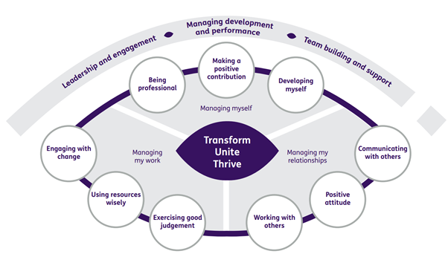

Our Ways of Working - Managing my Work

The main responsibilities and accountabilities of this role are that you will:

- Work in collaboration with the multi professional team.
- Provide individual and small group support as instructed by a teacher both within the school and on outings.
- Follow strategies to support children with visual impairment/complex needs to access their curriculum.
- Contribute to team meetings at the end of or start of the day.
- Contribute to all required paperwork in connection with children’s learning and care.
- Promote a safe and caring environment.
- Escort pupils in the locality of the school
- Assist in taking groups of pupils to other parts of the School and also on visits out of School
- Provide a high standard of personal care including washing, toileting and mealtime assistance.
- Lead and take responsibility for the organisation of resources or development of an aspect of the learning and care provision
- Any other duties as reasonably directed by the School Management Team and/or Director of Services.

Our Ways of Working – Managing Myself and Managing my Relationships

To do this role, you will:

- Be able to demonstrate previous experience of working with children
- Have demonstrable knowledge and an understanding of people with additional support needs
- Deliver personal care in a sensitive manner
- Be able to demonstrate the ability to relate to pupils in a supportive manner
- Be able to demonstrate the ability to work constructively as part of a group
- Have an aptitude to establish creative, co-operative working relationships
- Assist with moving & handling
- Work effectively when under pressure.
- Be able to demonstrate that you can communicate in a way which is clear, honest, constructive and inclusive tailored to the needs of our young people.
- Show initiative and flexibility

It would be desirable if you also:
- Have a basic knowledge of IT
- Are First Aid Trained
- Have previous experience of working with children with a visual impairment
- Have previous experience of working with children with a range of additional support needs
- Have previous experience of working in a school setting
- Have a Driving Licence and a willingness to undertake training to drive the School’s minibuses

On a day to day basis you will work with different people and teams, these could be:
- Families
- Colleagues
- External agencies
- GP’s and medical professionals
- Therapists
- Senior staff
- Other Sight Scotland and Sight Scotland Veterans colleagues

Requirements of this role are that you will:
- Hold a PDA qualification or equivalent
- You are a member of the PVG scheme (paid for by Sight Scotland)
- Have a 6 month probation period
- Take part in learning and development activity relevant to your post including Manual Handling, CALM, epilepsy awareness, gastro feeding and any other relevant necessary training.
- That you participate in all other staff training and development and maintain your own professional development
- You will wear the appropriate PPE in accordance with current guidance for the role, including wearing of face masks, gloves and aprons.
- Be respectful and diplomatic at all times when dealing with others.
- Be aware of equality and diversity issues through curricular activity, in line with Sight Scotland policies and procedures
- Demonstrate professionalism, positivity and integrity in line with Sight Scotland values.
- Contribute to the development of the organisation’s strategic improvement plan.
- Comply with and support all organisational policies and procedures, including Child Protection, Data Protection and confidentiality, Health and Safety and Equal Opportunities.
- Participate in and deliver learning and development activity within the provision and wider organisation.
- Protect and enhance the good reputation of the organisation at all times.

This job profile is not exhaustive. The duties of the post holder may be reviewed from time to time and the employee may be called upon to work in other locations within Sight Scotland.

