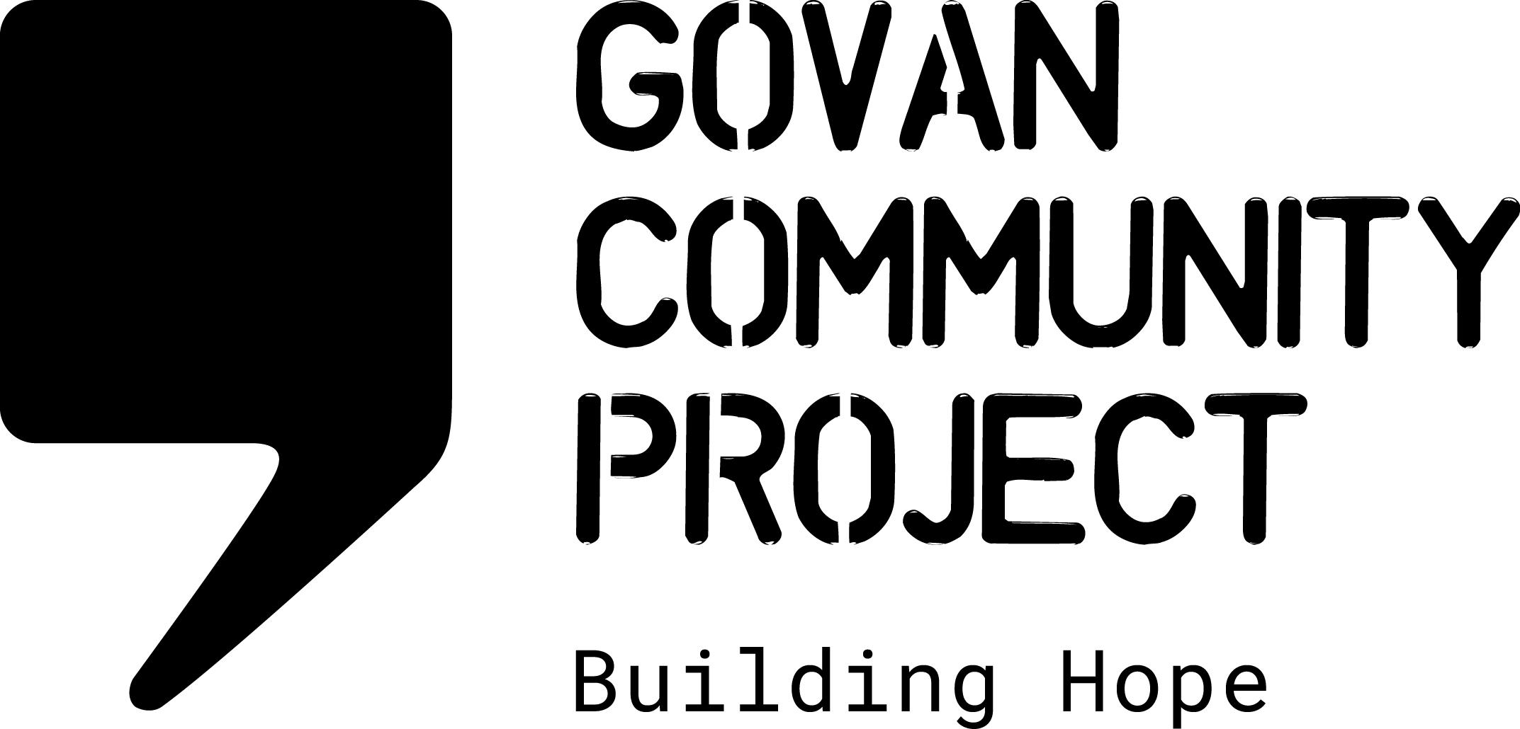
JOB DESCRIPTION

Job Title: | Community Development Manager
Location: | Govan, Glasgow
Hours Per Week: | 28 hours per week – preferably worked Tuesday to Friday
Salary Scale: | £28,366 pro rata
Duration of Post | Fixed Term Post for 2.5 years with possibility of extension dependent on funding
Reporting To: | Head of Charity
Responsible For: | CLD staff team & Volunteers

OVERALL PURPOSE OF THE JOB

Govan Community Project works with individuals and families in the asylum and refugee community, providing a range of holistic activities to support New Scots settling in Glasgow. Our range of support provides both practical supports to help mitigate the impact of destitution, combined with a range of community learning and development activities which empower individuals and families to rebuild their lives and make connections in their local community.

The Community Development Manager’s role will provide operational management of all frontline community development services. This includes: leading a team of community-based workers providing a wide range of support which includes ESOL classes, Homework Club, PAR projects; Men’s Group, Women’s Group, Cycle Library, health and wellbeing activities and support to engage with wider community activities.

The Manager will also be responsible for monitoring and evaluation of the service, and contributing to organisational and national policy developments in relation to supporting New Scots.

We are currently operating a Hybrid working model, with the potential of up to 50% of contracted hours being homebased, however this is at the discretion of management.

MAIN DUTIES AND RESPONSIBILITIES

Frontline Service Delivery

- Line manage, motivate and support a team of CLD staff and where necessary, volunteers/sessional staff
- Development of an operational delivery plan which ensures CLD activities meet the strategic objectives, mission and goals of the organisation
- Support the CLD team to develop individual work plans in line with strategic objectives and workload capacity
- Lead relationships with partner agencies and the local community in community development activities
- Work with the CLD staff team and fundraising officer to identify potential future opportunities for service development

Volunteer support

- Support the team to ensure volunteering opportunities, role descriptions, policies and procedures are inclusive and compliant with health and safety and safeguarding requirements
- Support Volunteer Coordinator to develop a full induction training & development programme for volunteers
- Support the Volunteer Coordinator with selection & supervision of CLD placement students
Monitoring & Reporting

- Coordinate and develop/adapt monitoring and evaluation systems for CLD activities.
- Provide quarterly updates to the Head of Charity on quantitative and qualitative data on engagement levels, activities delivered and case studies
- Provide bi-monthly updates on service delivery for Board Reports
- Develop regular service user consultation and feedback on the CLD service
- Provide the fundraising officer with relevant data including individual feedback for funding reports and proposals as and when required
- Manage allocated project budgets within delegated authority, ensuring all GCP financial protocols are followed

Project Promotion & Development

- Ensure the team provide regular input for social media updates
- Ensure any future development of CLD activities are designed in line with the Strategic Plan, evidence of need and engaging with coproduction principles
- Represent GCP at relevant networking events related to community activities ensuring the needs and priorities for people seeking asylum are represented
- Contribute to local and national policy developments on supporting New Scots in communities
- Engage with relevant local and national causes, research and campaigns (destitution, immigration policy, human rights, poverty etc)
- Identify other development and partnership opportunities for the CLD activities service in line with the Strategic Plan

Management Team Responsibilities

- Work as part of the Management Team to ensure all work is conducted in compliance with GCP policies, procedures and protocols
- Work as part of the Management Team to ensure regular reviews on progress of Strategic Plan
- Work as part of the Management Team to ensure management cover is in place for all activities being undertaken, including those occurring out of regular operational hours.

Other Duties

- Working as part of the staff team to maintain the values and ethos of Govan Community Project
- Adhere to all organisational policies and procedures
- Work with the staff team to contribute towards providing a safe, welcoming, clean and tidy environment for staff and visitors
- Attend meetings and contribute to strategic development
- Perform any other tasks or duties deemed necessary

Occasional weekend or evening work may be necessary
Membership of the PVG scheme or applying for membership is a requirement for this position

PERSON SPECIFICATION

Essential

- A qualification in community learning & development/community education or a minimum of 4 year’s experience working in a community-based setting
- Experience of developing and/or delivering community-based services
- Experience working with both children and adults in a community setting
- Experience of supporting volunteers
- Experience of managing and developing a small team
- Experience of project monitoring and evidencing impact of service delivery
- Experience of working with vulnerable people including following safeguarding procedures
- A commitment to the aims of the organisation
- Knowledge and understanding of social justice, empowerment and integration issues
- Ability to set and manage priorities within a busy workload
- Ability to work on own initiative and as part of a team
- A high level of competence in using database systems, google drive and Microsoft packages
- Excellent interpersonal and communication skills

Desirable

- Lived experience of the asylum process
- Experience of the voluntary sector and inter-agency working
- A good spoken level of a relevant second language, egg Arabic, Kurdish Sorani or Farsi
- Knowledge of local services available to people seeking asylum

