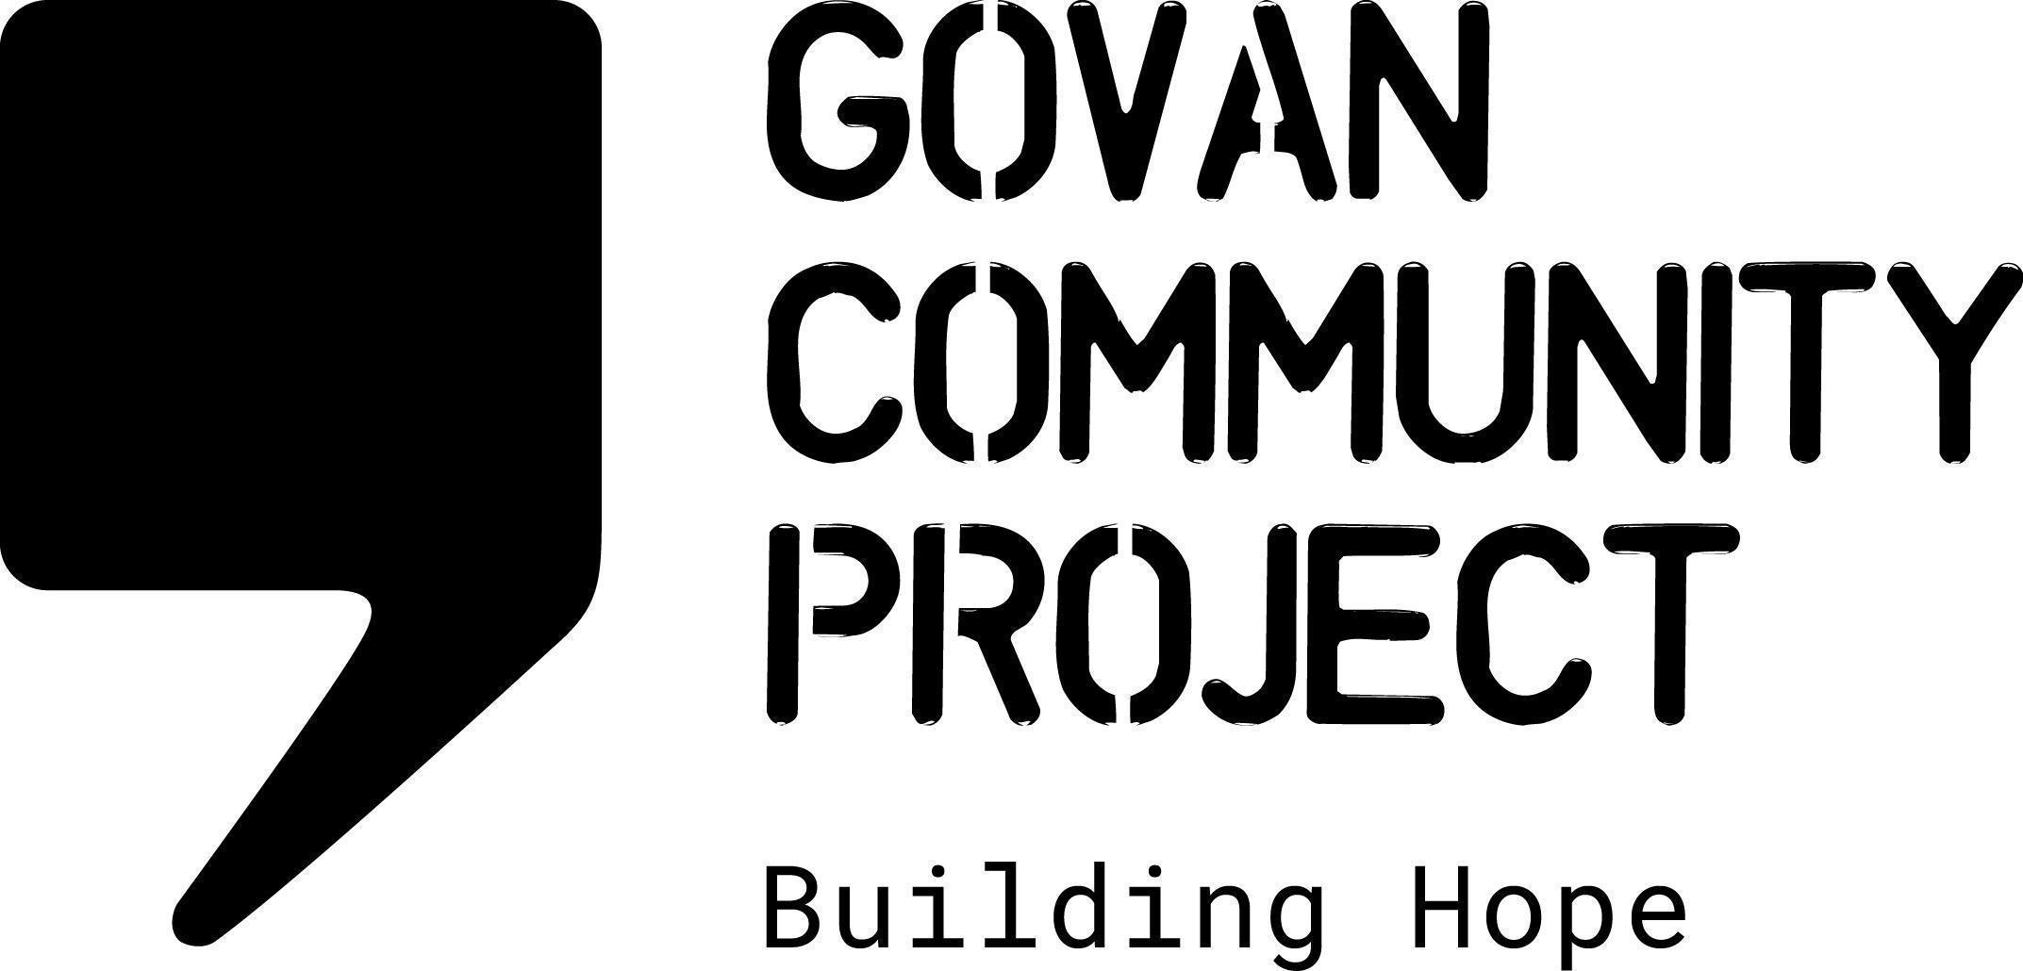
JOB DESCRIPTION

Job Title: | Group Facilitator & Coordinator
Location: | GCP Office, WFH and locations in Glasgow
Hours Per Week: | 14 hours per week
Salary Scale: | £23,634
Duration of Post | 1 year fixed term
Reporting To: | Food Projects Lead
Responsible For: | Food for All group members

ABOUT THE PROJECT
Govan Community Project (“GCP”) is a community-based organisation working in south-west Glasgow. We provide services and support for asylum seekers and refugees, such as advice & advocacy, social groups, English classes and co-production projects. ​Our values are: dignity, equality, collaboration, respect, trust and integrity.

This project engages with a group of experts by experience who have lived experience of the asylum process and food insecurity. The first phase of this project was commissioned by the Scottish Government ‘Tackling Food Insecurity’ Team, to explore the nature of food insecurity experienced by people seeking asylum and assess the current provision of food aid support in Glasgow. The group are now involved in a partnership project with Nourish Scotland delivering a series of workshops for community food providers in Glasgow, which you can read about here: https://www.nourishscotland.org/dignity-in-practice-involving-learning-from-the-asylum-community/

OVERALL PURPOSE OF THE ROLE
Support the Food Projects Lead and Nourish Scotland partners in the design and delivery of the project in order to meet the project aims and objectives. This will involve using Participatory Action Research or co-production methods, coordinating Food for All group activities, and facilitating group meetings and workshops. This post is funded by the Scottish Government Fair Food Fund.
MAIN DUTIES AND RESPONSIBILITIES
- Coordinate the activities of and the Food for All group, supporting the meaningful engagement of experts by experience.
- Work with colleagues and partners in developing and delivering activities for the group.
- Facilitate weekly meetings,either in person or online.
- Provide operational support and administrative tasks for the project.
- Provide regular 1:1 support for members of the group.
- Work with the Volunteer Coordinator on volunteer engagement and opportunities for further development.
- Collect and process data for monitoring and evaluation
- Organise regular consultation and feedback with group members.
- Provide contributions for regular social media and newsletter updates.

OTHER ORGANISATIONAL DUTIES AND RESPONSIBILITIES

- Work as part of the staff team to maintain and promote the values and ethos of Govan Community Project.
- Adhere to all organisational policies and procedures.
- Work with the staff team to contribute towards providing a safe, welcoming, clean and tidy environment for staff and visitors.
- Attend team meetings and contribute to strategic development.
- Perform any other tasks or duties deemed necessary.
- Occasional Weekend or Evening Work may be necessary in this post

ESSENTIAL SKILLS AND EXPERIENCE

- Excellent communication, interpersonal and team building skills
- Knowledge and understanding of Human Rights & Equalities and social justice issues
- Experience working with vulnerable groups
- Experience coordinating a team, e.g. volunteers
- Experience facilitating groups
- Ability to work unsupervised and as part of a team
- Ability to manage a varied workload
- A flexible working approach and excellent time management skills

DESIRABLE SKILLS AND EXPERIENCE

- Experience working with asylum seekers and refugees
- Lived experience of the asylum process
- Community Learning & Development background
- Facilitation Skills
- 2nd language such as Arabic/Farsi

