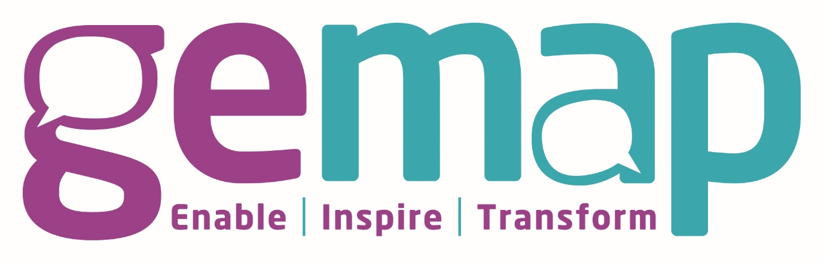

GEMAP Recruitment Pack

The Circle
69-71 Aberdalgie Road
Glasgow
G34 9HJ
01417735850
www.gemapscotland.co.uk
info@gemap.co.uk
Company Number: 372522
Charity Number: SCO23565


Welcome

Thanks for considering joining GEMAP.
The world of advice is changing, just as the world has post lockdowns and restrictions; for advice givers, it provides a range of new challenges and opportunities.
Our Mission
To assist clients in being financially secure and controlling their financial well-being.
By providing highly skilled, motivated, and trained staff
To maximise income and reduce non-essential outgoings by claiming all relevant benefits, grant support, and assist clients with complex or unmanageable debts.

GEMAP are a client focussed organisation where we see the person, not the problem.
We are committed to developing ourselves and the individuals and families we support in a way that puts people at the centre of everything we do.
Our shared values and principles set out our collaborative approach to the design and delivery of services.

Our shared behaviours
Commitment
To be focused on providing high-quality services for our clients and Stakeholders.
Collaborative
To work with all interested parties to ensure the best outcomes for clients
Customer focussed.
Ensuring the highest quality of services for our users using their input.
Lead
Ensure our vision for advice services is articulated and at the centre of strategic developments.

Our principles
Co-Design
Working with partners, staff, and clients to design solutions
Delegated Authority
To create solutions that empower users and colleagues
Evidence Led
To use evidence to inform decision making
Continuous Improvement
To continuously learn and improve what we do

About GEMAP

Working alongside
Glasgow City Council
GGNHSB
Scottish Government
Local RSL's

Working with
GP Practices
Schools
Women's services
Hospitals
Community organisations
Carers organisations
Law centres
Foodbanks
Community pantries
Family support

GEMAP by the numbers

