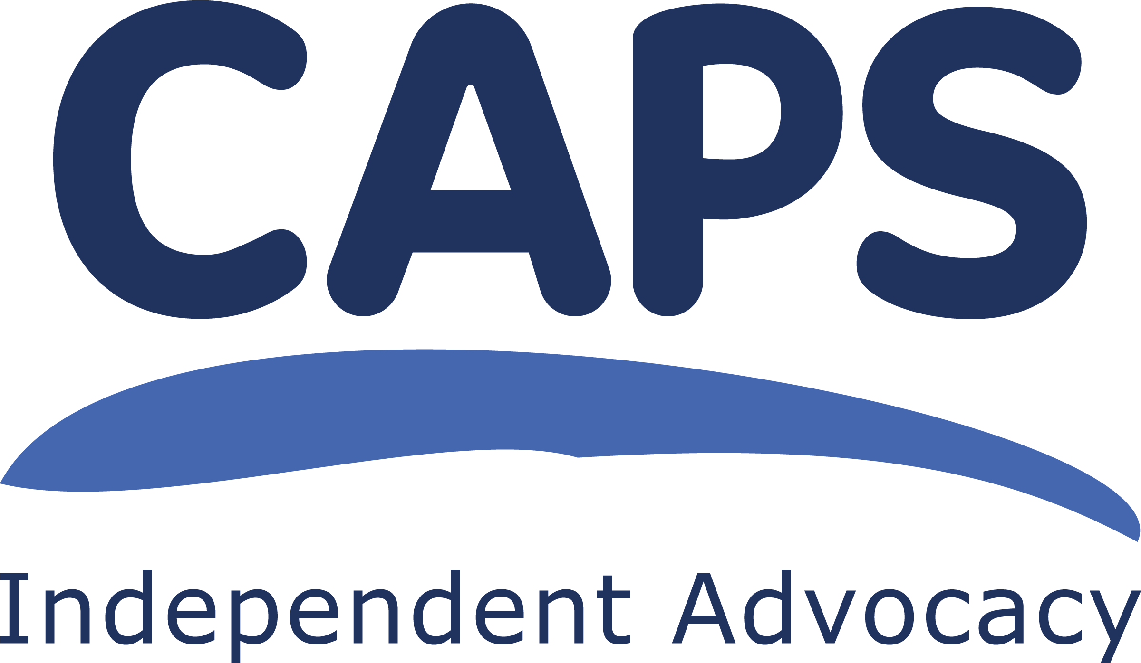
CAPS Independent Advocacy

JOB DESCRIPTION

POST: Collective Advocacy Worker (Edinburgh)

GEOGRAPHICAL REMIT: City of Edinburgh

LOCATION: CAPS office in Edinburgh

HOURS: 24 hours per week (FT week is 36.25 hours)

SALARY SCALE: AP4 (point 27 – 30), £ 25,778 - £ 28,533 p.a.

SALARY: £ 17,067 pro rata

LINE MANAGER: Collective Advocacy Manager

GENERAL PURPOSE OF POST

The main purpose of this post is to enable people who have lived experience of mental health issues to have a say in mental health policy making and the planning and provision of services, through the development and use of collective advocacy.

The focus of the work will be within the City of Edinburgh, working proactively across the four localities of Thrive Edinburgh (North East, North West, South East, South West).

The Collective Advocacy Worker will make policy and planning documents, reports and information accessible to people and assist them to deal with, and respond to, requests for their views as well as campaigning for better services. They will support experience-led research when appropriate and people’s involvement in raising awareness of their experiences to improve the way mental health services are delivered.

The post-holder will liaise directly with professionals, project staff and workers to enable people who use mental health services to play an active part in the development of the services they use.

In addition, a small part of this role will be to support the work of the Collective Advocacy worker ( Peer Community) and assist them in facilitating a collective advocacy group for mental health peer workers and volunteers in Edinburgh as part of CAPS role in the Peer Work Community of Practice, lead by Health in Mind and funded by Thrive Edinburgh.

ABOUT CAPS

CAPS is an Independent Advocacy Organisation which provides Individual Advocacy to people from East Lothian and Midlothian who have mental health issues or are using drugs and alcohol. We provide individual advocacy for children and young people going through the Children’s Hearings process, in these areas. We also provide Individual Advocacy for adults, and for children and young people, experiencing Eating Disorders who live anywhere in Lothian.
We provide Collective Advocacy to groups of people across Lothian with mental health issues, and to Veterans across Scotland, so they can come together and voice their experiences in order to bring about change for others or improvements in services.

The main purpose of CAPS’ work is therefore to assist people, through advocacy, as individuals or as members of a group, to set their own agenda, make their wishes known and to have a say in how they live and what services they use. Visit our website for more details www.capsadvocacy.org

We are set up so that the organisation and its staff are as free as possible from any conflicts of interest. We are independent from the people who fund us and those who provide other services to the people we work with. CAPS is a member of the Scottish Independent Advocacy Alliance (SIAA) and we adhere to the Principles and Standards of Independent Advocacy. CAPS was established in 1991.

TASKS

- make contact and consult with groups and individuals who have lived experience of using mental health services in Edinburgh;

- organise and facilitate meetings with groups and individuals at times that best suit them. These may be online or in person or a mix of both;

- help people get as much information as they want/need to make informed choices and understand their rights;

- use a variety of methods to help people to share and discuss what’s important to them;

- help people take forward the work they have identified as important;

- assist people to attend relevant mental health planning meetings/events and share their experience;

- represent the expressed views and interests of people who use mental health services at meetings where no individuals can attend;

- work closely with staff in the Collective Advocacy team to share learning and exchange of information between CAPS projects to ensure the maximum impact of people’s views and experiences;

- gather information about issues that affect a number of people and carry out further research with interested participants;

- as directed by the people involved, contact and consult with other relevant groups e.g. workers, clinicians, planners of services, educational establishments;

- distribute publicity about Independent Advocacy and CAPS collective advocacy projects;

- raise awareness and understanding about the importance of Independent Advocacy;

- use IT to prepare reports, promotional material, and to gather information, and use databases to manage communication within and outwith the project, adhering to GDPR procedures;

- report on agreed targets: recording, monitoring, reviewing and evaluating the work done.

- prepare and give presentations;

- support people to play an active part in the development of policy and strategic planning and to campaign for better services;

- support people to play an active part in the development and evaluation of services, particularly within the Thrive Welcome Teams;

- build and maintain effective partnerships between people who use services and professionals;

- assist in facilitating the Peer Forum (collective advocacy for mental health peer workers and volunteers) by supporting the Collective Advocacy worker (Peer Community)

- raise awareness of the Peer Forum, planning and facilitating Forum meetings and taking forward issues arising from them as appropriate

General tasks

- work independently, prioritise workload and meet deadlines;

- work alongside other Collective Advocacy staff as required as part of the CAPS staff team and contribute to the smooth running of the office;

- have a commitment to and ensure the practical application of CAPS’ policies and procedures;

- be aware of boundaries in all the relationships established in carrying out this work;

- ensure that your actions and work behaviours meet the standards set by CAPS;

- ensure all your work behaviours display an anti-racism approach and challenge any prejudice and discrimination shown to people with protected characteristics.

- any other duties deemed relevant to the post.

CONTACTS

- people who use mental health services and other members of the public;

- mental health peer workers and volunteers;

- mental health service policy makers, planners and commissioners;

- mental health service providers;

- staff from other advocacy organisations;

- other CAPS staff, volunteers and Management Committee members

MANAGEMENT
You will be line managed by the Collective Advocacy Manager. You will be ultimately accountable to the Management Committee and will be expected to report to them when required. You will also take part in team meetings with other CAPS’ staff.

LOCATION
This post is based primarily in CAPS office in Norton Park, Edinburgh, however, you will be expected to work from CAPS head office in Musselburgh on occasions. These locations may be subject to change in the future and you would be required to work in any CAPS office in Lothian. You may work from home from time to time depending on work responsibilities. You may need to travel throughout Lothian and occasionally outside these areas. Travel expenses will be reimbursed in accordance with CAPS’ Expenses Policy.

FUNDING
This post is funded by the City of Edinburgh Health and Social Care Partnership and is subject to continued funding.

EMPLOYER
Your employer will be CAPS’ Management Committee.

TRAINING
You will be expected to participate in training and personal development as identified through supervision with your line manager. You may also ask for particular pieces of training. It may not be possible to approve a particular piece of training if we do not have the resources.

WORKING HOURS

Some evening or weekend work is possible and if required, would be accommodated into the contractual hours.

HOLIDAYS

30 days annual leave plus 5 fixed and 6 floating public holidays, pro rata.

MISCELLANEOUS
For the good of CAPS, all staff have a duty to be flexible enough in their working practice to support the work of other functions within the organisation.

This post will be subject to membership of the Protecting Vulnerable Groups Scheme (PVG Scheme) and appropriate check.

CAPS is a Scottish Charitable Incorporated Organisation. Scottish Charity number SC021772

