

**Ayrshire Hospice Circular**

**Terms and Conditions 2023/01**

|  |  |
| --- | --- |
| Dear Colleague  **PAY AND CONDITIONS – PAY INCREASE 2023/24**  **ALL EMPLOYEES (WITH THE EXCEPTION OF MEDICAL STAFF)**   1. **Summary**   This circular informs changes in the pay for all hospice employees (with the exception of medical staff). The pay award is to be included in April salaries and is effective from to 1st April 2023.   1. **Changes from 1st April 2023**   Most staff will receive a consolidated average uplift of **c6.5%** with a floor of **£1,548** and a cap of **£3,755** and with an effective date of 1st April 2023. A full list of the scale points to be applied under the terms of this pay increase from 1st April 2023 are set out in Appendix A and Appendix B (Retail 40 hour)   1. **Scottish Living Wage**   The Ayrshire Hospice reflects the Scottish Living Wage rate and as such a minimum salary of **£23,240** will be applied to the pay structure. This reflects an hourly rate of **£11.92** per hour.   1. **Action**   HR will ensure recruitment advertisements and new employment contracts or contract variations reflect the above detailed changes. Finance will ensure payroll is processed reflecting the new pay scales.   1. **Terms and Conditions**   For 2023 only, an additional holiday to be taken at any time during the year has been awarded to celebrate the Kings coronation.  The temporary increase to mileage claims will revert back to 45p per mile with effect from the 1st April. Mileage incurred in march and claimed in April will be paid at the increased rates. All future mileage expenses will be paid at the original rate.   1. **Queries**   Employees should direct any queries to their line manager in the first instance or to their HR Partner.  Yours sincerely  **Liz Denovan**  **Liz Denovan**  **Director of Operations** | 1st April 2022  For action  Head of HR  HR Team  Head of Finance  Payroll  For information  Executive Leadership Team  Operational Managers |

**Pay Scales and Pay Points from 1st April 2023**

**Appendix A**

**Ayrshire Hospice Payrates at 1st April 2023**



**Appendix A**

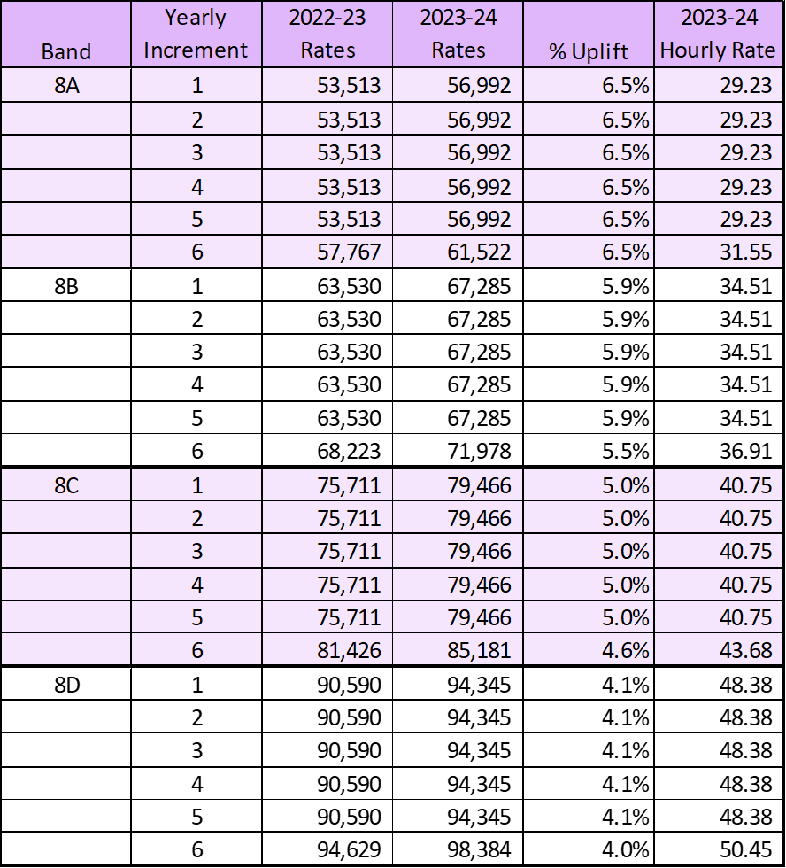

**Appendix B**

**Pay Scales and Pay Points from 1st April 2023 – 40 Hour Contracts (Retail)**

