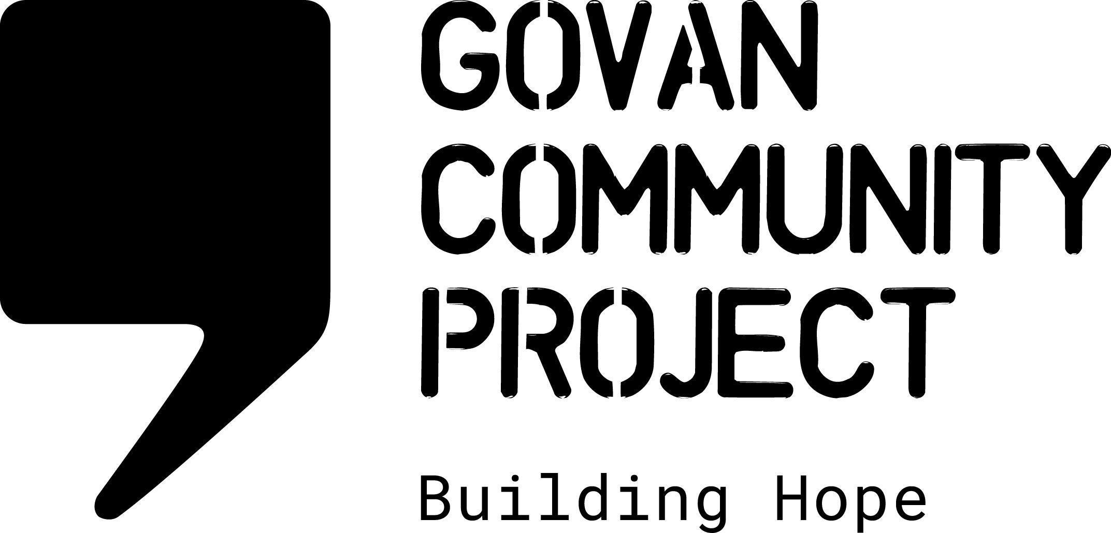
JOB DESCRIPTION

Job Title: | Outreach Caseworker Caseworker
Location: | Govan Community Project office in Govan and 1 day per week in Cranhill Development Trust
Hours Per Week: | 28 hours per week
Salary Scale: | £23,634 pro rata
Duration of Post | 1 year Fixed term post (extension possible subject to funding)
Reporting To: | Asylum Support Service Manager
Responsible For: | Working with the casework team to provide advice and advocacy to asylum seekers accessing Home Office support

OVERALL PURPOSE OF THE JOB

To provide an outreach casework support service 1 day per week in the East of Glasgow, in partnership with Cranhill Development Trust.
To work with a team of caseworkers to provide destitution advice and to advise, support and empower people in the asylum process to access Home Office support and other local community based services.

MAIN DUTIES AND RESPONSIBILITIES

Asylum Support Service Delivery
- Offer face to face asylum support casework appointments 1 day per week from Cranhill Development Trust.
- Deliver direct casework duties: provide advice and advocacy to asylum seekers on accessing Home Office support
- Provide destitution advice for those who are not currently eligible for Home Office support, including applying for destitution grants and assisting clients to access emergency accommodation.
- Work in a person-centred manner to identify additional needs, for example, completing social work referrals or assisting with accessing health care
- Signpost community members to relevant local services
- Work with, and occasionally supervise, casework volunteers
- Input accurate and up to date information and case notes on our database
- Keep up to date on asylum support, policy changes and local services
- Work in partnership with other refugee support agencies in Glasgow
REPORTING

- Assist the service manager to conduct regular service user consultation and feedback on the advice and advocacy service
- Work with the service manager and colleagues to ensure services are delivered in compliance with OISC regulations
- Contribute to local and national policy developments on immigration policy and asylum support
OTHER DUTIES

- Working as part of the staff team to maintain the values and ethos of Govan Community Project
- Adhere to all organisational policies and procedures
- Work with the staff team to contribute towards providing a safe, welcoming, clean and tidy environment for staff and visitors
- Attend meetings and contribute to strategic development
- Attend training as required and share learning with the wider team
- Perform any other tasks or duties deemed necessary

PERSON SPECIFICATION

Essential

- An excellent working knowledge of Home Office support available to asylum seekers
- Experience of completing Home Office support applications (section 4, section 95 and section 98)
- Experience of working with vulnerable people, people in crisis situations and people experiencing destitution
- Experience of advocating on people’s behalf to ensure fair access to statutory services
- A commitment to the aims of the organisation
- Experience of working with interpreters
- Knowledge and understanding of social justice, empowerment and integration
- Ability to prioritise tasks as well as flexibility to adapt to changing demands
- Ability to work on own initiative and as part of a team
- Confident using database systems, google drive and Microsoft packages
- Excellent interpersonal and communication skills

Desirable

- Lived experience of the asylum process
- OISC accreditation in asylum and protection (either level 1 or 2)
- Experience of submitting appeals to the asylum support appeal tribunal
- A good spoken level of a relevant second language, e.g. Arabic, Kurdish Sorani or Farsi
- Experience of working with volunteers
- An excellent knowledge of local services available to asylum seekers

