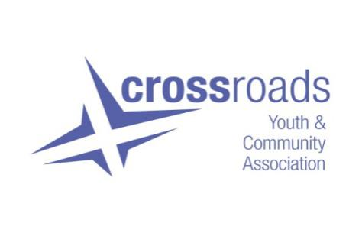

**Job Description**

**JOB TITLE**: Youth and Community Worker

**HOURS OF WORK:** 21hrs PW (Mon – Fri with evening and weekend work as required)

**SALARY:** SJC salary banding 23-26 (pro-rated to £16064)

**CONTRACT:** Until end June 2024

**LOCATION:** Based within theCharity’s main office in the Gorbals working across the Gorbals.

**ACCOUNTABLE TO:** Joint staff team, Charity Manager, Board Members

**The Aim of Community Work in Crossroads**

Crossroads Youth and Community Association’s work and values are built on the central belief that “everyone had the right to live gloriously: whatever in society prevents this, should be challenged and whatever in the individual helps should be nurtured”

The main aim of community development work in Crossroads is to collectively bring about social change and justice, by working with communities to:

* Identify their needs, opportunities, rights and responsibilities
* Plan, organise and take action
* Evaluate the effectiveness and impact of the action

We will do all this in ways which continually challenge oppressions and tackle inequalities staying true to our beliefs that community development should be rooted in values and principles.

**The Main Purpose of this Role**

To develop further our dignified approach to food insecurity across the community working with young people, families and the wider community.

Taking an approach that is universal, human and dignified to;

***Reduce isolation*** creating space and activities for local people to connect, build bonds, and friendships in our community hub and outdoor allotment space.

***Alleviate levels of food and fuel insecurity*** – by opportunities to learn new skills while gaining confidence in cooking, shop alternatively and access support and advice services to build resilience.

**Main Duties of the post**

* Create a sense of community around food (i.e. our allotment and building based activities)
* Support the development of local responses to rising levels of food insecurity locally
* Enable community influence and control

Represent and promote the work of Crossroads to partners, other organisations and statutory bodies on the aims and outcomes of project work in order to gain support and promote the aims and profile of the project.

**Key Tasks**

* To lead on the planning, facilitation and delivery of groups at our allotment site.
* To engage and deliver ‘growing’ workshops for youth and community groups.
* Purposeful community engagement.
* Develop innovative responses and solutions to rising levels of food insecurity.
* Support the continued development of our family cooking sessions.
* Develop the skills, confidence and knowledge of groups to enable them to achieve their aims.
* To attend and fully participate in service delivery staff/joint staff meetings and Board meetings as required.
* To work co-operatively as part of Crossroads’ wider staff team.
* To carry out administration/finances relating directly to the post in line with organisational procedures and to support the work of the admin/finance Officer relating to the wider work of Crossroads.
* To prepare written reports and review/evaluation material for Crossroads’ Board, funders and other target audiences as appropriate.
* To build networks and partnerships and represent Crossroads at external events.
* To participate in staff training and development.
* To comply with Crossroads’ policies, procedures, frameworks and processes.
* To undertake any other reasonable duties commensurate with the post at the agreed request of the staff/joint staff, Charity manager and Crossroads’ board.
* To be willing to work unsocial hours, weekends etc as the role requires.

This list of duties is not exhaustive and will be reviewed periodically in discussion with the post holder.